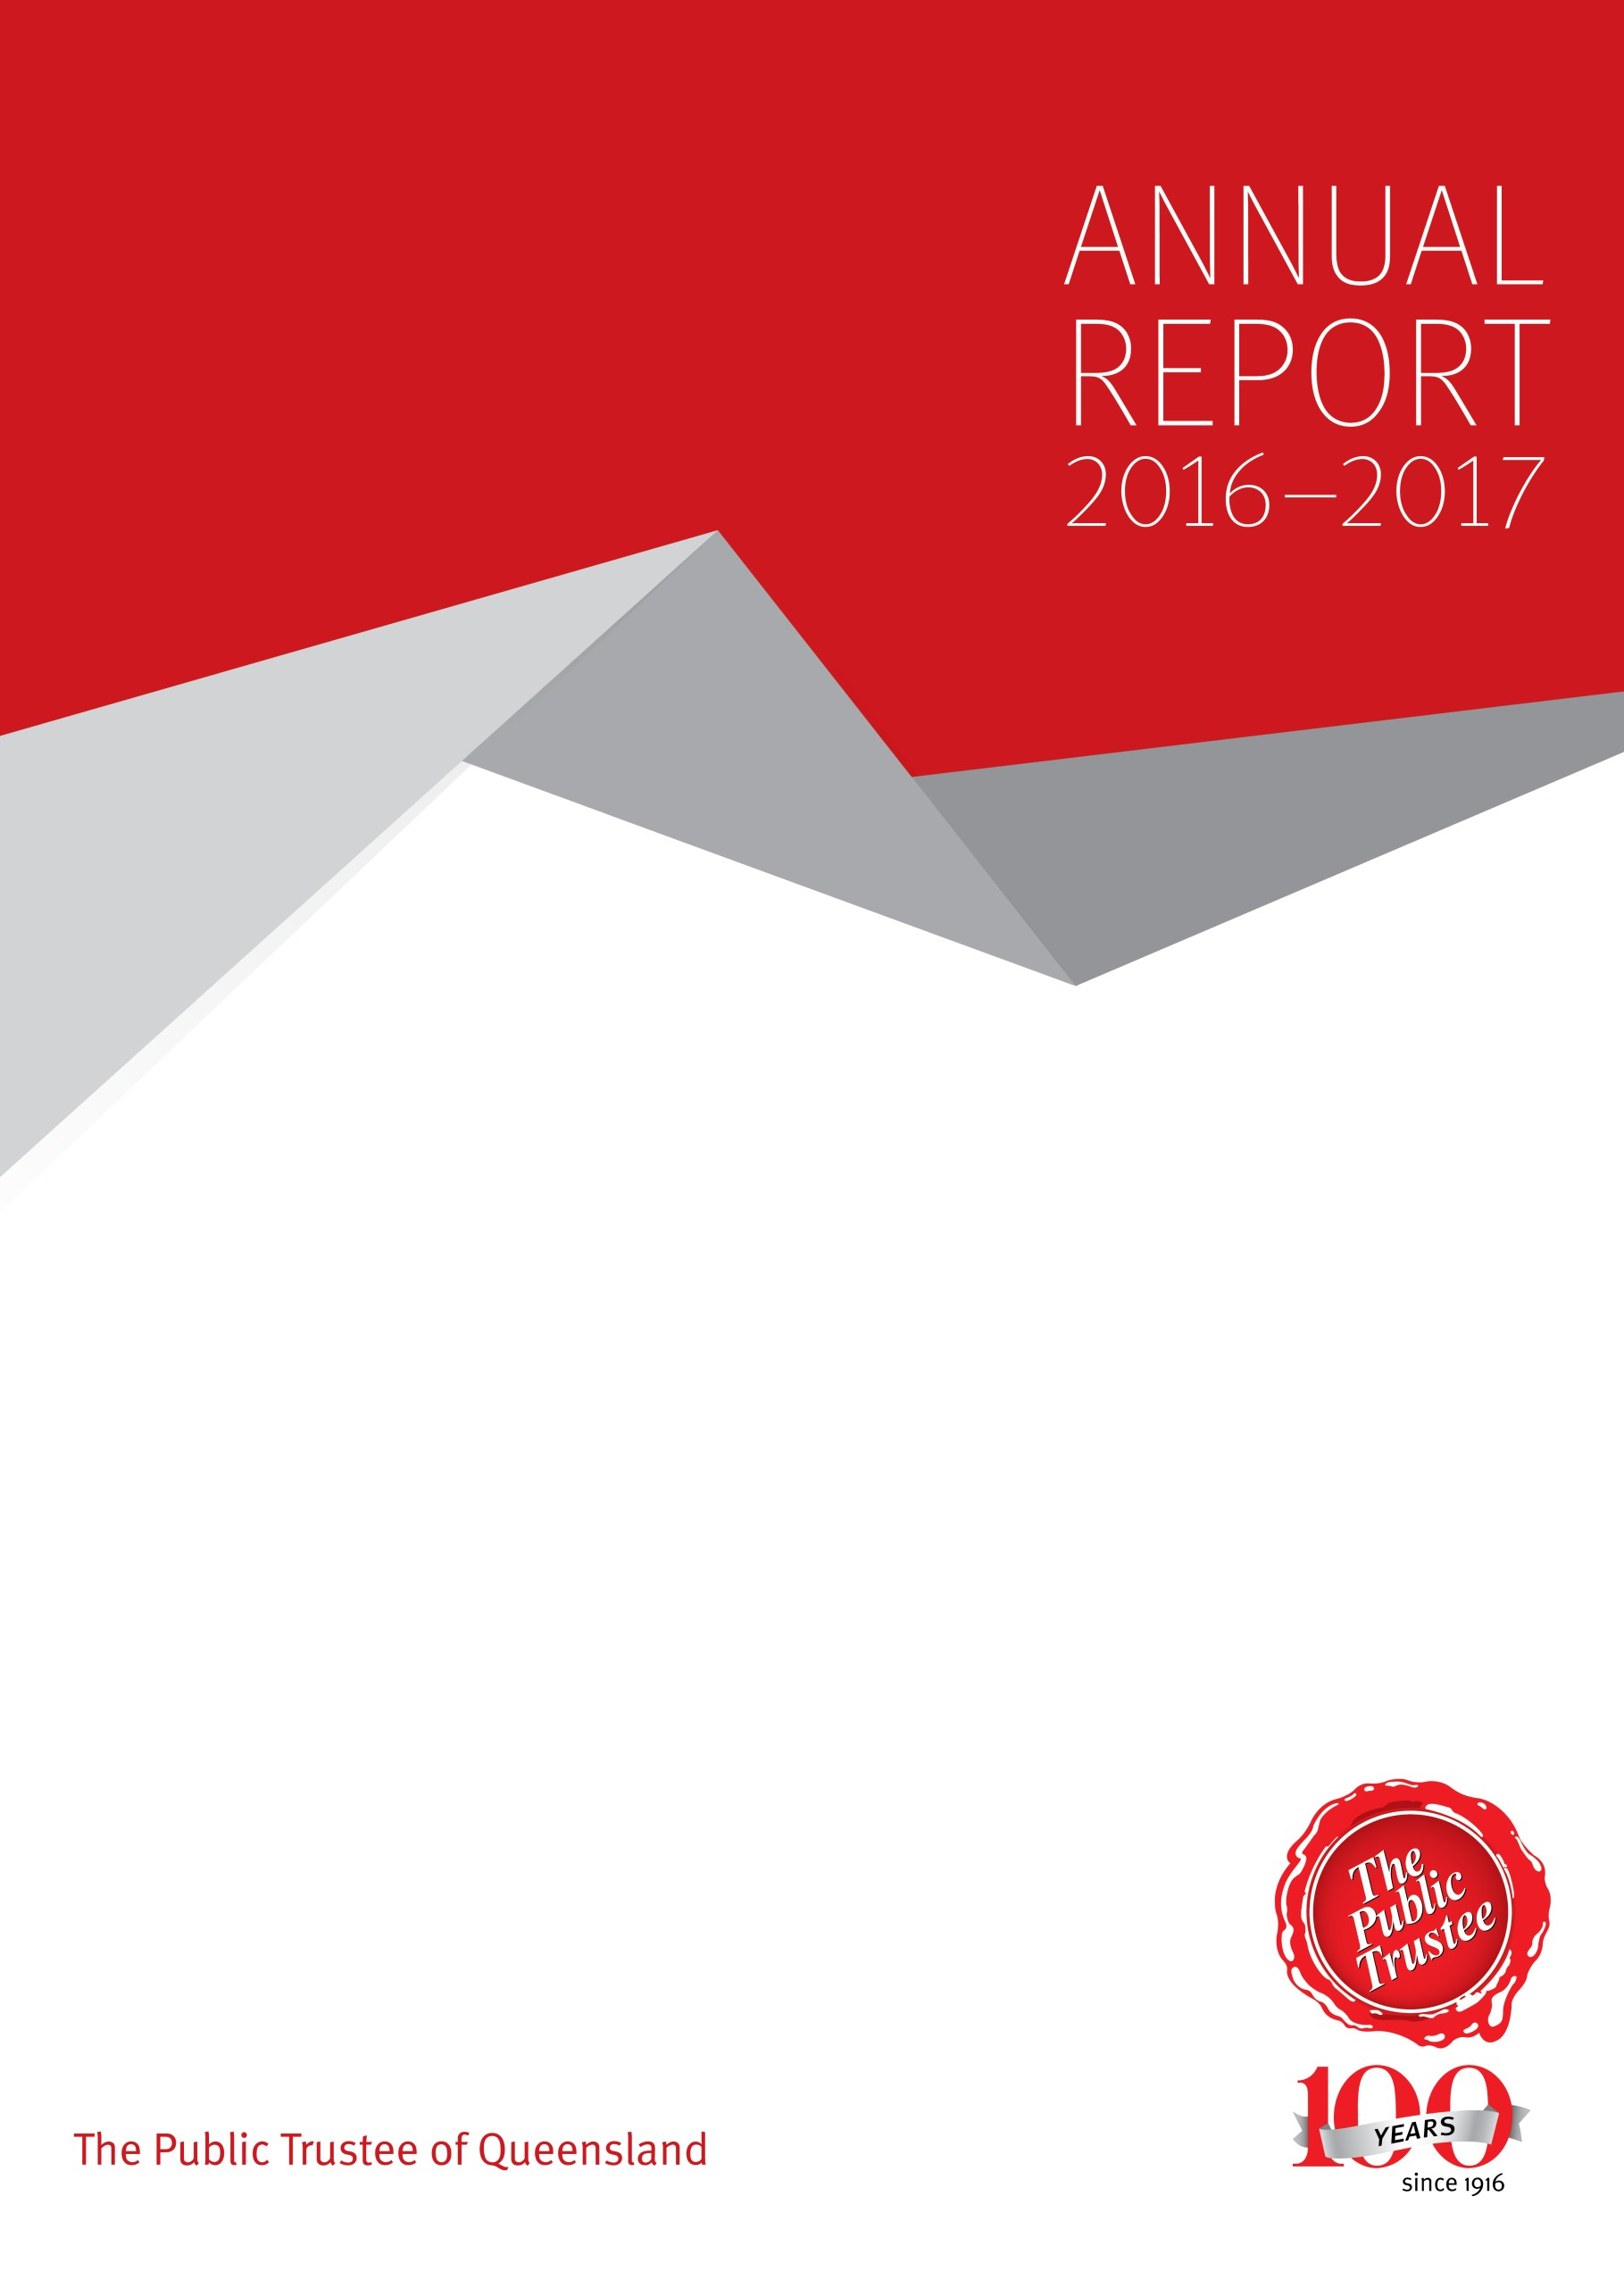
Page i The Public Trustee of Queensland Annual Report 2016-17

This annual report provides information about the Public Trustee of Queensland’s (Public Trustee) financial and corporate performance for 2016–17. It has been prepared in accordance with the Financial Accountability Act 2009 (FAA).

The Public Trustee is committed to providing accessible services to Queenslanders from all culturally and linguistically diverse backgrounds. If you have difficulty in understanding this annual report, you can contact us on 1300 360 044 and we will arrange an interpreter to effectively communicate the report to you.

Copyright

© The Public Trustee of Queensland 2017
Published by The Public Trustee of Queensland, September 2017 444 Queen Street, Brisbane Qld 4000.

Licence

This annual report is licensed by the State of Queensland (The Public Trustee of Queensland) under a Creative Commons Attribution (CC BY) 4.0 International licence.

In essence, you are free to copy, communicate and adapt this annual report, as long as you attribute the work to the State of Queensland (The Public Trustee of Queensland).
To view a copy of this licence, visit http://creativecommons.org/licenses/by/4.0/

Copies of this publication can be obtained at https://www.pt.qld.gov.au/about/publications/annual- reports/, by calling 1300 360 044 or emailing governance@pt.qld.gov.au
ISSN 1839 – 1451

Attribution

Content from this annual report should be attributed as:

The State of Queensland, (The Public Trustee of Queensland), annual report 2016–2017.

Letter of Compliance iv
Year in review 1
About the Public Trustee of Queensland 2
Our locations 2
Our vision 3
Our purpose 3
Our values 4
Our achievements 4
Official Solicitor 5
Our strategic direction 6
Performance indicators 7
Our future priorities 8
Our key challenges 8
Our 2017–18 budget highlights 9
Non–financial performance 10
Queensland Government Objectives for the community 10
Community Service Obligations 11
Service delivery 12
Philanthropic charitable trusts 14
Financial performance 16
Public Trustee of Queensland Investment Fund – Growth Trust 19
Management and structure 20
Executive management 21
Senior internal management committees 23
Boards and committees with external membership 27
Public Sector Ethics Act 1994 30
Queensland Public Service values 31
Governance – risk management and accountability 33
Governance and Risk Directorate 33
Risk management 33
External scrutiny 34
Internal audit 34
Information systems and recordkeeping 35
Governance – human resources 36
Workforce planning and performance 36
Staffing 36
Early retirement, redundancy and retrenchment 37
Office locations 38
Outreach locations 39
Legislation 41
Glossary 42
Acronyms 45
The Public Trustee of Queensland Financial Statements 46
The Public Trustee of Queensland Growth Trust 91
Open data 114
Compliance Checklist 115

Letter of Compliance

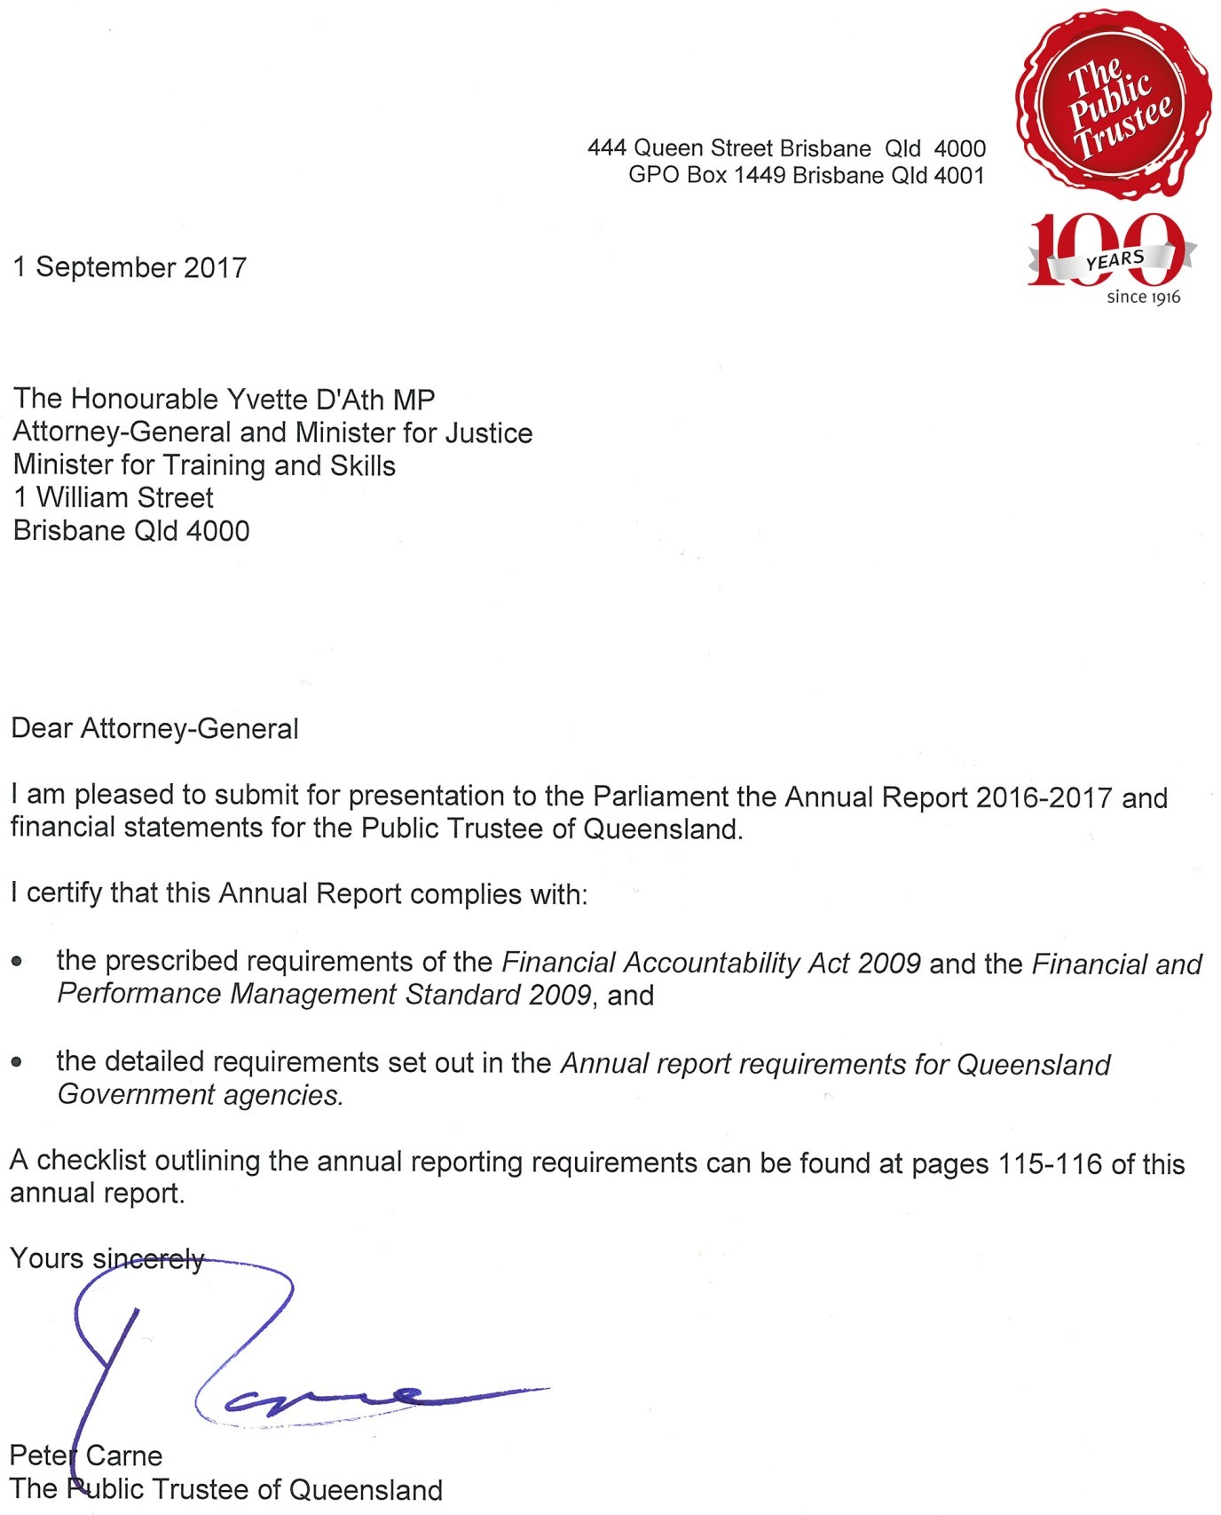

Year in review

In 2016, the Public Trustee celebrated 100 years since establishment of the organisation as the Public Curator in 1916. Our centenary provided an opportunity to celebrate our significant achievements and reflect on how we have remained relevant to successive generations of Queenslanders by providing important community services such as making Wills and Enduring Powers of Attorney (EPAs), financial management, administering deceased estates and managing trusts.

Since 1916, the Public Trustee has grown to become the largest public trustee organisation in Australia. In accordance with our governing legislation, the Public Trustee Act 1978, we continue to successfully deliver valuable services to the people of Queensland while remaining wholly self-funding. Our services are delivered throughout Queensland via a network of 16 regional offices ensuring that all Queenslanders have access to essential services at all life-stages. I am very proud of our people who meet the needs of our clients with professionalism and empathy and demonstrate a commitment to the Queensland Public Service values in everything that they do.

The Public Trustee of Queensland Strategic Plan 2016-2020 (Strategic Plan) outlines our strategic direction and objectives to deliver on our vision and purpose and contribute to the achievement of the Queensland Government’s objectives for the community by delivering quality frontline services and building safe, caring and connected communities.

During 2016-17, Public Trustee staff made 25,136 free Wills and 3,165 EPAs. We also provided financial management for 9,359 clients, accepted 2,142 new deceased estates for administration and managed 4,649 trusts and client assets valued at $2.5 B. In accordance with specific legislated responsibilities, we delivered a range of services to the Queensland Government and the community including administration of unclaimed moneys and managing the estates of prisoners. Our prudent financial management has ensured the sustainability of our services and the ability to deliver Community Service Obligations (CSO) to Queenslanders valued at $33.8 M. These include the provision of free wills and rebates on fees for financial management for vulnerable clients with limited income and assets.

The Public Trustee is committed to supporting the Queensland community through education, financial support and partnerships with other government agencies. In 2016-17, we provided further funding to support campaigns to raise awareness and prevent elder abuse in our community. We also provided funding to support the work of the Court Network which provides information and support for Queenslanders attending courts including hearings of the Queensland Civil and Administrative Tribunal (QCAT).

We are also working in partnership with other Queensland Government agencies and the National Disability Insurance Agency (NDIA) to ensure that Public Trustee clients who are eligible for services are registered as the National Disability Insurance Scheme (NDIS) is rolled out in Queensland. We are also working closely with other state trustees to address particular issues for our client groups.

To ensure the Public Trustee is well-placed to meet these and other challenges, I implemented a revised executive structure in late 2016. The newly created positions of Executive Director, Digital and Technology and Executive Director, Client Experience and Delivery will oversee the transformation of client experience and service delivery supported by investments in digital technology. With these developments, I am confident that the Public Trustee will continue to provide services that meet the needs of Queenslanders and the community.

Peter Carne
The Public Trustee of Queensland

About the Public Trustee of Queensland

The Public Trustee has been serving Queenslanders since 1916 and is governed by the Public Trustee Act 1978. The Public Trustee is self-funding and receives no financial assistance from the Queensland Government. Operating as a corporation sole, we provide financial, trustee and legal services to the people of Queensland.

In providing our services we aim to ensure:
- Prudent management of the financial assets of members of the community
- Support for vulnerable members of the community
- An orderly succession of assets between generations
- The provision of life-planning assistance to the Queensland community by making Wills free of charge and Enduring Powers of Attorney documents at an affordable cost.

Our locations

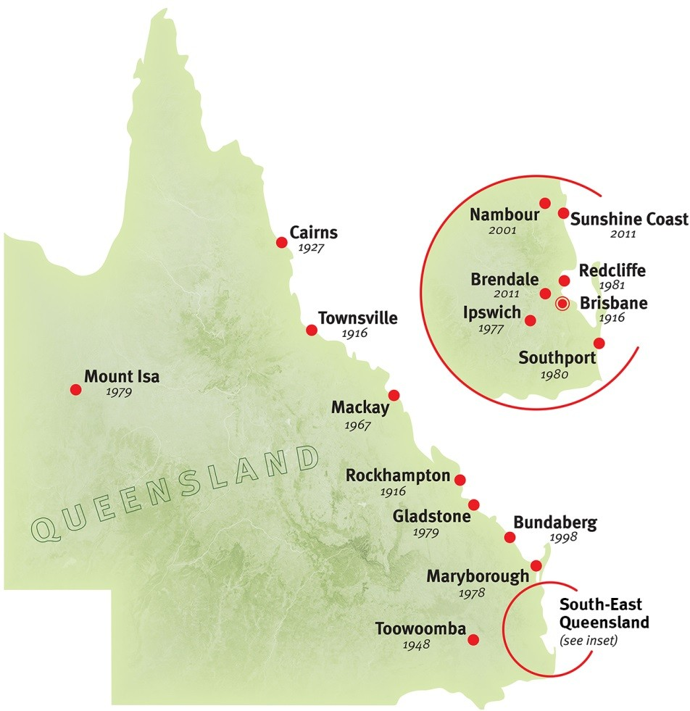
We provide our services through a network of 16 regional offices in the following locations, including our head office at 444 Queen Street, Brisbane:

  - Brendale
  - Brisbane
  - Bundaberg
  - Cairns
  - Gladstone
  - Ipswich
  - Mackay
  - Maryborough
  - Mount Isa
  - Nambour
  - Redcliffe
  - Rockhampton
  - Southport
  - Sunshine Coast
  - Toowoomba
  - Townsville

We also provide services outside of the above locations through the Queensland Government Agent Program (QGAP) and the local court networks.

For contact details of our office locations and where our services are provided outside of our regional office locations, please refer to pages 38-40. Alternatively, you can also visit our website at www.pt.qld.gov.au.

Our vision

To be the independent trustee for Queenslanders providing security and peace of mind.

Our purpose

To lead the evolution and delivery of trustee, estate and administration services that make a positive difference in the lives of Queenslanders.

We provide professional and accessible services in:
Administration of deceased estates
Trusts
Will making
Financial management for those with impaired capacity for decision-making
Facilitating philanthropy

In addition, we also provide the following services:
Safe and secure storage of Wills
- Administering unclaimed moneys for the State of Queensland
- Managing the estates of prisoners under Part 7 of the Public Trustee Act 1978
- Special functions of a public nature under Part 5 of the Public Trustee Act 1978
- Community education on elder abuse.

Our values

We align to the values of the Queensland Public Service:
- Customers first
- Ideas into action
- Unleash potential
- Be courageous
- Empower people

Pages 31-32 of this report highlight how the Public Trustee is implementing and embedding these values into all areas of our operations.

Our achievements

Our key achievements during 2016–17 included:
- Provision of a range of CSO valued at $33.8 M at no cost to Government including:
- fees rebated for some clients with limited assets
- making 25,136 free Wills and 3,165 EPAs
- public education in areas such as Wills and EPAs with an emphasis on planning for life
- providing funds for a range of community services such as the Office of the Public Guardian and the Civil Law Legal Aid Scheme administered by Legal Aid Queensland
- Providing financial management for 9,359 clients and acting as financial attorney for 233 clients
- Managing 4,649 trusts
- Accepting 2,142 new deceased estates for administration
- Managing client assets totalling $2.5 B
- Continued enhancements to frontline service delivery through the:
- development of formally recognised technical training (Level 1 and Level 2) which enables staff to achieve Certificate IV level qualifications. Level 1 technical training was delivered to 46 staff. The next intake for Level 2 technical training is scheduled for October 2017
- implementation of recommendations from the end to end review of financial management activities to improve service delivery
- Recognition of prior learning: Certificate IV in Personal Trust Administration (nationally accredited) has been awarded to 15 staff members for the Public Trustee Level 1 and Level 2 technical training
- Delivery of a Wills and Enduring Power of Attorney Accreditation program to 16 staff
- Annual client satisfaction surveys demonstrate we have met customer expectations in the provision of services for:
- deceased estate administration
- Will making services
- financial management for clients with impaired financial decision-making capacity (results are available on page 13)
- Continued support of philanthropic endeavours through the financial management of charitable trusts
- In response to customer feedback, four specialist “Centres of Excellence” have been established (Testamentary Trusts, Minors Trusts, Group Housing and Advanced Residential Care), designed to improve service delivery by providing:
- improved communication

- faster and more consistent responses to client enquiries
- streamlined processes
- a specialist knowledge base
- Providing ongoing sponsorship to the Department of Communities, Child Safety and Disability Services’ No excuse for elder abuse campaign
- Advocating for Public Trustee clients who are eligible for NDIS via participation in regular forums with other human rights agencies to ensure clients are registered and engaged with the NDIS
- Delivery of, in collaboration with the Queensland University of Technology (QUT), the
Leadership and Management Development Program to 31 middle managers
- Maintaining strong financial performance which resulted in an operating surplus of $2.4 M
- Independent review of the Growth Trust investment strategy, resulting in a higher level of asset diversification, a lower level of volatility and simplification of administration
- Development of a Workplace Health and Safety (WH&S) Strategic Plan that aligns with the Strategic Plan
- Development of a WH&S management system framework and policy in accordance with AS4801 Occupational Health and Safety Management Systems
- Implementation of the Queensland Public Service values across the Public Trustee.

Official Solicitor

The Official Solicitor is the Public Trustee’s in-house legal advisor and is appointed pursuant to section 16 of the Public Trustee Act 1978.

The Official Solicitor provides advice and conducts litigation on behalf of the Public Trustee in his many different roles. These services include:
- Provision of legal advice and the conduct of litigation in circumstances where the Public Trustee is appointed personal representative of deceased estates
- Providing advices and litigation services when the Public Trustee is appointed administrator for an adult with a decision-making incapacity
- Conveyancing, leasing and other property related transactions on behalf of estates under administration and the Public Trustee as a corporation sole.

The Official Solicitor has identified a number of trends in the work he undertakes on behalf of the Public Trustee, for example:
- There is a steady increase in the number of family provision applications made, usually by adult children of a deceased person, in respect of estates. The majority of these matters resolve by agreement, often following an alternative dispute resolution process – in particular mediation
- The Public Trustee often finds himself appointed administrator for an adult with impaired capacity in circumstances where that adult has been the subject of financial elder abuse. The role of the Official Solicitor is to offer advice on the prospects of recovery of property or money misappropriated. These are often difficult cases where the adult for whom the Public Trustee is appointed administrator (as a result of the misappropriation) is of extremely limited means to support litigation. In addition, it is often the case that the funds or property misappropriated have been dissipated by the person who has acted improperly.

The Official Solicitor also provides advice to the Public Trustee in the development of laws. The Public Trustee made submissions to the Australian Law Reform Commission in regard to a report relating to elder abuse – particularly in respect of federal laws and the possible approaches to preventing
such abuse.

The Public Trustee provided comment in respect of amendments to the Succession Act 1981 (and the Trusts Act 1973) which was amended by the Court and Civil Legislation Amendment Act 2017. The amendments to the Succession Act 1981 will have a significant impact upon the Public Trustee’s work as personal representative for deceased estates and as a Will maker. The amendments include holding that a disposition, grant or power given to a de facto spouse in a person’s Will is revoked when the de facto relationship ends (this is similar to the effect on a Will when a marriage is dissolved). The legislature also clarified the meaning of “stepchild” for the purposes of the family provision sections of the Succession Act 1981.

The Public Trustee has been involved in a number of significant legal cases during the year including:
- The Public Trustee of Queensland v Mrs X [2016] QSC 179 - where the Public Trustee went to some lengths to ensure that the benefit of a deceased estate properly would be paid to benefit the deceased’s wife who resided in a middle eastern country
- Doleman v Doleman [2017] QSC 113 - where the role of an administrator pursuant to the Guardianship and Administration Act 2000 and the capacity of others to conduct litigation on behalf of a person with a relevant decision making incapacity was examined by the Supreme Court.

Our strategic direction

Our strategic direction is documented in the Strategic Plan which is available on our website. The Strategic Plan sets the parameters for our strategic direction to staff, clients and stakeholders.

Our Strategic Plan outlines how we will contribute to the achievement of the Queensland Government’s objectives for the community, our priorities and our strategies. It also includes performance indicators determining how our objectives will be measured.

The Public Trustee’s strategic objectives are:

Our clients

Drive value for clients through tailored services to meet changing needs
- Partner with clients to identify changing needs and demand for services by 2020 and beyond
- Tailor our services to meet client needs and regional diversity
- Improve our communication with clients by providing options in the way information is provided
- Identify new client markets and develop services to meet requirements.

Our services

Implement targeted service delivery models that increase client satisfaction and improve efficiency
- Identify preferred service models for each of the Public Trustee’s core functions
- Implement the preferred service delivery models in a staged manner
- Develop supporting systems required to ensure agility, providing the foundations for future innovations that meet our clients’ changing needs.

Our stakeholders

Strengthen the Queensland community and government’s confidence and value in our services
- Promote knowledge and benefit of the services of the Public Trustee
- Collaborate and partner with inclusive community representative organisations and government
- Strengthen positive engagements with our clients and their support networks
- Enhance accessible and effective regional service delivery for all Queenslanders.

Our business

Deliver the surplus required to enable sustainable reinvestment that supports current and future business objectives
- Optimise revenue from our business operations to ensure ongoing viability
- Achieve our service delivery cost target
- Optimise return on our assets to meet business objectives
- Strengthen and improve core services and identify future opportunities that build additional revenue streams.

Our people

Develop an engaged, empowered and flexible workforce with the agility to readily respond to changing imperatives
- Build on our professional and capable workforce with the right skills, knowledge, attitude and tools to meet client and stakeholder expectations
- Develop increased workforce agility through knowledge management, workforce mobility, embedded diversity strategies and flexible work practices
- Grow and maintain a highly engaged workforce.

These strategies are necessary to maintain our frontline service delivery commitment to the people of Queensland and to support the initiatives that contribute to the Queensland Government’s objectives for the community.

Performance indicators

Our achievement of our strategic objectives will be measured by the following indicators:

Our clients
- Client demand and preferences are tracked via customer focus groups and analysis of state-wide demographic data to determine future demand for services
- Client satisfaction levels are improved. Client satisfaction surveys measure and record client preferences and this data is used for the purposes of continuous improvement
- Take-up of services is increased.

Our services
- Services are delivered from approved budgets
- Service effectiveness and efficiency metrics are met
- Implementation of new service delivery models are achieved on time and within budget.

Our stakeholders
- Foster collaborative and open relationships with sector partners, government agencies and other stakeholders
- Foster close ties with various agencies and community groups in the aged care and disability services sectors
- Promote knowledge and benefit of the services of the Public Trustee and improve community awareness through community education such as through Wills Week, Elder Abuse Awareness Week and Philanthropy Week.

Our business
- Revenue from services is increased year on year to facilitate the delivery of quality frontline services and to meet the continued demand for CSO
- Return on assets is improved
- New revenue opportunities are actioned.

Our people
- Improvement in workforce capability
- Employee engagement is increased
- Workforce capacity is aligned, measured and improved.

Our future priorities

To support our strategies, a number of key priorities for 2017–18 have been identified including:
- Providing ongoing financial management for Queenslanders with impaired financial decision-making capacity
- Continued provision of a range of CSO at no cost to the Queensland Government
- Investment in the enhancement of technology and continual review of service delivery models and locations to better meet growing and changing demographic needs of Queenslanders
- Investment in upgrading facilities at regional offices to better service clients
- Enhancement of frontline service delivery in response to client satisfaction survey outcomes
- Providing services to the philanthropic sector
- Ensuring we have the required capability for future service delivery by developing a strategic workforce plan.

Our key challenges

In 2017–18, we will continue to deliver quality effective and efficient frontline services by ensuring our business model is capable of meeting the increasing demand for our services.

The Public Trustee is facing increasing demand for its services due to age related illness and increasing complexity in the inter-generational transfer of assets. This is seeing a greater demand for the Public Trustee’s financial management services and increased complexity around deceased estates. Technological advances in an age of digital disruption are also impacting the way the Public Trustee delivers services. To ensure sustainability for the future, significant planning is underway to ensure we are positioned to meet these challenges and harness these opportunities.

The key challenges to achieving our core commitments are:
- Maintaining delivery of quality frontline services
- Ensuring service delivery models and information technology adapt and respond to client, community and business needs
- Maintaining community confidence in the services we provide
- Ensuring strong leadership and governance frameworks to enable us to effectively respond to changes
- Ensuring appropriate focus on business as usual while implementing longer term strategic initiatives
- Continual focus on organisational capabilities and systems
- Sustainability of the current business models in light of increasing operating costs, increased demand for CSO and external economic factors.

Our 2017–18 budget highlights

We are committed to meeting the Queensland Government’s objectives to provide quality and efficient services to our clients. We continue to redevelop regional offices to improve efficiency of frontline service delivery and accessibility to all clients, as well as continuing to maintain appropriate workplace health and safety standards for clients and staff.

During 2017–18 capital expenditure is estimated to be $13.5 M which includes:
Capital budget (M)

$8.8 M

Building improvements and refurbishment

$0.8 M

Business system upgrade

$3.9 M

Plant and equipment

Non–financial performance

We contribute to the Queensland Government’s objectives for the community of delivering quality frontline services and building safe, caring and connected communities. We support vulnerable Queenslanders through our work in financial administration, by facilitating the orderly transfer of assets and by providing life planning assistance through our Wills and Enduring Powers of Attorney making service.

For more information about our objectives, please see the Strategic Plan on our website - http://www.pt.qld.gov.au/.

Queensland Government Objectives for the community

Below are our achievements against the Queensland Government’s objectives for the community for the 2016–17 reporting period.

Delivering quality frontline services
- Delivered over $33.8 M in CSO at no cost to the Queensland Government including:
- fees rebated for some clients with limited assets
- providing a free Will making service and community education
- public education in areas such as Wills and EPAs with an emphasis on planning for life
- Made 25,136 Wills and 3,165 EPAs
- Provided financial administration services for 9,359 adults with impaired decision-making capacity and acted as financial attorney for 233 people
- Implemented four specialist “Centres of Excellence” - Testamentary Trusts, Minors Trusts, Group Housing and Advanced Residential Care
- Continued ongoing review of service delivery models and locations to better meet growing and changing demographic needs of Queenslanders
- Continued support for philanthropic endeavours through the management of charitable trusts (see pages 14-15 for more information).

Building safe, caring and connected communities
- Support for a range of community services such as the Office of the Public Guardian and funding of the Civil Law Legal Aid Scheme administered by Legal Aid Queensland
- Continued to contribute funding to the Department of Communities, Child Safety and Disability Services’ No excuse for elder abuse campaign
- Maintained our Will making outreach services to ensure Queenslanders can access our services
- Provided extensive community education around the importance of a valid Will and EPA.

Community Service Obligations

A range of CSO were provided in 2016-17 including:

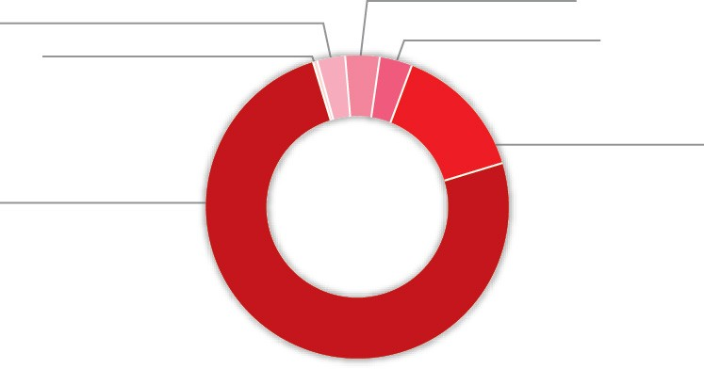$1.0 M
Public community education and advice to the courts and tribunals in the areas in which the Public Trustee has expertise

$1.1 M
A cash contribution to the Office of the Public Guardian

$0.4 M
Civil Law Legal Aid - outlays written-off and administrative support

$25.3 M
Fees rebated for clients with limited assets
$1.1 M Other

$4.9 M
Provision of free Will making service to Queenslanders

The total cost of CSO delivered for the 2016–17 financial year was $33.8 M representing an increase of 7.8 per cent from the previous financial year which was $31.3 M. An amount of $36.0 M is budgeted for 2017–18.

Category of Community Service Obligations | 2016–17  Actual | 2017–18  Budget
Fees rebated for clients with limited assets | $25,326,315 | $26,962,605
Fees rebated for principal residence and other | $978,887 | $738,361
Management of estates of prisoners | $128,562 | $420,310
Public community education and advice to the courts and tribunals in the areas in which the Public Trustee has expertise | $980,003 | $1,420,635
Providing free Will making service to Queenslanders | $4,838,680 | $5,025,240
Cash contribution to the Office of the Public Guardian | $1,132,000 | $1,160,300
Civil Law Legal Aid - outlays written-off and administrative support | $381,460 | $238,313
Total | $33,765,907 | $35,965,764

CSO are reported in our Financial Statements in two areas:
- Deduction from fee revenue ($32.3 M 2016–17) where there are a rebate of fees or services provided at no charge
- Expenditure ($1.5 M 2016–17) as contributions towards other sector operations.

Service delivery

The Public Trustee is required to plan service delivery to measure and monitor the efficiency and effectiveness of our services. Service delivery uses internal capabilities such as human resources, financial, information and communication technology and is measured using service standards and other measures. The Public Trustee sets service standards and other measures and publishes our expected results in our Service Delivery Statements (SDS) as part of our budget papers. Actual results for 2016-17 are published on page 13.

By measuring performance, the extent to which the Queensland Government’s services are creating value can be determined.

Our service areas and service standards
Client Experience & Delivery is the frontline interface with our clients and the community. The Public Trustee strives to make a positive difference in the lives of our clients while ensuring we fulfil our fiduciary responsibilities.
The SDS discloses service standards that relate to the efficiency and effectiveness of services.

Service area objective

To deliver a full range of professional, accessible and reliable trustee, financial and related services that meet client needs.

Services and service area description
The major services provided by Client Experience & Delivery are:

Deceased estate administration
The Public Trustee acts as executor and trustee or administrator in deceased estate matters pursuant to Wills or on intestacy.

In 2016–17, the Public Trustee accepted 2,142 new deceased estate matters for administration.

Financial management
The Public Trustee acts as an administrator for financial matters for clients with impaired decision-making capacity pursuant to the Guardianship and Administration Act 2000 or as a financial attorney pursuant to the Powers of Attorney Act 1998.

In 2016–17, the Public Trustee provided financial management for 9,359 clients and acted as financial attorney for 233 people. Fees rebated for clients with limited assets under our CSO were $25.3 M.

Will making service
Wills are prepared free of charge for all Queenslanders over 18.
In 2016–17, the Public Trustee prepared 25,136 Wills and 3,165 EPAs.

This table outlines our performance against service standards:

Service Standards | Notes | 2016-17  Target/Est. | 2016-17  Actuals
Service: Deceased Estate Administration
Effectiveness measure  Overall client satisfaction with deceased estate administration service as measured by client satisfaction index | 1 | 70% | 74%
Efficiency measure  Percentage of deceased estates administered within target timeframe | 2 | 70% | 73%
Service: Financial Management
Effectiveness measure  Overall client satisfaction with financial management service as measured by client satisfaction index | 3 | 70% | 76%
Service: Will Making Service
Effectiveness measure  Overall client satisfaction with Will preparation services as measured by client satisfaction index | 4 | 90% | 97%
Efficiency measure  Cost per Will | 5 | $191 | $192

Notes:
- The satisfaction index is calculated by an independent market research provider on an annual basis. The index is calculated by summing 50 per cent of the overall satisfaction score and 50 per cent of the single overall weighted satisfaction factors score to obtain a total index score.
- Reflects current actual status of the administration of the estate within the Client Information Management System.
- The satisfaction index is calculated by an independent market research provider on an annual basis. The index is calculated by summing 50 per cent of the overall satisfaction score and 50 per cent of the single overall weighted satisfaction factors score to obtain a total index score.
- All clients preparing a Will with the Public Trustee receive a Wills Questionnaire. The Wills Questionnaire contains eight questions relating to the quality and the delivery of the Will making service provided. The overall satisfaction level is calculated as a percentage of positive responses to total number of responses received.
- This measure is calculated using the total cost of making free Wills divided by the number of Wills drafted and completed in the financial year.

Philanthropic charitable trusts

The Public Trustee is trustee for the following leading philanthropic charitable trusts in Queensland.

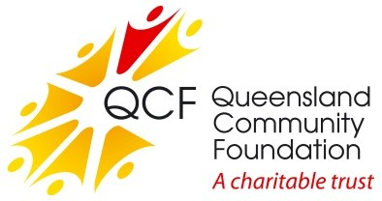
Queensland Community Foundation
The Queensland Community Foundation (QCF) was established in 1997 to provide a permanent source of philanthropic funding for charitable organisations to enable them to respond to the needs of the Queensland community.

The QCF continued to grow in 2016–17 and now has funds under management exceeding $80 M. During the year, QCF paid distributions to a broad range of charities in excess of $2.0 M.

For further information visit www.qcf.org.au.

QCF Sub Fund: Gulf Area Community Social Development Established under the umbrella of the QCF in 2000, this sub fund has assets in excess of $6 M.

The sub fund supports the Gulf Area Community by providing grants to projects and initiatives that encourage educational, health, cultural and social development.

Queensland Aboriginal and Torres Strait Islander Foundation The foundation was established in 2008 and provides a secure, independent and perpetual funding source to advance the education of Aboriginal and Torres Strait Islander children and young people in Queensland through provision and promotion of scholarships.

The trust has net assets of approximately $39 M with distributions totalling $1.8 M in 2016-17.

Scholarships of more than $2.2 M for 1,390 Indigenous students from 244 Queensland high schools were approved in 2016–17. A total of 6,299 students have been approved for scholarships since the foundation commenced in 2008.

For further information visit www.qatsif.org.au.

Lady Bowen Trust
Established in 2006, the trust aims to re-engage people experiencing chronic homelessness so they achieve genuine, positive and lasting outcomes. The trust supports Mission Australia which maintains Roma House, a facility to enhance clients’ life skills, confidence and resilience while assisting them to find secure accommodation.

The trust has net assets of approximately $5.0 M with distributions totalling $0.2 M in 2016-17.

For further information visit www.ladybowentrust.org.au.

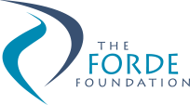
Forde Foundation
The Forde Foundation was established in August 2000 in response to the findings of the Commission of Inquiry into Abuse of Children in Queensland Institutions, better known as the Forde Inquiry. The foundation is designed to support former residents of Queensland institutions. Financial support is provided to individuals for specific purposes such as dental care, education, training and personal development opportunities.

The foundation has net assets of approximately $4.0 M with distributions totalling $0.2 M in 2016–17.

For further information visit www.fordefoundation.org.au.

Gladstone Foundation
Established in early 2011, the foundation allows for industry funds to be channelled into this perpetual trust to provide social infrastructure and service needs in the Gladstone Region.

Specific purposes of the trust are relieving poverty, assisting the aged, relieving sickness or distress, advancing religion and education, providing child care services on a non-profit basis and other purposes which benefit the Gladstone Region.

Initial capital received by the trust was $13.5 M. The foundation has net assets of approximately $8.5 M as at 30 June 2017 with distributions totalling $2.1 M paid in 2016-17. In 2016–17, the foundation awarded grants totalling $3.2 M for four major projects in the Gladstone region with $1.1 M remaining to be claimed. After taking into account the balance of outstanding grant commitments to be claimed, the balance of uncommitted funds at 30 June 2017 was approximately $7.4 M.

For further information visit www.gladstonefoundation.org.au.

Financial performance

The Public Trustee’s Financial Statements are included from page 46.

The Public Trustee has achieved a sound financial result for 2016–17 recording an operating surplus of $2.4 M. The financial performance benefited from savings in contractor expenses and higher than anticipated fees revenue.

A summary of our revenue and expenditure over the last seven financial years is as follows:

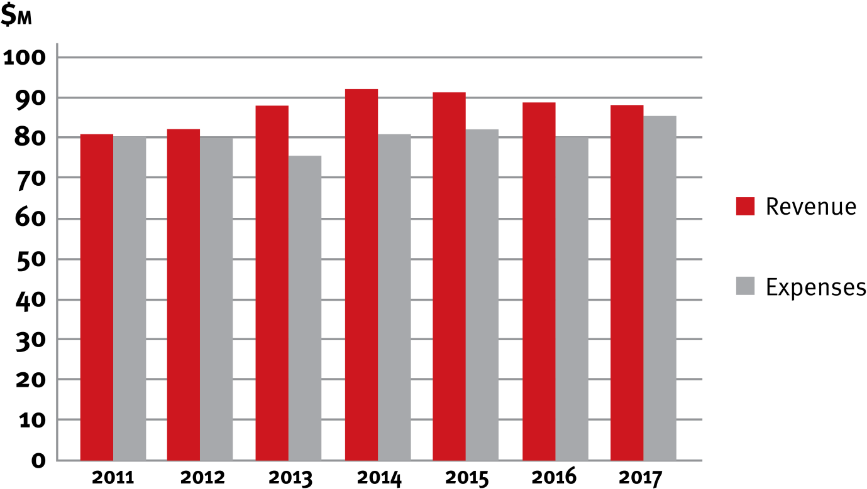
Revenue & Expenses

Our revenue sources in the last two financial years comprise the following:

Revenue sources | 2015–16 | 2016–17
Fees and Charges | 59% | 63%
Interest Revenue | 36% | 33%
Other Revenue | 5% | 4%
Total Revenue | 100% | 100%

Gross revenue from fees and charges increased by 5 per cent from the previous year. The majority of CSO are deducted from gross fees to arrive at net fees and charges reported in the financial statements, with the remaining CSO amount recorded in contributions expense. This year, we provided a total of $33.8 M in CSO at no cost to the Queensland community which was a 7.8 per cent increase from the previous year. The main driver of the increase in CSO was a 7.6 per cent increase in fees rebated for clients with limited assets. As the Public Trustee is self-funded, these obligations were met from our own sourced revenue.

Interest revenue was lower than the previous year due to a lower interest rate environment. Other revenue decreased 3 per cent with a reduction of $0.7 M from proceeds from insurance claims.

Our expenditure in the last two financial years comprises the following:

Expenditure | 2015–16 | 2016–17
Employee Expenses | 58% | 58%
Supplies and Services | 20% | 22%
Interest Expense | 16% | 14%
Depreciation and Amortisation | 2% | 2%
Contributions | 2% | 2%
Other Expenses | 2% | 2%
Total Expenditure | 100% | 100%

Total expenses increased 6 per cent from the previous year. Non-employee expenses increased by 5 per cent due to an increase in supplies and services in comparison to the previous year. The increase in supplies and services expenditure is predominantly due to higher planned building maintenance spend across all regions, the expensing of a new fleet of multifunctional printer devices and higher computer and temporary and contract staff expenses during the year.

Employee expenses increased as a result of a higher number of full-time equivalent staff (FTE) coupled with a 2.5 per cent increase in staff salaries in the 2016–17 year.

Other Comprehensive Income
The Public Trustee holds interests in financial assets and various land and buildings located throughout the state from which our offices operate. These assets are recorded at fair value and are revalued periodically in accordance with Australian Accounting Standards. The gains and losses that result from these revaluations are recorded as other comprehensive income in the statement of comprehensive income.

In June 2017, land and building values were updated using indices provided by State Valuation Services that were derived from observable inputs such as market data and publicly available information on market transactions resulting in a $1.2 M increase in the asset revaluation surplus.

The market value of the Public Trustee’s financial assets recorded unrealised losses of $3.0 M due to a highly unfavourable bonds market in 2016-17. These factors resulted in a total other comprehensive loss of $1.8 M for 2016–17, which combined with the operating surplus, resulted in total comprehensive income of $0.7 M for 2016–17.

Statement of Financial Position

Total Assets
Total assets comprise:
  - cash
  - financial instruments (mainly short to medium term investments)
  - property, plant and equipment.

As at 30 June 2017, the Public Trustee held $950 M in assets, an increase of $16 M from 30 June 2016, mainly due to a larger investment portfolio compared to the prior year.

Total Liabilities
The Public Trustee’s liabilities include amounts held for clients, amounts owing to staff for leave entitlements and amounts owed to suppliers.

Total liabilities were $751 M as at 30 June 2017, an increase of $16 M on the previous year. The increase in liabilities is primarily due to an increase in amounts held on behalf of clients.

Statement of Changes in Common Fund Reserves
Total Common Fund reserves are $199 M as at 30 June 2017 which is in line with the prior year. This is due to the operating surpluses achieved during the previous financial years.

A summary of our assets and liabilities over the last seven financial years is as follows:

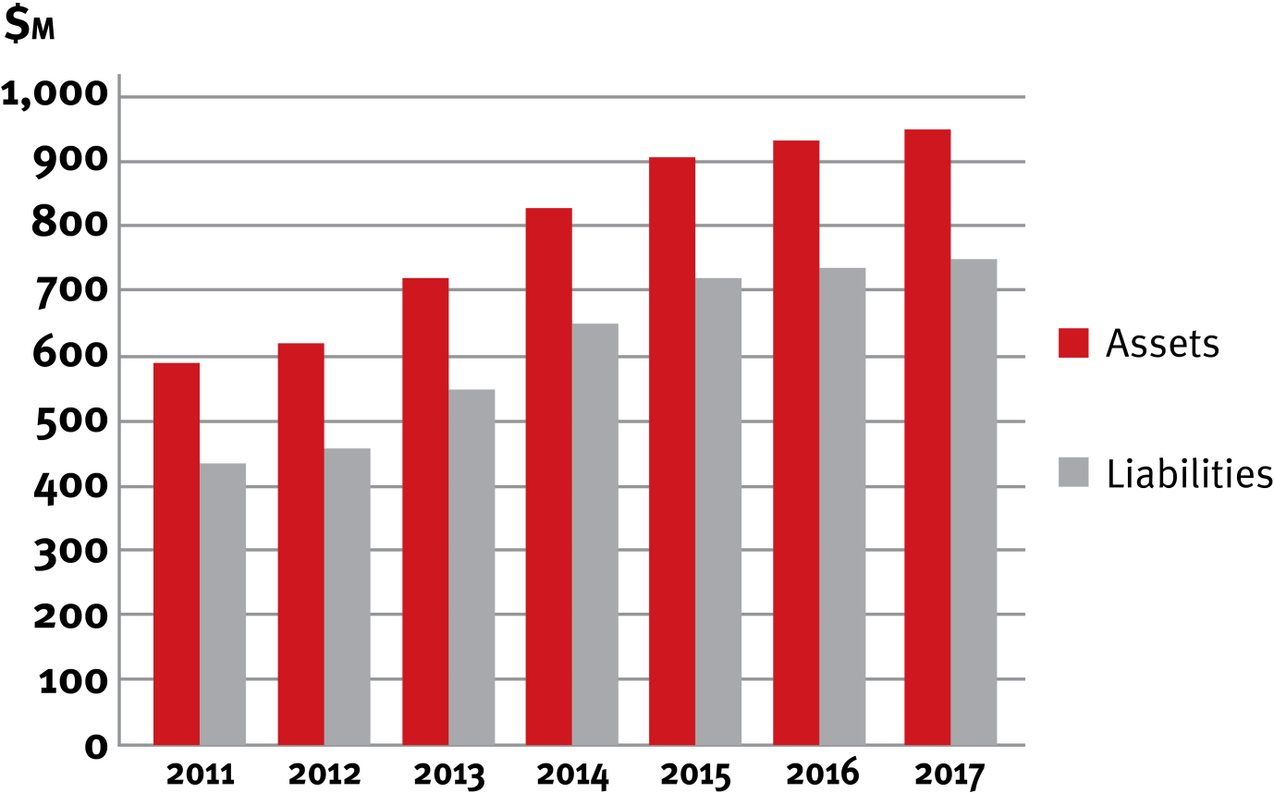
Assets & Liabilities

Prospective Outlook
A small budgetary surplus is forecast for the 2017–18 financial year. This accommodates the increasing cost of frontline services to better serve our clients.

Chief Finance Officer Statement
Our Chief Finance Officer (CFO) has fulfilled the responsibility as required by the FAA. The CFO has provided the Public Trustee of Queensland with a statement about financial controls, in accordance with section 57 of the Financial and Performance Management Standard 2009 (FPMS). This statement was noted by the Audit and Risk Management Committee (ARMC).

Public Trustee of Queensland Investment Fund – Growth Trust

The Public Trustee Investment Fund - Growth Trust (Growth Trust) was established to provide our clients with the opportunity to have their funds managed by the Public Trustee with the expert assistance of a professional investment manager. The Public Trustee is the manager and trustee of the Growth Trust and is responsible for determining the investment objectives and strategy, arranging for the proper investment of all monies and ensuring the appointed investment manager achieves acceptable rates of return. The Public Trustee has appointed QIC Limited ACN 130 539 123 (QIC) as the investment manager of the Growth Trust.

The objective of the Growth Trust is to provide a fully diversified investment strategy for those seeking long-term income and capital growth.

In 2016, a review was undertaken of the Growth Trust’s investment strategy in consultation with an independent external advisor and QIC.

Following the review, the Public Trustee implemented a change of investment strategy in April 2017 with the Growth Trust investing primarily into one fund, the QIC Growth Fund, with approximately 1% of holdings invested in the QIC Cash Enhanced Fund for cash management purposes. Prior to this, the Growth Trust was investing in ten QIC sub-funds.

The QIC Growth Fund provides for greater diversification of asset classes and investments which the Public Trustee considers will deliver a better risk/return outcome. The range of asset classes has been expanded to include real estate, infrastructure, private equity and alternative assets, as well as cash, fixed interest and shares.

Associated with the change in the investment strategy, the investment objective for the Growth Trust was revised upwards to generate average returns of CPI + 2.4% p.a. over rolling five year periods from CPI + 1.9% p.a. over rolling ten year periods.

The investment objective of the Growth Trust and performance for the applicable period ending 30 June 2017 is as follows:

Fund | CPI Objective (after fees) | Objective Target Return (%) | Annualised Return (%)
Growth Trust | CPI + 2.4% over rolling 5 years | 4.37% | 8.29%

Further information on the Growth Trust is available in its Product Information Statement and additional information is available on our website at http://www.pt.qld.gov.au/about/publications/investments/.

Management and structure

The Public Trustee of Queensland
Senior Director, Office of the
Chief Executive Officer
Senior Director, Governance & Risk
Risk Management
Strategy and Planning
Fraud and Corruption Control

Right to information/Information Privacy
Head of Internal Audit
Government Relations Complaints Management
Compliance
Executive Director, Client Experience &
Delivery
Deputy Public Trustee & Official
Solicitor
Executive Director, Investment & Finance Services & Chief Finance
Officer
Senior Director, Human Resources &
MarComms
Executive Director, Digital &
Technology
Deceased Estates Administration
Office of the Official Solicitor
Corporate Finance
Human Resources
Investment Strategy
Information and Technology Services
Trust Management Services
Legal Services
Learning and Development
Taxation Services
Digital
Corporate Legal
Will Making Services support
Property and Asset Management
Internal Communications
Enterprise Change Office
Financial Management Marketing
Procurement Information and
Business and Product Records
Development Management
Customer Satisfaction and Customer Data Analytics
Security
Audit and Evaluation

Our executive structure was reviewed in 2016 as part of the Public Trustee’s commitment in our Strategic Plan to lead the evolution and delivery of trustee, estate and administrative services that make a positive difference in the lives of Queenslanders. The revised executive structure is designed to drive implementation of the plan.

Executive management

Peter Carne
The Public Trustee of Queensland
Peter Carne commenced his second term as the Public Trustee of Queensland in March 2016, after his previous term as the Public Trustee of Queensland from 2009 to 2014. Peter brings over
30 years of legal expertise to his statutory appointment. In addition to managing his own legal practice, Peter has held a number of roles including Chief Executive Officer (CEO) of the Queensland Law Society, Commissioner of the Queensland Legal Aid Commission, Director of the College of Law (Qld) and Director of Lexon Insurance Pte Ltd. In 2003, he was awarded the Centenary Medal for his contribution to the legal profession and in 2017 Peter was made a life member of the Queensland Law Society.

Peter has a Bachelor of Arts and a Bachelor of Laws from the University of Queensland and is a Fellow of the Australian Institute of Company Directors.

Mark Crofton
Deputy Public Trustee and Official Solicitor
Mark Crofton is the Deputy Public Trustee and Official Solicitor. In the latter role Mark heads the Office of the Official Solicitor, providing in-house legal advice to the Public Trustee of Queensland in his many and varied capacities.

Mark has a Bachelor of Arts and a Bachelor of Laws (Hons) from the University of Queensland and a Masters of Laws from QUT and was a 2011 Churchill Fellow. He has extensive experience practising law in both the private and public sectors and has spent a large part of his career undertaking legal work in relation to succession, trusts and clients with a disability.

Amanda MacDougall
Executive Director, Client Experience & Delivery
Amanda MacDougall commenced with the Public Trustee in May 2017 as Executive Director, Client Experience & Delivery. In this role, Amanda is responsible for the customer experience across all product and service lines including regional service delivery, channel strategy and business growth by new business and product development. Her career spans 20 years, 15 of which have been in management roles, leading teams across customer service, customer loyalty programs, sales, operations, marketing, business development and general management across a diverse range
of industries, including mining, aviation, the public sector and most recently, ASX Top 200 financial services.

Amanda is committed to delivering robust commercial outcomes through an unrelenting focus on the customer, galvanising teams to execute the Strategic Plan. Her key focus is to lead the strategic change program to invigorate the customer experience across all product and service lines for the Public Trustee. Amanda has completed the Company Director’s course with the Australian Institute of Company Directors.

Justine Callaghan
Acting Executive Director, Investment & Finance Services & CFO
Justine Callaghan commenced in June 2017 as the Acting Executive Director Investment & Finance Services and CFO. Justine is responsible for the financial management and investment frameworks of the Public Trustee. Prior to this appointment, Justine was the Director Finance at the Public Trustee from October 2015. Justine has extensive experience in senior finance leadership roles predominantly in the mining industry, in particular with Glencore (formally Xstrata and Mount Isa Mines Limited).
Justine has transitioned from mining to the public sector with management roles at West Moreton Hospital and Health Service and the Public Trustee.

Justine has a Bachelor of Commerce (majoring in Accounting) from the University of Southern Queensland and is a Certified Practising Accountant. She is a recent graduate of the Australian Institute of Company Directors, Company Directors course.

David Cook
Executive Director, Digital & Technology
David Cook commenced as the Executive Director, Digital & Technology in April 2017 and is accountable for Digital and Technology Strategy, Enterprise Change delivery and Information and Records Management for the Public Trustee. His career has included roles leading operations, strategy, customer service, account management, security/business resilience, continuous improvement, consultancy, merger and acquisition and commercial management across defence, retail, high technology, resources and financial services.

David has a Bachelor of Business (Dist), an MBA (Dist) and has undertaken advanced training in Negotiation, Six Sigma, Lean, Total Quality Management, Risk Management, Sales Systems and Technology Governance. David is a graduate member of the Australian Institute of Company Directors and is an experienced not-for-profit Director and Chair.

Erica Gallagher
Senior Director, Human Resources & MarComms
Erica Gallagher commenced in January 2016 as the Director Human Resources. Erica’s role was later changed to Senior Director, Human Resources & MarComms when the executive management structure was reviewed in 2016. Erica’s career spans over 30 years, 15 of which have been in senior leadership roles. Erica has worked in government and the not-for-profit disability sector in Western Australia. Erica is committed to contemporary human resource practice and the enhancement of the human resource profession by focusing on employee engagement, organisational culture, diversity of perspective, capability enhancement, performance development and managing the complexity of the workforce in a global environment of digitalisation and intergenerational challenges.

Erica was the Australian Human Resources Institute (AHRI) Western Australia State President and is currently a Councillor on the AHRI Queensland Council.

Josephine Giles
Senior Director, Governance & Risk
Josephine commenced as Senior Director, Governance & Risk in May 2017. In this position, Josephine is responsible for leading all governance and related functions for the Public Trustee, including government relations, statutory reporting, compliance and risk management, complaints management, fraud and corruption control, business continuity planning, information privacy, right to information and administrative access and release. Josephine has extensive experience across Queensland Government agencies including Queensland Health, Queensland Treasury and the Department of the Premier and Cabinet.

Josephine has a Bachelor of Commerce (majoring in Accounting and Finance) and a Graduate Certificate in Policy Analysis from Griffith University and is a graduate member of the Australian Institute of Company Directors.

Elissa Pearse
Senior Director, Office of the CEO
Elissa commenced as Senior Director, Office of the CEO following a period of service as Director Strategy and Risk. Elissa works closely with the Public Trustee of Queensland and the Executive Management Team (EMT) on strategy and business planning and provides secretariat support to the ARMC.

Elissa has a Bachelor of Business (majoring in Banking and Finance) and a Bachelor of Laws (Hons) from QUT and a Graduate Diploma in Legal Practice from the College of Law, Sydney. She has over 10 years’ experience in the financial services industry in the United Kingdom and Australia.

Senior internal management committees

The Public Trustee has established a range of internal committees to support all areas of operation. The committees have varying roles and functions and are established for specific purposes either because of a legislative imperative or in response to the needs of the organisation.
Internal committees play an important role in helping to meet compliance obligations.
These committees are an integral part of our governance arrangements that also include performance reporting and internal and external conformance to ensure that better practice and standards are applied and adhered to in all areas of our operations.

Executive Management Team
The EMT is the senior leadership team for the Public Trustee. The purpose of the EMT is to:
- Support the Public Trustee of Queensland in meeting the responsibilities outlined in the
Public Trustee Act 1978 and other relevant legislation
- Provide leadership, direction and guidance to ensure that the Public Trustee provides quality trustee, estate and financial administration services to the people and Government of Queensland.

The EMT undertakes the following functions:
- Determining strategic vision and purpose, developing strategic objectives and initiatives
- Monitoring implementation of those strategic objectives and initiatives
- Making recommendations to the Public Trustee in relation to strategic planning, policy setting, budget and resource allocation
- Ensuring the future sustainability of the organisation
- Building organisational capability to ensure ongoing viability of the Public Trustee

- Embedding sound organisation risk management principles
- Assessing the material and strategic business risks facing the organisation.

Membership of the EMT is determined by the Public Trustee of Queensland. The members as at 30 June 2017 were:
- The Public Trustee of Queensland
- Deputy Public Trustee and Official Solicitor
- Executive Director, Client Experience & Delivery
- Executive Director, Investment & Finance Services & CFO
- Executive Director, Digital & Technology
- Senior Director, Human Resources & MarComms
- Senior Director, Office of the CEO
- Senior Director, Governance & Risk.

The EMT met 26 times during 2016–17.

Organisational Performance Group
The role of the Organisational Performance Group (OPG) is to provide a forum to share information across the Public Trustee through:
- Overseeing the implementation of the Public Trustee’s operational and specific purpose plans developed to support the Strategic Plan
- Monitoring ongoing organisational performance.

The core functions of the OPG are to:
- Monitor and review organisational performance against delivery of existing priorities, operational and specific purpose plans
- Monitor organisational performance against key metrics
- Ensure appropriate action is being taken where necessary to address any performance issues
- Share information in relation to future developments that may impact strategic direction including policy changes, technological developments, research activities and legislative and regulatory requirements to inform future priorities.

Membership of the OPG is determined by the Public Trustee of Queensland. The members as at 30 June 2017 were:
- The Public Trustee of Queensland
- Deputy Public Trustee and Official Solicitor
- Executive Director, Client Experience & Delivery
- Executive Director, Investment & Finance Services & CFO
- Executive Director, Digital & Technology
- Senior Director, Human Resources & MarComms
- Senior Director, Office of the CEO
- Senior Director, Governance & Risk
- Director Finance
- Director Investment & Taxation Services
- Director Property
- Director Estates & Trusts
- Director Disability Services
- Director Capability & Performance
- Deputy Official Solicitor
- Director Legal Services

- Chief Information Officer (CIO)
- Manager Marketing & Communication
- Head of Internal Audit.

OPG met 12 times during 2016–17.

Workplace Health and Safety Committee
The Public Trustee has a WH&S Committee to ensure compliance with the Work Health and Safety Act 2011.

Members of the committee are:
- Senior Director, Human Resources & MarComms (Chair)
- Manager HR Operational Services (acting chair when the Senior Director, Human Resources & MarComms is not available)
- Senior Coordinator WH&S & Injury Management
- Coordinator WH&S & Injury Management
- Property Manager
- Health and Safety Representatives (HSR) (from each regional location and one from each floor in the Brisbane office)
- Regional Managers (where the regional office has not nominated a Health and Safety Representative).

The committee met three times during 2016–17.

Establishment Review Committee
The primary function of the Establishment Review Committee is to consider vacancies (both temporary and permanent) and proposals for higher duties, secondments (in and out) and the use of temporary staff on a case by case basis to establish the criticality to fill positions, as aligned with the Queensland Government’s principles.

Members of the committee are:
- Senior Director, Human Resources & MarComms (Chair)
- Executive Director, Client Experience & Delivery
- Executive Director, Investment & Finance Services & CFO
- Human Resource (Recruitment) Officer (secretariat).

The committee met 49 times during 2016–17.

Strategic Asset Management Committee
The key objective of the Strategic Asset Management Committee is to oversee the development, review and revision of the Public Trustee’s asset management plan and monitor progress of key initiatives.

Members of the committee are:
- Executive Director, Investment & Finance Services & CFO (Chair)
- The Public Trustee of Queensland
- Executive Director, Digital & Technology
- Deputy Public Trustee & Official Solicitor
- Senior Director, Human Resources & MarComms
- Senior Director, Office of the CEO
- Executive Director, Client Experience & Delivery

- Senior Director, Governance & Risk
- Director Property
- Director Capability & Performance
- CIO
- Director Investment & Taxation Services
- Director Finance
- Managing Lawyer.

The committee met seven times during 2016 –17.

The Insurance Sub-Committee supports the Strategic Asset Management Committee through the provision of strategic and risk management advice in relation to the management of client and corporate insurances held by the Public Trustee.

Members of the Insurance Sub-Committee are:
- Executive Director, Investment & Finance Services & CFO (Chair)
- Executive Director, Client Experience & Delivery
- Senior Director, Governance & Risk
- Director Property
- Managing Lawyer.

The sub-committee met five times during 2016 –17.

Update
The WH&S Action Plan Working Group and the Information Steering Committee were referred to in the 2015-2016 Annual Report but were dissolved in 2016-17.

The WH&S Action Plan Working Group had been formed to implement the action plans arising from the external audit of the Public Trustee’s Work, Health and Safety Management Systems which had taken place in 2015-16. The WH&S Action Plan Working Group was dissolved in December 2016 after all of the action plans had been implemented.

The Information Steering Committee was responsible for:
- Providing whole-of-agency leadership, strategic direction and oversight in the planning and delivery of information and communications technology (ICT) related initiatives
- Providing assurance that information management and ICT is being appropriately governed to ensure return on investment through effective delivery of approved initiatives.

During 2016-17, the Public Trustee made a number of changes to business operations including the formation of a Digital and Technology Directorate. The Public Trustee dissolved the Information Steering Committee in June 2017 after these changes had been implemented.

Boards and committees with external membership

Public Trust Office Investment Board
Act or instrument | Section 21(1) of the Public Trustee Act 1978
Functions | - Controlling and managing the investments of the Common Fund  - Providing advice to the Public Trustee on the investment management of the Public Trustee of Queensland Investment Fund.
Achievements in 2016-17 | - Reviewed the credit policy, taking into consideration the risk appetite of the organisation and the counterparty risks that prevail in the global financial environment  - Reviewed the operating limits for interest rate risk  - Approved and monitored the investment strategy of the Common Fund taking into consideration the continued historically low yield environment  - Endorsed the interest rates payable to clients  - Provided advice to the Public Trustee on the strategic review of the Public Trustee of Queensland Investment Fund, including transition to the QIC Growth Fund  - Reviewed strategic advice on property assets held within the Common Fund.
Financial reporting | Not exempted from audit by the Auditor-General and transactions of the entity are accounted for in the financial statements of the Public Trustee of Queensland.
Remuneration
Position | Name | Meetings/ sessions attendance | Approved annual, sessional or daily fee | Approved sub- committee fees if applicable | Actual fees received (GST  exclusive)
The Public Trustee of Queensland | Peter Carne | 3 | N/A | N/A | N/A
External Member | Henry Smerdon | 2 meetings  + 3 special assignments | Meeting fee - 4 hours or less  $196.00. Special Assignment fee - 4 hours or less  $163.00 | N/A | $881.00
External Member | Neville Ide | 1 | 4 hours or less  $359.00 | N/A | $359.00
Officer of the Department administered  by the Treasurer | Warwick Agnew | 3 | N/A | N/A | N/A
No. scheduled meetings | 3
Total out of pocket expenses | N/A

Under the Public Trustee Act 1978, the Public Trust Office Investment Board must consist of at least three members, one of whom shall be the Public Trustee of Queensland and one of whom shall be an officer of the Department administered by the Treasurer. Mr Warwick Agnew is a Deputy Under Treasurer, Advisory, Commercial Group within Queensland Treasury.

Mr Neville Ide’s appointment to the Public Trust Office Investment Board ended in September 2016. Following Mr Ide’s term coming to an end, the Governor-in-Council approved that:
- Mr Henry Smerdon be reappointed as an External Member from 7 July 2017 to 6 July 2020
- Ms Sandra Birkensleigh be appointed as an External Member from 7 July 2017 to 6 July 2020.
The Public Trust Office Investment Board has adopted the Code of Conduct for the Queensland Public Service.

Audit and Risk Management Committee
The ARMC is an independent advisory body established to assist the Public Trustee of Queensland in fulfilling his responsibilities as the Accountable Officer under the FAA, FPMS and other relevant legislation.

The ARMC operates under terms of reference established in accordance with the Audit Committee Guidelines – Improving Accountability and Performance published by Queensland Treasury.

The committee assists with reviewing:
- Financial statement preparation processes and oversight
- The risk management framework
- The fraud and corruption control framework
- Internal audit plans for endorsement
- Actions from internal and external audit reviews.

The ARMC met four times during 2016–17. An out of session joint meeting was held with the Public Trust Office Investment Board in August 2016 to discuss the Strategic Plan.

Voting members of the ARMC for 2016-17 were:

Name | Details
Stephen Maitland | External Chair (until December 2016)
Sandra Birkensleigh | External Chair (from March 2017)
Lisa Dalton | External Member (until December 2016)
Glenn Poole | External Member
Janine Walker | External Member (from March 2017)
Mark Crofton | Nominated representative of the Public Trustee of Queensland

Standing invitees of the ARMC are:
- The Public Trustee of Queensland
- EMT members
- Queensland Audit Office (QAO)
- Head of Internal Audit.
The recommendations made by the QAO during 2016–17 were considered by the committee and are being appropriately addressed by management.

Member profiles

Stephen Maitland, Chair (outgoing), OAM, RFD, is an accountant and a former banker. Stephen was previously CEO of the Queensland Office of Financial Supervision and is now a corporate advisor and non-executive director.

Sandra Birkensleigh, Chair (incoming), is an experienced non-executive director currently holding a number of Board positions, including with the NDIA. She is a Council member of the University of the Sunshine Coast and Chair of their Audit and Risk Committee, and an independent member of the Audit Committee of the Reserve Bank of Australia. A qualified chartered accountant, she was formerly a partner of PricewaterhouseCoopers.

Lisa Dalton, External Member (outgoing), is a governance professional with over 17 years’ experience in senior executive positions with responsibility for governance, risk, human resources, strategy and communications. Lisa is a non-executive director and chartered secretary for a number of companies and is a member of several audit and risk management committees.

Glenn Poole, External Member (ongoing), is a former Auditor-General of Queensland. Glenn is a member of several audit and risk management committees.

Janine Walker, External Member (incoming), is an experienced Chair and Board Director and an Adjunct Professor in the Griffith Business School. She is currently a Deputy Chair of the Board and a member of the Finance Committee and the Audit and Risk Management Committee of the Metro South Hospital and Health Service, and the independent Chair of the Workplace Relations Committee of the Queensland Catholic Education Commission.

Mark Crofton, deputy Public Trustee and Official Solicitor, Nominated Representative of the Public Trustee (ongoing), refer to page 21.

Remuneration payments
Remuneration to external members during the 2016–17 financial year is detailed below.

Remunerated committee members | Amount (GST exclusive)¹
Stephen Maitland (Delphin Associates) | $9,350
Sandra Birkensleigh | $9,350
Lisa Dalton | $6,250
Glenn Poole | $12,500
Janine Walker  (French Street Consulting) | $6,250
Total | $43,700

Voting members are required to comply with the Code of Conduct for the Queensland Public Service during their term.

1 Includes fees outstanding for services provided during 2016–17.

Public Sector Ethics Act 1994

Our staff are bound by the Code of Conduct for the Queensland Public Service. The Public Trustee maintains high ethical standards that support and underpin our fiduciary responsibilities.

Our Strategic Plan has an emphasis on the delivery of quality frontline services by providing our clients with professional and effective services in a responsive manner. To deliver quality frontline services, we must have competent staff who act in an ethical manner.

In delivering quality services, we continued to enhance our culture as an ethical workplace through a range of strategies which raised awareness of ethical standards and which supported ethical decision making and behaviour. Those strategies included:
- Educating staff about ethical standards required in the workplace through our orientation program and mandatory online compliance training including:
  - Code of Conduct
  - Fraud and corruption control
  - Information privacy
  - Right to information
  - Complaints management
  - Recordkeeping and file management
- Supporting line managers in inducting new staff by providing the following resources on our intranet:
  - Induction guidelines
  - Induction planner
  - New employee induction manual
- Complying with the Public Service Act 2008, the Public Sector Ethics Act 1994 and by promoting to all staff the Public Service Commission Directive regarding declaration of gifts and benefits received and offered
- Updating our Fraud and Corruption Control policy, procedure and plan
- Complying with the Public Interest Disclosure Act 2010 through having the required policy and procedures available on our website
- Reviewing human resource policies and procedures to align with the Queensland Public Service values and Code of Conduct.

Queensland Public Service values

The Queensland Public Service values are the cornerstone of our workplace culture and are underpinned by the Public Sector Ethics Act 1994 and the Code of Conduct for the Queensland Public Service.

During 2016-17, we continued to embed and implement the values into our organisation as illustrated by the examples given below.

Customers first
- We continued to provide quality frontline services in estate administration, financial management, trusts management and the Will and EPA making service
- We established four specialist Centres of Excellence for Testamentary Trusts, Minors Trusts, Group Housing and Advanced Residential Care to provide better services for these client groups
- We provided ongoing sponsorship to the Department of Communities, Child Safety and Disability Services’ No excuse for elder abuse campaign
- We undertook annual client satisfaction surveys to measure how we are meeting our customers’ expectations.

Ideas into action
- We invested in the enhancement of technology and review of service delivery models and locations to better meet growing and changing demographic needs of Queenslanders
- We upgraded facilities at regional offices to better service clients
- We delivered enhancements to frontline service delivery in response to client satisfaction survey outcomes.

Unleash potential
- We introduced industry standard professional training to staff to enhance our workforce with the right skills, knowledge and attitude to meet client and stakeholder expectations
- We delivered the Corporate Orientation program every eight weeks to 98 new staff
- We are continuously improving our business processes to deliver better services not only to our clients but also to our staff. In 2016-17, we reviewed our Study and Research Assistance Scheme (SARAS) policy to streamline processes and to ensure effective management approval of SARAS applications.

Be courageous
- 31 Public Trustee staff commenced the Leadership and Management Development Program at QUT in January 2017. This program aims to develop and reinforce the key strategic skills and behavioural dynamics required of our managers in the workplace to drive innovation and maintain a contemporary environment. The program is aimed at developing the skills, competencies and capabilities of our middle managers.
- We delivered the Evolving Capability Conference 2016 to 54 middle and senior managers.
This professional development conference focused on creating innovative thinkers
and evolving capabilities that encourage new ways of delivering services in accordance with our Strategic Plan.

Empower people
- We facilitated workshops across the Public Trustee to raise awareness of the Queensland Public Service values and to build accountability and ultimately a high performance culture.
- We developed and implemented initiatives as a result of the feedback received through the Employee Opinion Survey.

Employee Opinion Survey
Our staff participated in the 2016 Working for Queensland Employee Opinion Survey conducted in April and May 2016. A total of 455 Public Trustee staff participated in this survey and answered questions relating to employee engagement, job satisfaction and their perception about leadership within the organisation.

Following the 2016 survey, three areas of focus were identified for action:
- Organisational leadership
- Workload and health
- Workplace fairness.

The following key initiatives were implemented and are ongoing to address the survey results:

Organisational leadership
- Communication from executive and senior management on the Strategic Plan and how our staff can support delivery of initiatives
- Leadership management and development program for middle managers.

Workload and health
- Increased focus on WH&S with the completion of inspections and assessments of all regional office locations and enhancement of the WH&S system
- Client Experience and Delivery – a multi-faceted approach to workload has been adopted with capability reviews and re-assignment of resources
- Stabilisation of the workforce through permanent appointments and other strategies aligning workforce structure with ongoing roles for job security.

Workplace fairness
- Increased communication to staff on all aspects of the working environment.
- Enhanced focus on developing and updating policies for recruitment and selection, workplace health and safety and SARAS.

Governance – risk management and accountability

Governance and Risk Directorate

The Governance & Risk Directorate (Governance & Risk) was established as part of the review of the executive structure in 2016. Governance & Risk is responsible for overseeing essential governance functions and ensuring accountability throughout the organisation. Governance & Risk’s functions include:
- Statutory reporting including annual reporting and SDS
- Risk management framework
- Fraud and corruption control
- Government relations
- Complaints management
- Compliance and internal accountability
- Administrative access and release
- Related policies and procedures.

Governance & Risk is responsible for the effective implementation and compliance within the organisation with particular legislative requirements including the:
- Right to Information Act 2009
- Information Privacy Act 2009
- Public Interest Disclosure Act 2010.

Risk management

The Public Trustee is committed to ensuring efficient and effective performance: risk management is integral to achieving our vision.

The Public Trustee’s risk management framework supports the embedding of a risk management culture within the Office and assists staff to implement sound risk management practices.

Our risk management policy and procedures are reviewed periodically and were last approved in November 2016. Our risk management policy was developed with reference to AS/NZS ISO 31000:2009, Risk Management–Principles and Guidelines. The policy, together with the risk management procedures, provide a systematic and structured approach to integrating risk management into the broader governance and accountability frameworks in the organisation.

The Public Trustee risk management framework encompasses:
- Fraud and corruption control
- Business continuity planning
- Insurance coverage
- Sources of assurance including internal controls.

These are supported by the Executive Director, Investment & Finance Services & CFO, Head of Internal Audit and Senior Director, Governance & Risk with the expertise of the ARMC.

External scrutiny

The Public Trustee is subject to external scrutiny by entities including the:
- Auditor-General, QAO
- Queensland Ombudsman
- Crime and Corruption Commission Queensland
- Legal Affairs and Community Safety Committee.

Internal audit

The Audit and Evaluation Unit provides independent, objective assurance and consulting activity to improve the operational performance of the Public Trustee.

The role of the unit is defined in the Audit and Evaluation – Internal Audit Charter which is approved by the Public Trustee of Queensland and endorsed by the ARMC. The unit operates in accordance with the Audit Committee Guidelines: Improving Accountability and Performance (Queensland Treasury). The charter has regard to the FPMS and the standards of auditing as disseminated by the Institute of Internal Auditors.

The unit is autonomous and reports directly to the Public Trustee of Queensland. Our strong links with QAO provide the foundation for a collaborative audit approach to ensure optimal audit coverage across all areas of the organisation.

The current Head of Internal Audit is appropriately qualified and holds the following qualifications:
- Bachelor of Commerce (Honours)
- Certified Internal Auditor
- Certification in Control Self-Assessment
- Certified Financial Services Auditor
- Certified Information Systems Auditor.

The unit provides the following:
- Financial and compliance audits
- Operational and efficiency audits
- Information system audits
- Investigations.

Our Strategic and Annual Internal Audit Plan is developed in consultation with key stakeholders and takes into account the significant risks identified by management through the Risk Management Framework.

The operations of the Audit and Evaluation Unit are overseen by the ARMC.

During the 2016–17 financial year, the Audit and Evaluation Unit conducted independent reviews and audits of our internal controls, business processes and management practices.

Our key achievements for 2016–17 included:
- Reviewing Client Experience & Delivery and corporate operations to provide the Executive Director, Investment & Finance Services & CFO with assurances to support sound processes and procedures underpinning the financial statements
- Providing information papers for general consumption to Client Experience & Delivery and across support activities, to raise awareness of current issues being encountered and to assist directors and managers to understand and address topical issues

- Ongoing development of the unit’s Computer Assisted Audit Techniques which has been progressed to introduce continual monitoring of payments
- Assessment of external risks identified through communications with other organisations
- Reviewing the unit’s audit management software to ensure the timely review and implementation of past issues and recommendations
- Developing and implementing data analytics to identify transactions requiring further review
- Providing advice, support and guidance to staff to assist them in discharging their responsibilities in accordance with the Public Trustee’s policies and procedures.

Information systems and recordkeeping

The Public Trustee continues to improve its compliance with the Public Records Act 2002 and the principles contained in Government Standards such as Information Standard 40 (Recordkeeping), Information Standard 31 (Retention and Disposal), Information Standard 18 (Information Security) and Information Standard 34 (Metadata).

Areas that have been progressed during 2016-17 include:
- Review of the Information Management policy and development of Information Management Framework and Strategy
- Creation of the enterprise Information Asset Register
- Review and update of the Vital Records policy
- Develop a Digitisation standard including destruction procedures in line with Queensland State Archives
- Commence integration of disparate mail centres, completed in Brisbane head office
- Review and improve the recordkeeping practices in the Investment business unit
- Continue mandatory online recordkeeping training for all staff and contractors
- Support the electronic Document and Records Management System (eDRMS) to ensure reliability, performance and security of electronic records
- Dispose of public records in accordance with the Public Trustee Office Retention and Disposal Schedule (QDAN 651 v.1) and the General Retention and Disposal Schedule.

Work has commenced to renew the Recordkeeping Strategy and Public Trustee Retention and Disposal Schedules in line with digitisation initiatives during 2017–18.

Governance – human resources

Workforce planning and performance

Our staff are employed under the Public Service Act 2008 and related industrial instruments aligning with Queensland Public Service Commission policies and directives.

The workforce profile FTE establishment is 572.53 (as per the Minimum Obligatory Human Resources Information report for the quarter ending 30 June 2017). The Public Trustee employs over 614 staff as headcount. The following table provides a comparison between actual and budgeted FTE for the current period and an estimate for 2017-18.

Staffing

610
2017–18

Total full-time staff
The total staff profile is fully funded by Public Trustee at no cost to government.
609.26
Budget
597.00
Budget
572.53
Actual

600
590

580

570

560

550
2016–17

For 2016-17, the permanent retention rate was 85.34 per cent and the separation rate was
  - per cent.

A capability review and workforce modelling will be undertaken in 2017-18 to ensure the workforce is best positioned to continue to deliver on our Strategic Plan.

A range of people and capability development strategies and initiatives were implemented in 2016–17 including the:
    - Development and delivery of the Evolving Capability Conference 2016 to 54 middle and senior managers. This professional development conference focused on creating innovative thinkers and evolving capabilities that encourage new ways of delivering services in accordance with our Strategic Plan
    - Continuous improvement and review of the online mandatory compliance training, including the development of the Cyber Security Awareness program
    - Design of the Corporate Orientation program delivered every eight weeks to a total of 98 new staff
    - Commenced delivery of the Leadership and Management Development Program to the first cohort of 31 middle managers. This program was developed in partnership with and delivered by QUT
    - Development and delivery of a technical induction program for 124 staff
    - Delivery of Level 1 technical training to 46 staff

    - Reviewing Level 2 technical training for procedural and legislative updates with the next intake scheduled for October 2017
    - Recognition of prior learning: Certificate IV in Personal Trust Administration (nationally accredited) awarded to 15 staff for the Public Trustee Level 1 and Level 2 technical training
    - Delivery of a Wills and Enduring Power of Attorney Accreditation program to 16 staff
    - Continuing availability of the SARAS and other training and development opportunities to staff
    - Implementing the Queensland Public Service values across the organisation.

Key policy updates included the review and update of the Recruitment and Selection Policy as part of our continued commitment in our Strategic Plan to attract and retain an engaged, empowered and flexible workforce. This policy was complemented by refreshed recruitment and selection panel documentation which served to provide further resources for panel members.

In addition, key policies that were reviewed in 2016-17 included the WH&S Policy which was reviewed and updated to demonstrate our commitment to providing and maintaining a safe and healthy work environment for all staff, contractors, visitors and clients. Safety and incident prevention is vital to delivering high quality trustee and administration services and an integral part of our responsibilities.

Our key focus areas for 2017–18 for workforce development are:
    - Developing organisational leadership
    - Introducing effective change management practices across the workforce
    - Providing training programs and resources
    - Further embedding our organisational values through a commitment to improved communication
    - Continuing to streamline our recruitment and employment screening processes
    - Improving performance management processes and systems
    - Continuing to improve our workplace health and safety framework, policies and processes
    - Further enhancing workforce and dashboard analytics and reporting to target hotspots and formulate workforce strategies.

Early retirement, redundancy and retrenchment

No redundancy, early retirement or retrenchment packages were paid during the 2016–17 financial year.

Office locations

To contact any of our office locations, phone 1300 360 044 or email clientenq@pt.qld.gov.au.

Brisbane
Trustee House
444 Queen Street, Brisbane QLD 4000
GPO Box 1449, Brisbane QLD 4001
Phone: (07) 3213 9288

Brendale
170 South Pine Road, Brendale QLD 4500 PO Box 5204, Brendale DC QLD 4500 Phone: (07) 3142 1900

Bundaberg
Trustee House
189 Bourbong Street, Bundaberg QLD 4670
PO Box 860, Bundaberg QLD 4670
Phone: (07) 4181 0800

Cairns
Trustee House
27 Sheridan Street, Cairns QLD 4870
PO Box 656, Cairns QLD 4870
Phone: (07) 4040 7300

Gladstone
Trustee House
66 Goondoon Street, Gladstone QLD 4680
PO Box 5021, Gladstone QLD 4680
Phone: (07) 4962 1100

Ipswich
Trustee House
99 Brisbane Street, Ipswich QLD 4305
PO Box 140, Ipswich QLD 4305
Phone: (07) 3432 6611

Mackay
Trustee House
18 Brisbane Street, Mackay QLD 4740
PO Box 401, Mackay QLD 4740
Phone: (07) 4969 4600

Maryborough
Trustee House
88 Ellena Street, Maryborough QLD 4650
PO Box 280, Maryborough QLD 4650
Phone: (07) 4183 0900

Mount Isa
Trustee House
18 Miles Street, Mount Isa QLD 4825 PO Box 2000, Mount Isa QLD 4825 Phone: (07) 4764 0500

Nambour
72 Currie Street, Nambour QLD 4560
PO Box 49, Buddina QLD 4575
Phone: (07) 5314 1800

Redcliffe
Trustee House
165 Sutton Street, Redcliffe QLD 4020
PO Box 131, Redcliffe QLD 4020
Phone: (07) 3817 9100

Rockhampton
Trustee House
67 East Street, Rockhampton QLD 4700
PO Box 273, Rockhampton QLD 4700
Phone: (07) 4999 3600

Southport
Trustee House
66 Nerang Street, Southport QLD 4215
PO Box 876, Southport QLD 4215
Phone: (07) 5588 5333

Sunshine Coast
Suite 1-3, 20 Innovation Parkway,
Birtinya QLD 4575
PO Box 49, Buddina QLD 4575
Phone: (07) 5314 1800

Toowoomba
Trustee House
447 Ruthven Street, Toowoomba QLD 4350
PO Box 139, Toowoomba QLD 4350
Phone: (07) 4631 8100

Townsville
Trustee House
438 Flinders Street, Townsville QLD 4810
PO Box 960, Townsville QLD 4810
Phone: (07) 4753 0111

Outreach locations

Our outreach locations and dates for our Wills and Enduring Power of Attorney making service are as follows:

Brisbane
The Brisbane office services eight venues around the metropolitan area each month.
- Chermside Centrelink - Third Friday of each month. Two Wills officers attend on each visiting day.
- Cleveland Courthouse - Monday to Thursday each week. One Wills officer attends on each visiting day.
- Holland Park Courthouse - Tuesday and Thursday each week. One Wills officer attends on each visiting day.
- Mitchelton Centrelink - Second and fourth Friday of each month. One Wills officer attends each visiting day.
- Nundah Centrelink - First Friday of each month. One Wills officer attends each visiting day.
- Toowong Centrelink - Fourth Friday of each month. One Wills officer attends each visiting day.
- Wynnum Courthouse - Wednesday each week. One Wills officer attends each visiting day.
- Woodridge Centrelink - Third Wednesday of each month. One Wills officer attends each visiting day.
- We also provide an outside visitation service for people with a disability. This service operates every Monday, and also on other days in cases where urgent visits are required. Venues depend on individual client circumstances, but include hospitals, hospices, nursing homes and private residences. One Wills officer is accompanied on each visit by another Public Trustee staff member to assist in witnessing Wills.

Bundaberg
The Bundaberg Office services two venues, approximately one day each month.
- Gin Gin Neighbourhood Centre - Wednesday quarterly and will vary due to demand.
- Childers Courthouse - Wednesday every four to six weeks depending on demand.

Cairns
The Cairns Office services one venue, one day per month.
- Mareeba Courthouse - Third or fourth Wednesday of every month (set around court sitting dates).
- Arrangements are also being made to service the Atherton Courthouse one day per month in 2017-18.

Ipswich
The Ipswich Office services two venues, two days per month.
- Beaudesert Courthouse - Third Thursday of every second month.
- Richlands Courthouse - First Thursday of every month.

Maryborough
The Maryborough Office services three venues, over approximately 10 days of each month.
- Gympie Courthouse - Fortnightly on every alternate Friday.
- Hervey Bay Courthouse - Monday and Tuesday each week.
- Tin Can Bay RSL - Delivered on a quarterly basis.

Mount Isa
The Mount Isa office services one venue on an ‘as required’ basis.
- Cloncurry Courthouse - The community outreach service is delivered on an ‘as required’ basis.

Redcliffe
The Redcliffe office services one venue, four days each month.
- Caboolture Courthouse - Wednesday each week in 2016-17. Efforts are presently being made to source an alternative venue for 2017-18.

Rockhampton
The Rockhampton office services five venues, approximately three days of the month.
- Yeppoon Courthouse - First and third Tuesday of every month.
- Central Queensland University –Third Wednesday of each month.
- Mount Morgan Courthouse – Delivered on an ‘as required’ basis.
- Woorabinda Aboriginal Community - Delivered quarterly.
- Dululu – Delivered quarterly.

Southport
The Southport office services three venues, over approximately 12 days of the month.
- Beenleigh Courthouse - Every Tuesday and every alternate Thursday of the month.
- Palm Beach Centrelink - Every alternate Thursday.
- Robina Centrelink - Every Wednesday of the month.

Sunshine Coast
The Sunshine Coast office services two venues, over four days of the month.
- Caloundra Courthouse - First and third Friday of every month.
- Noosa Courthouse - First and third Thursday of every month.

Townsville
The Townsville office services four venues, over approximately four days of the month.
- Ayr Courthouse - Tuesday once each month (set around court sitting dates).
- Charters Towers Courthouse – Tuesday once each month (set around court sitting dates).
- Ingham Courthouse – Tuesday once each month (set around court sitting dates).
- The Willows (Townsville Seniors and Carers Office) Centrelink – Tuesday once each month.

Legislation

The Public Trustee has a wide range of powers and functions and operates under many Acts including:

Acquisition of Land Act 1967 Acts Interpretation Act 1954 Adoption Act 2009
Agents Financial Administration Act 2014
Airports Assets (Restructuring and Disposal) Act 2008
Associations Incorporation Act 1981
Body Corporate and Community Management Act 1997
Building Units and Group Titles Act 1980 Charitable Funds Act 1958
Child Protection Act 1999
Child Protection (International Measures) Act 2003
City of Brisbane Act 2010 Civil Partnerships Act 2011 Collections Act 1966
Companies (Acquisition of Shares) (Application of Laws) Act 1981
Corrective Services Act 2006
Criminal Proceeds Confiscation Act 2002
Debt Collectors (Field Agents and Collection Agents) Act 2014
Disposal of Uncollected Goods Act 1967 Drugs Misuse Act 1986
Financial Accountability Act 2009 Gaming Machine Act 1991
Guardianship and Administration Act 2000 Industrial Relations Act 2016
Information Privacy Act 2009
Integrated Resort Development Act 1987 Land Act 1994
Land Sales Act 1984 Legal Profession Act 2007 Liquor Act 1992
Local Government Act 2009
Local Government Electoral Act 2011
Manufactured Homes (Residential Parks) Act 2003
Mineral Resources Act 1989
Mixed Use Development Act 1993 Motor Accident Insurance Act 1994
Motor Dealers and Chattel Auctioneers Act 2014
National Injury Insurance Scheme (Queensland) Act 2016
Personal Injuries Proceedings Act 2002 Police Powers and Responsibilities Act 2000 Powers of Attorney Act 1998
Property Law Act 1974 Property Occupations Act 2014 Public Guardian Act 2014
Public Interest Disclosure Act 2010
Public Officers Superannuation Benefits Recovery Act 1988
Public Records Act 2002 Public Sector Ethics Act 1994 Public Service Act 2008 Public Trustee Act 1978
Residential Services (Accreditation) Act 2002
Residential Tenancies and Rooming Accommodation Act 2008
Retirement Villages Act 1999 Right to Information Act 2009 Sanctuary Cove Resort Act 1995
Second-hand Dealers and Pawnbrokers Act 2003
South Bank Corporation Act 1989 Storage Liens Act 1973 Succession Act 1981
Surrogacy Act 2010 Trust Accounts Act 1973
Trustee Companies Act 1968 Trusts Act 1973
Victims of Crime Assistance Act 2009 Water Act 2000
Workers’ Compensation and Rehabilitation Act 2003
Work Health and Safety Act 2011 Youth Justice Act 1992

Glossary

This glossary provides a simple description of some terms used in this report to generally assist the reader.

Administrator
An administrator is a substitute decision-maker and makes decisions on behalf of an adult with impaired decision making capacity in respect to financial matters. An administrator is appointed by QCAT or the Court under the Guardianship and Administration Act 2000.

Attorney
An attorney is the person nominated by an individual under a power of attorney or an EPA to manage their affairs.

Beneficiary
A beneficiary is a person or organisation who receives a benefit under a Will or Trust which may include personal effects, property or money.

Charitable and Philanthropic Trusts
The Public Trustee acts as trustee for various significant charitable and philanthropic trusts. These trusts are established for charitable purposes and usually will have a deductible gift recipient status, which means that people who make donations to the trustee for the use of the charitable trust can receive a tax deduction for the donation.

Common Fund
Under section 19 of the Public Trustee Act 1978, all moneys vested in or coming into the hands of the Public Trustee on behalf of clients, shall be held in one or more common funds and shall be invested by the Public Trustee.

Enduring Powers of Attorney (EPAs)
An EPA is an important legal document that gives someone else the power to make personal or financial decisions on your behalf under the Powers of Attorney Act 1998. The Public Trustee accepts appointment as a financial attorney under EPAs.

Further information regarding EPAs can be found in the publication ‘Let’s talk about enduring powers of attorney’ available online at https://www.pt.qld.gov.au/about/publications/brochures-and- videos/

Executor
The role of an Executor of a Will is to administer the estate of a deceased person and distribute the assets in accordance with the deceased’s Will.

Further information regarding executorship can be found in the publication ‘Let’s talk about executor services’ available online at https://www.pt.qld.gov.au/about/publications/brochures-and- videos/

Intestacy
Where a person dies without a valid Will the person is said to have died intestate. The person who administers the estate and distributes it in these circumstances is normally referred to as an Administrator. The Public Trustee is often asked to act as administrator in intestate estates.

Further information regarding Intestacy can be found in the publication ‘Let’s talk about intestacy’
available online at https://www.pt.qld.gov.au/about/publications/brochures-and-videos/

Majority
Majority is the age at which a minor (child) is said to have reached full legal age and is competent to manage his/her own affairs. The age of majority in Queensland is prescribed by the Law Reform Act 1995. Section 17 of that act provides that “the age of majority is 18 years”.

Minor’s Trust
Often there is a need for a Trustee to hold property on behalf of a minor. The Public Trustee often becomes involved in a minor’s trusts where the child has received assets from a deceased estate or personal injury claim etc. In these circumstances the Public Trustee holds the assets in trust for the benefit of the minor.

Philanthropic Trusts – see Charitable and Philanthropic Trusts

The Public Trustee of Queensland (Public Trustee)
The Public Trustee is legislated by the Public Trustee Act 1978 and is a corporation sole constituted by the act.

The appointment to the position of Public Trustee (Public Trustee of Queensland) is made by the Governor-in-Council and the position holder is subject to the Minister for Justice.

Public Trustee of Queensland Investment Fund (PTIF)
A unit trust is an investment vehicle that enables a number of investors to pool their money to make investments in a variety of assets such as property and shares. The PTIF now consists of one unit trust, the Public Trustee of Queensland Growth Trust (Growth Trust). The Public Trustee is the Trustee and manager of the Growth Trust. QIC is the investment manager.

Queensland Civil and Administrative Tribunal (QCAT)
QCAT has the legislative power to appoint guardians and administrators for an adult with impaired decision-making capacity. This makes sure that the adult’s needs are met and their interests protected.

Queensland Government Agent Program (QGAP)
In rural and smaller regional areas, local and state Government offices have been nominated as part of the QGAP as agents for public sector agencies including the Public Trustee. A broad range of Government services can be accessed at these offices which provide information, help and advice on all State Government services. Information on participating offices can be found at: www.qld.gov.au/about/contact-government/contacts/government-service-offices/.

Trust
A trust is where the owner of property is obliged to deal with that property for the benefit of some other person or people or for some particular purpose recognised by law, for example for a charitable purpose. There are three key elements of a trust: a trustee, beneficiary/beneficiaries (or, in the case of a charitable trust, a charitable purpose) and trust property.

Trustee
A trustee is the person (including the Public Trustee) who holds the trust property and administers the trust in accordance with the terms of the trust for the benefit of the beneficiary/beneficiaries or the purpose of the trust. The trustee is under an obligation to deal with those assets not for his or her own benefit but for the benefit of the beneficiaries or the purpose of the trust (for example a charitable purpose).

Trust Assets
These are the assets of the trust held by the trustee for beneficiaries or for a purpose in accordance with the terms of the trust.

Will
A Will is a document stating how a testator (the maker of the Will) would like their estate (assets) to be distributed after they die. The Succession Act 1981 defines how a Will should be prepared for it to be valid.

Further information regarding the Public Trustee’s Will making service can be found in the publication ‘Let’s talk about wills’ available online at https://www.pt.qld.gov.au/about/publications/brochures-and- videos/.

Acronyms

ACN | Australian Company Number
AHRI | Australian Human Resources Institute
ARMC | Audit and Risk Management Committee
ARRs | Annual report requirements for Queensland Government agencies
CEO | Chief Executive Officer
CFO | Chief Finance Officer
CIO | Chief Information Officer
CPI | Consumer Price Index
CSO | Community Service Obligation(s)
eDRMS | electronic Document and Records Management System
EPA | Enduring Power of Attorney
EMT | Executive Management Team
FAA | Financial Accountability Act 2009
FPMS | Financial and Performance Management Standard 2009
FTE | Full-time equivalent staff
ICT | Information and communications technology
IT | Information Technology
NDIA | National Disability Insurance Agency
NDIS | National Disability Insurance Scheme
OPG | Organisational Performance Group
PTIF | Public Trustee of Queensland Investment Fund
QAO | Queensland Audit Office
QCAT | Queensland Civil and Administrative Tribunal
QGAP | Queensland Government Agent Program
QCF | Queensland Community Fund
QDAN | Queensland Disposal Authority Number
QIC | QIC Limited ACN 130 539 123
QUT | Queensland University of Technology
SARAS | Study and Research Assistance Scheme
SDS | Service Delivery Statements
WH&S | Workplace Health and Safety

The Public Trustee of Queensland

ABN 12 676 939 467

Financial Statements Year Ended 30 June 2017

Contents

Financial Statements
Statement of Comprehensive Income | FS1
Statement of Financial Position | FS2
Statement of Changes In Equity | FS3
Statement of Cash Flows | FS4
Notes to the Financial Statements
Basis of Financial Statements Preparation | FS7
Notes About Our Financial Performance | FS9
Notes About Our Financial Position | FS13
Notes About Risks and Other Accounting Uncertainties | FS21
Notes About Our Performance Compared to Budget | FS29
What We Look After on Behalf of the Government and Our Clients | FS33
Other Information | FS36
Certification of the Public Trustee of Queensland | FS42
Independent Auditor’s Report | FS43

General Information

The Public Trustee of Queensland operates as a corporation sole governed by the Public Trustee Act 1978 and reports to Queensland Parliament through the Attorney-General. The Public Trustee is a department for the purposes of the Financial Accountability Act 2009 (the Act); the Public Trustee being the accountable officer of the Public Trust Office under section 65(3) of the Act and section 3 of the Financial Accountability Regulation 2009.

For the purpose of this report, ‘the Public Trustee’ refers to the corporation and ‘the Public Trustee of Queensland’ refers to the independent statutory individual.

The head office and principal place of business of the Public Trustee: Trustee House, 444 Queen Street, Brisbane QLD 4000.

For information in relation to the Public Trustee’s financial statements, please call (07) 3213 9288, email clientenq@pt.qld.gov.au or visit the internet site at
www.pt.qld.gov.au.

The Public Trustee of Queensland

Statement of Comprehensive Income Year Ended 30 June 2017
 | Notes | 2017 | 2016
 |  | $'000 | $'000
Revenue
Fees | 1 | 55,020 | 52,680
Interest revenue | 2 | 28,927 | 32,205
Other revenue | 3 | 3,864 | 3,988
Total Revenue |  | 87,811 | 88,873
Expenses
Employee expenses | 4 | 49,577 | 46,590
Supplies and services | 5 | 18,716 | 16,446
Depreciation and amortisation |  | 2,110 | 1,968
Interest expense | 12 | 12,025 | 13,026
Contributions | 6 | 1,663 | 1,172
Other expenses | 7 | 1,283 | 1,562
Total Expenses |  | 85,374 | 80,764
Operating Result |  | 2,437 | 8,109
Other Comprehensive Income
Items that will not be reclassified to Operating Result
Increase/(decrease) in asset revaluation surplus | 14 | 1,228 | (519)
Items that may be reclassified to Operating Result
Net (loss)/gain on available-for-sale financial assets |  | (3,002) | 2,789
Total Other Comprehensive Income |  | (1,774) | 2,270
Total Comprehensive Income |  | 663 | 10,379

The above statement should be read in conjunction with the accompanying notes.

FS1

Statement of Financial Position As at 30 June 2017
 | Notes | 2017 | 2016
 |  | $'000 | $'000
ASSETS
Current Assets
Cash and cash equivalents | 8 | 184,937 | 176,551
Receivables | 9 | 14,369 | 15,836
Other financial assets | 10 | 516,693 | 440,237
Prepayments |  | 448 | 744
Total Current Assets |  | 716,447 | 633,368
Non-Current Assets
Other financial assets | 10 | 194,008 | 262,101
Property, plant and equipment | 11 | 39,251 | 37,539
Intangible assets |  | 474 | 732
Total Non-Current Assets |  | 233,733 | 300,372
Total Assets |  | 950,180 | 933,740
LIABILITIES
Current Liabilities
Payables |  | 7,198 | 2,719
Deposits held in trust | 12 | 728,872 | 718,603
Accrued employee benefits | 13 | 13,382 | 12,018
Total Current Liabilities |  | 749,452 | 733,340
Non-Current Liabilities
Accrued employee benefits | 13 | 1,328 | 1,663
Total Non-Current Liabilities |  | 1,328 | 1,663
Total Liabilities |  | 750,780 | 735,003
Net Assets |  | 199,400 | 198,737
EQUITY
Asset revaluation surplus | 14 | 25,735 | 24,507
Accumulated surplus |  | 173,665 | 174,230
Total Equity |  | 199,400 | 198,737

The above statement should be read in conjunction with the accompanying notes.

FS2

Statement of Changes in Equity Year Ended 30 June 2017
 | Accumulated  Surplus* | Asset Revaluation  Surplus | Total Equity
 | $'000 | $'000 | $'000
Balance as at 1 July 2015 | 163,332 | 25,026 | 188,358
Operating result for the year | 8,109 | - | 8,109
Other comprehensive income
Decrease in asset revaluation surplus | - | (519) | (519)
Net gain on available-for-sale financial assets | 2,789 | - | 2,789
Balance as at 30 June 2016 | 174,230 | 24,507 | 198,737
Balance as at 1 July 2016 | 174,230 | 24,507 | 198,737
Operating result for the year | 2,437 | - | 2,437
Other comprehensive income
Increase in asset revaluation surplus |  | 1,228 | 1,228
Net loss on available-for-sale financial assets | (3,002) | - | (3,002)
Balance as at 30 June 2017 | 173,665 | 25,735 | 199,400

- Please refer to Note 16 for further information relating to accumulated surplus.

The above statement should be read in conjunction with the accompanying notes.

FS3

Statement of Cash Flows Year Ended 30 June 2017
 | Notes | 2017 | 2016
 |  | $'000 | $'000
Cash Flows From Operating Activities
Inflows:
Fees received |  | 56,237 | 53,990
Interest revenue received |  | 28,926 | 32,208
Other revenue received |  | 1,095 | 1,250
GST collected from customers |  | 7,632 | 6,341
Net amount accepted of deposits held in trust |  | 10,316 | 17,344
Outflows:
Payments to suppliers and employees |  | (68,495) | (63,446)
GST paid to suppliers |  | (3,857) | (2,411)
GST remitted to ATO |  | (3,571) | (3,813)
Interest expense |  | (12,025) | (13,026)
Net Cash From Operating Activities |  | 16,258 | 28,437
Cash Flows From Investing Activities
Inflows:
Sales of other financial assets |  | 158,996 | 170,667
Sales of property, plant and equipment |  | - | 321
Outflows:
Payments for other financial assets |  | (164,518) | (260,140  )
Payments for property, plant and equipment |  | (2,350) | (773)
Net Cash Flow From Investing Activities |  | (7,872) | (89,925)
Net Increase/(Decrease) in Cash and Cash Equivalents |  | 8,386 | (61,488)
Cash and Cash Equivalents at Beginning of the Financial Year |  | 176,551 | 238,039
Cash and Cash Equivalents at End of the Financial Year | 8 | 184,937 | 176,551

The above statement should be read in conjunction with the accompanying notes.

FS4

Statement of Cash Flows Year Ended 30 June 2017
2017 | 2016
$'000 | $'000

Reconciliation of Operating Result to Net Cash From Operating Activities
Operating Result | 2,437 | 8,109
Depreciation and amortisation expense | 2,110 | 1,968
Net loss on sale of plant and equipment | 15 | 229
Net gain on sale of other financial assets | (855) | (211)
Archival services received below fair value - revenue | (1,927) | (1,917)
Archival services received below fair value - expense | 1,927 | 1,917
Change in Assets and Liabilities:
Decrease in receivables | 1,467 | 110
Decrease in prepayments | 296 | 445
Increase/(Decrease) in payables | (510) | (565)
(Decrease)/Increase in accrued employee benefits | 1,029 | 703
Increase in deposits held in trust | 10,269 | 17,649
Net Cash From Operations | 16,258 | 28,437

FS5

Contents

Basis of Financial Statements Preparation |  | FS7
Notes About Our Financial Performance
1 | Fees | FS9
2 | Interest Revenue | FS9
3 | Other Revenue | FS10
4 | Employee Expenses | FS10
5 | Supplies and Services | FS11
6 | Contributions | FS11
7 | Other Expenses | FS12
Notes About Our Financial Position
8 | Cash and Cash Equivalents | FS13
9 | Receivables | FS13
10 | Other Financial Assets | FS14
11 | Property, Plant and Equipment | FS16
12 | Deposits Held In Trust | FS19
13 | Accrued Employee Benefits | FS20
14 | Asset Revaluation Surplus | FS20
Notes About Risks and Other Accounting Uncertainties
15 | Fair Value Measurement | FS21
16 | Accumulated Surplus | FS22
17 | Commitments | FS22
18 | Contingent Liabilities | FS23
19 | Financial Risks Disclosures | FS24
20 | Events Occurring After the Reporting Period | FS28
Notes About Our Performance Compared to Budget
21 | Budget to Actual Comparison | FS29
What We Look After On Behalf of the Government and Our Clients
22 | Administered Transactions and Balances | FS33
23 | Other Funds Managed By the Public Trustee | FS34
Other Information
24 | Key Management Personnel Disclosures | FS36
25 | Related Party Transactions | FS38
26 | Taxation | FS39
27 | First Year Application of New Accounting Standards or Change In Accounting Policy | FS39
28 | Future Impact of Accounting Standards Not Yet Effective | FS39

FS6

BASIS OF FINANCIAL STATEMENTS PREPARATION

Objectives of the Public Trustee

The Public Trustee provides trustee, estate and administration services to the people of Queensland.

The Public Trustee Act 1978 (the Act) grants the Public Trustee broad and general powers in relation to the financial operations of the Public Trustee and its funds, particularly the Common Fund. Under section 19 of the Act, all moneys vested in or coming into the hands of the Public Trustee are required to be held in one or more Common Funds. All dealings that are transacted through the Common Fund are controlled by the Public Trustee and are not administered on behalf of the Government.

The Public Trustee is a self-funded organisation which provides its full range of services to the community at no cost to the Government.

Compliance with Prescribed Requirements

The Public Trustee has prepared these financial statements in compliance with the requirements of the Public Trustee Act 1978 and section 42 of the Financial and Performance Management Standard 2009. The financial statements comply with Queensland Treasury’s Minimum Reporting Requirements for reporting periods beginning on or after 1 July 2016 and other authoritative pronouncements.

The Public Trustee is a not-for-profit entity and these general purpose financial statements have been prepared on an accruals basis in accordance with Australian Accounting Standards and Interpretations applicable to not-for-profit entities.

New accounting standards early adopted and/or applied for the first time in these financial statements are outlined in Note 27.

The Reporting Entity

The financial statements include the value of all revenue, expenses, assets, liabilities and equity controlled by the Public Trustee through the Common Fund.

Interest in Associates

Associates are those entities in which the Public Trustee has significant influence, but no control or joint control, over the financial and operating policies.

The Public Trustee is one of the contributors and sponsors of the QCF Management Co. Ltd which was established on 3 December 2010 to provide administration, marketing and management support for the Queensland Community Foundation for which the Public Trustee is a Trustee.

As the transactions and balances of QCF Management Co. Ltd are immaterial, it has not been included in these accounts.

Accounting Estimates and Judgements

The preparation of financial statements requires the determination and use of certain critical accounting estimates, assumptions and management judgements that have the potential to cause a material adjustment to the carrying amounts of assets and liabilities within the next financial year. Such estimates, judgements and underlying assumptions are reviewed on an ongoing basis. Revisions to accounting estimates are recognised in the period in which the estimate is revised and in future periods as relevant.

FS7

Accounting Estimates and Judgements (Continued)

Estimates and assumptions with the most significant effect on the financial statements are outlined in the following notes:

  - Allowance for impairment – Note 9;
  - Valuation of property, plant and equipment and change of useful life for buildings – Note 11;
  - Valuation of accrued employee benefits – Note 13;
  - Contingent liabilities – Note 18; and
  - Valuation of financial instruments – Note 10.

Presentation Matters

- Currency and Rounding

Amounts included in the financial statements are in Australian dollars and rounded to the nearest $1,000 or, where that amount is $500 or less, to zero, unless disclosure of the full amount is specifically required.

- Comparatives

Comparatives have been regrouped or reclassified where necessary (not material to financial statements).

- Current/Non-Current Classification

Assets and liabilities are classified as either 'current' or 'non-current' in the statement of financial position and associated notes.

Assets are classified as 'current' where their carrying amount is expected to be realised within 12 months after the reporting date. Liabilities are classified as 'current' when they are due to be settled within 12 months after the reporting date, or the organisation does not have an unconditional right to defer settlement to beyond 12 months after the reporting date.

All other assets and liabilities are classified as non-current.

Authorisation of Financial Statements for Issue

The financial statements for the year ended 30 June 2017 were authorised for issue by the Public Trustee of Queensland and the Executive Director Investment and Finance Services and Chief Financial Officer (Acting) at the date of signing the certification of the Public Trustee.

FS8

NOTES ABOUT OUR FINANCIAL PERFORMANCE

Fees
 | 2017  $’000 | 2016  $’000 | Accounting Policy – Fees
Administration of estates and trusts and other professional fees | 80,511 | 75,990 | The Public Trustee recognises revenue when the revenue has been earned and can be reliably measured and if it is probable that future economic benefits will  flow to it.
Trust fees | 4,674 | 4,540
Auctions revenue | 2,087 | 2,313
Community service obligations | (32,252) | (30,163)
 | 55,020 | 52,680
Fees for matters are recognised at the time the charges are levied and services are performed. The rates and timing of charges are governed by the Public Trustee Act 1978.

Where, due to financial circumstances, a client is unable to pay the full amount of the fee, a rebate for all or part of the fee may be given in accordance with Community Service Obligations (CSOs) arrangements. These CSOs are shown as an offset against revenue.

The Public Trustee also receives trustee fees for acting as trustee of the Public Trustee of Queensland Investment Fund. The fee is set as a percentage of funds under management and is outlined in the product information statement for the trust. Trustee fees are recognised based on the number of days a
service is provided.

Interest Revenue

 | 2017 | 2016 | Accounting Policy – Interest Revenue
 | $’000 | $’000
Cash – at call deposits | 3,924 | 5,302 | Interest income is recognised using the effective interest method.  Interest income is recognised for financial assets when it is probable that economic benefits will flow to the Public Trustee and the amount of income can be measured reliably. Interest income is accrued on a time basis, by reference to the principal outstanding and at the effective interest rate applicable. The effective interest rate is the rate that exactly discounts estimated future cash flows through the expected life of the  financial asset to that asset's net carrying amount on initial recognition.
QIC unit trust | 1,022 | 1,170
Semi-government securities (i) | 4,637 | 4,846
Corporate securities (i) | 1,936 | 1,307
Corporate notes (ii) | 4,552 | 4,415
Fixed rate deposits | 10,498 | 11,437
Compounding deposits | 159 | 743
Floating rate deposits | 2,156 | 2,929
Other interest | 43 | 56
 | 28,927 | 32,205
(i) Fixed interest rate applies to these securities.
(ii) Floating interest rate applies to corporate notes.

FS9

Other Revenue
 | 2017  $’000 | 2016  $’000 | Accounting Policy - Gain/Loss On Sale and Revaluation of Financial Assets
Property revenue | 836 | 924 | At initial recognition, the Public Trustee measures a financial asset at its fair value. Subsequent recognition of financial assets detailed in Note 10.
Sundry revenue | 246 | 936
Archival services received below fair value | 1,927 | 1,917
Gain on sale of semi- government securities | 784 | 232
Gain/(Loss) on revaluation of QIC unit trust | 71 | (21)
 | 3,864 | 3,988

Employee Expenses
 | 2017  $’000 | 2016  $’000 | Accounting Policy – Salaries and Wages  and Sick Leave
Employee Benefits
Salaries and wages | 38,461 | 36,521 | Wages and salaries due but unpaid at reporting date are recognised in the statement of financial position at the current salary rates. As the Public Trustee expects such liabilities to be wholly settled within 12 months of reporting date, the liabilities are recognised at undiscounted amounts. As sick leave is non- vesting, an expense is recognised for this leave as it is taken.  Accounting Policy - Annual Leave and Long Service Leave  Employee leave entitlements including on- costs are expensed in the profit or loss and recognised as a liability each month. Refer Note 13 for further details.  Accounting Policy – Employer Superannuation Contributions  Employer superannuation contributions are paid to QSuper, the superannuation scheme for Queensland Government employees, at rates determined by the Treasurer on the advice of the State Actuary. Contributions are expensed in the period in which they are paid or payable. The Public Trustee's obligation is limited to its contribution to QSuper which has defined benefit and defined contribution categories. The liability for defined benefits is held on a whole-of-government basis and reported in those financial statements pursuant to AASB 1049 Whole of Government  and General Government Sector Financial Reporting.
Annual leave | 4,069 | 3,640
Employer superannuation
contributions | 5,125 | 4,827
Long service leave | 1,046 | 943
Employee Related Expenses
Workers’ compensation
insurance | 109 | 111
Other employee related
expenses | 767 | 548
 | 49,577 | 46,590
Full-time Equivalent
Employees (i) | 573 | 553
(i) The number of full-time equivalent employees (FTEs)
is based on the Minimum Obligatory Human Resource
Information (MOHRI) definition as provided by the
Queensland Public Service Commission.
Key management personnel and remuneration
disclosures are detailed in Note 24.
Accounting Policy - Workers’ Compensation
Insurance
The Public Trustee pays premiums to WorkCover
Queensland in respect of its obligations for employee
compensation. Workers' compensation insurance is a
consequence of employing employees, but is not
included in an employee's total remuneration package. It
is not an employee benefit and is recognised separately
as an employee related expense.

FS10

Supplies and Services
 | 2017  $’000 | 2016  $’000 | Accounting Policy – Supplies and Services
Advertising and promotion | 313 | 534 | Under the accrual basis of
Archival services received | 1,927 | 1,917 | accounting, the Public Trustee
Auction expenses | 22 | 9 | recognises expenses when incurred,
Computer expenses | 4,245 | 4,021 | usually when goods are received or
Consultants, contractors and agency |  |  | services are consumed. This may
temporary staff | 4,043 | 2,826 | not be when the goods or services
Fixed assets repairs and expenses | 1,431 | 1,007 | are actually paid for.
Investment and registry fees | 2,410 | 2,194
Motor vehicles and travel | 318 | 255
Office expenses | 1,530 | 1,423
Operating lease expense | 552 | 447
Professional and management fees | 326 | 346
Rates, utilities and cleaning | 1,599 | 1,467
 | 18,716 | 16,446

Contributions
2017  $’000 | 2016  $’000
1,132 | 1,112
381 | 60
150 | -
1,663 | 1,172

Contribution to the Office of the Public Guardian (i)
Civil Law Legal Aid Scheme outlays (i) Contribution to the Department of Justice and Attorney-General (ii)

Disclosures – Contributions
(i) The Public Trustee provides Community Service Obligations to the Queensland community in the form of contributions to the Office of the Public Guardian and the Civil Law Legal Aid in accordance with section 63A of the Public Trustee Act 1978 and section 13 of the Public Trustee Regulation 2012 respectively.
(ii) Provision of funding through the Department of Justice and Attorney-General (DJAG) to allocate to the Court Network Inc. to deliver court support services in the Brisbane Queensland Civil and Administrative Tribunal.

FS11

Other Expenses
 | 2017 | 2016 | Accounting Policy – Gain or Loss  on Sale of Property, Plant and Equipment
 | $’000 | $’000
Bad debt recoveries and write-offs ^{i} | 192 | 216 | Any gain or loss on the disposal of
Sponsorships | 81 | 74 | property, plant and equipment is recognised in profit or loss.
Insurance premiums ^{ii} | 537 | 472
External audit fees ^{iii} | 290 | 310
Special payments ^{iv} | 110 | 210 | Accounting Policy – Special
Bank fees | 50 | 48 | Payments
Loss on sale of property, plant and
equipment | 16 | 229 | Special payments include ex gratia
Entertainment and hosting | 7 | 3 | expenditure and other expenditure
 | 1,283 | 1,562 | that the Public Trustee is not
 |  |  | contractually obligated or where
 |  |  | there is no clear legal obligation to
 |  |  | make a payment under the contract
 |  |  | terms. The Public Trustee maintains
 |  |  | a register of all special payments
 |  |  | greater than $5,000 in accordance
 |  |  | with the Financial and Performance
 |  |  | Management Standard 2009.

Disclosures
- Includes the Public Trustee’s reimbursement / write-off relating to client matters: $306,350 (2016: $265,385).

- Insurance Premiums - The Public Trustee’s non-current physical assets and other risks are primarily insured through the Queensland Government Insurance Fund, premiums being paid on a risk assessment basis.

- Total audit fees payable to the Queensland Audit Office relating to the 2016-17 financial statements are $290,000 (2016: $310,000) comprising the Public Trustee’s financial statements of $270,000 (2016: $290,000) and the Public Trustee of Queensland Investment Fund (PTIF) $20,000 (2016: $20,000). There are no non-audit services included in this amount.

- 3 settlements were paid relating to deceased estates in 2016-17 totalling $110,410 (2016: $181,670).

FS12

NOTES ABOUT OUR FINANCIAL POSITION

Cash and Cash Equivalents

 | 2017  $’000 | 2016  $’000 | Accounting Policy – Cash and Cash Equivalents
Cash at bank and on hand | 5,533 | 2,777 | For the purpose of presentation in
Cash – QTC at call deposits | 136,086 | 130,189 | the statement of financial position and statement of cash flows, cash
QIC unit trust ^{i} | 43,318 | 43,585
 | 184,937 | 176,551 | and cash equivalents includes:
i QIC unit trust is classified as ‘Cash and cash equivalents’ as it is |  |  | o cash on hand;
a short term, highly liquid investment which can be redeemed within two business days. |  |  | - deposits held at call with financial institutions;  - other short term, highly liquid
 |  |  | investments with original
 |  |  | maturities of three months or less
 |  |  | that are readily convertible to
 |  |  | known amounts of cash.

Receivables
 | 2017  $’000 | 2016  $’000 | Accounting Policy – Receivables
General receivables | 583 | 1,048 | Receivables are measured at amortised cost which approximates their fair value at reporting date. Receivables are recognised at the amounts due at the time of sale or service delivery. Settlement of these amounts is usually required within 30 days from invoice date.  The collectability of receivables is assessed periodically with an allowance being made for impairment. All known bad debts were written-off as at 30 June 2017.  Accounting Policy – Impairment  The Public Trustee assesses at the end of each reporting period whether there is objective evidence that a receivable or group of receivables is impaired. A receivable or group of receivables is impaired and impairment losses are incurred only if there is objective evidence of impairment as a result of one or more events that occurred after the initial recognition of the asset (a ‘loss event’) and that loss event (or events) has an impact on the estimated future cash flows of the financial asset or group of financial assets  that can be reliably estimated.
Accrued revenue | 6,281 | 7,124
Client receivables | 6,066 | 6,733
Civil Law Legal Aid Scheme Advances | 1,586 | 1,719
 | 14,516 | 16,624
Less: Allowance for impairment | (147) | (788)
 | 14,369 | 15,836
Impairment
Allowance for impairment as at 1 July | (788) | (1,111)
Amounts written off during the financial year | 593 | 286
Decrease in allowance for impairment | 48 | 37
Allowance for impairment as at 30 June | (147) | (788)

FS13

Receivables (Continued) Disclosures
As at 30 June 2017, receivables not past due and not impaired were $14.3m (2016: $15.6m). No receivables have had their terms renegotiated so as to prevent them from being past due or impaired. Details of the individually impaired receivables are as follows:

Aging Analysis of Individually Impaired Receivables
30 June 2017 | < 30  Days | 30 – 60  Days | 61 – 90  Days | > 90  Days | Total
 | $'000 | $'000 | $'000 | $'000 | $'000
Receivables past due but not impaired | - | 12 | 5 | 12 | 29
Receivables (gross) past due and impaired | - | - | - | 117 | 117
Allowance for impairment | - | - | - | (78) | (78)
Carrying amount | - | 12 | 5 | 51 | 68

Aging Analysis of Individually Impaired Receivables
30 June 2016 | < 30  Days | 30 – 60  Days | 61 – 90  Days | > 90  Days | Total
 | $'000 | $'000 | $'000 | $'000 | $'000
Receivables past due but not impaired | - | 45 | 6 | 81 | 132
Receivables (gross) past due and impaired | - | - | 9 | 797 | 806
Allowance for impairment | - | - | (5) | (717) | (722)
Carrying amount | - | 45 | 10 | 161 | 216

Other Financial Assets

 | 2017  $’000 | 2016  $’000 | Accounting Policy – Other Financial  Assets
Current |  |  | Classification  Classification is based on the purpose for which the investments were acquired. Management determines the classification of its investments at initial recognition and, in the case of assets classified as held-to- maturity, re-evaluates this designation at the end of each reporting date.  The Public Trustee classifies its other financial assets in the following categories:  - financial assets at fair value through profit or loss;  - held-to-maturity investments; and  - available-for-sale financial assets.  i. Financial assets at fair value through profit or loss  Financial assets at fair value through profit or loss are financial assets held for trading. A financial asset is classified in this category if acquired  principally for the purpose of selling within 12 months.
Available-for-sale
Semi-government securities | 128,855 | 122,093
Corporate bonds | 76,077 | 50,683
Corporate notes | 151,847 | 178,781
 | 356,779 | 351,557
Held to maturity
Fixed rate deposits | 115,979 | 71,661
Floating rate deposits | 38,580 | 17,019
Compounding deposits | 5,355 | -
 | 159,914 | 88,680
 | 516,693 | 440,237
Non-Current
Held to maturity
Fixed rate deposits | 168,872 | 193,164
Compounding deposits | - | 5,196
Floating rate deposits | 25,136 | 63,741
 | 194,008 | 262,101
Please refer Note 15 for further details on fair value.

FS14

Other Financial Assets (Continued) Accounting Policy – Classification (Continued)
- Held-to-maturity investments

Held-to-maturity investments are non-derivative financial assets with fixed or determinable payments and fixed maturities that the Public Trustee has the intention and ability to hold to maturity. If the Public Trustee were to sell other than an insignificant amount of held-to-maturity financial assets, the whole category would need to be reclassified as available-for-sale. Deposits are categorised under this category. Held-to-maturity investments are included in non-current assets, except for those with maturities less than 12 months from the reporting date, which are classified as current assets.

- Available-for-sale financial assets

Available-for-sale financial assets are non-derivative financial assets that are designated as available for- sale or are not classified in any of the other categories. All available-for-sale financial assets are classified as current assets. Available-for-sale financial assets include bonds and floating rate notes.

Accounting Policy - Recognition

The Public Trustee recognises financial assets on the date they become party to the contractual agreement. At initial recognition, the Public Trustee measures a financial asset at its fair value.

Measurement

Subsequent to initial recognition, financial assets are measured as follows:

- Financial assets at fair value through profit or loss

These instruments are measured at fair value with changes in their fair value recognised in the profit or loss. Interest income is recognised in profit or loss using the effective interest method.

- Held-to-maturity investments

Held-to-maturity investments are carried at amortised cost using the effective interest method, less impairment losses. Interest income is recognised in profit or loss using the effective interest method.

- Available-for-sale financial assets

Available-for-sale financial assets are carried at fair value with changes in their fair value recognised in equity. Realised gains/losses recognised in equity are transferred to the profit or loss on de-recognition of the asset. Interest income is recognised in the profit or loss using the effective interest method.

Impairment

The Public Trustee assesses at the end of each reporting period whether there is objective evidence that a financial asset or group of financial assets is impaired. A financial asset or a group of financial assets is impaired and impairment losses are incurred only if there is objective evidence of impairment as a result of one or more events that occurred after the initial recognition of the asset (a ‘loss event’) and that loss event (or events) has an impact on the estimated future cash flows of the financial asset or group of financial assets that can be reliably estimated.

De-recognition

Financial assets are derecognised when the right to receive cash flows from the investments have expired or the Public Trustee has transferred substantially all risks and rewards of ownership.

FS15

Property, Plant and Equipment

Balances and reconciliations of carrying amount
 | Land (at FV) * Level 2  (i) & (ii) | Buildings (at FV) * Level 2  (i) & (iii) | Building  Level 3  (iv) | Plant and  Equipment | Work in  progress
30 June 2017 |  |  |  |  |  | Total
 | $’000 | $’000 | $’000 | $’000 | $’000 | $’000
Gross | 20,103 | 12,086 | 3,040 | 8,024 | 587 | 43,840
Less Accumulated Depreciation | - | (1,015) | (464) | (3,110) | - | (4,589)
Carrying amount at 30 Jun 2017 | 20,103 | 11,071 | 2,576 | 4,914 | 587 | 39,251
Carrying amount at 1 July 2016 | 18,875 | 11,842 | 2,667 | 3,852 | 303 | 37,539
Acquisitions | - | - | - | 524 | 1,826 | 2,350
Disposals | - | - | - | (15) | - | (15)
Depreciation |  | (1,016) | (91) | (744) | - | (1,851)
Transfers between asset classes |  | 245 | - | 1,297 | (1,542) | -
Net revaluation increment | 1,228 | - | - | - | - | 1,228
Carrying amount at 30 Jun 2017 | 20,103 | 11,071 | 2,576 | 4,914 | 587 | 39,251

 | Land (at FV)* Level 3  (i) & (ii) | Buildings (at FV)* Level 3  (i) & (iii) | Building  Level 3  (iv) | Plant and  Equipment | Work in  progress
30 June 2016 |  |  |  |  |  | Total
 | $’000 | $’000 | $’000 | $’000 | $’000 | $’000
Gross | 18,875 | 11,842 | 3,040 | 6,608 | 303 | 40,668
Less Accumulated Depreciation | - |  | (373) | (2,756) | - | (3,129)
Carrying amount at 30 Jun 2016 | 18,875 | 11,842 | 2,667 | 3,852 | 303 | 37,539
Carrying amount at 1 July 2015 | 14,690 | 17,503 | 2,759 | 3,897 | 293 | 39,142
Acquisitions | 22 | - | - | 627 | 123 | 772
Disposals | - | - | - | (210) | - | (210)
Depreciation | - | (979) | (92) | (575) | - | (1,646)
Transfers between asset classes | - | - | - | 113 | (113) | -
Net revaluation increment | 4,163 | (4,682) | - | - | - | (519)
Carrying amount at 30 Jun 2016 | 18,875 | 11,842 | 2,667 | 3,852 | 303 | 37,539
- FV = Fair Value

- The Public Trustee’s land and buildings were last comprehensively revalued based on specific appraisals by Herron Todd White Pty Ltd and CBRE Valuations Pty Ltd at 30 June 2016.
During 2016-17, land fair values were revalued upwards by $1.23m using indices provided by State Valuation Service that were derived from observable inputs such as market data and publicly available information on market transactions. The Public Trustee has reviewed these indices and believes they reflect a valid estimation of the assets’ fair value at reporting date, taking into account the most recent valuations. Indexation was not applied in respect of buildings in 2016-17 as the movement in the relevant index (‘Asset revaluation index: Non-residential construction, Queensland’ obtained from the Australian Bureau of Statistics) was below the materiality threshold of 5% in accordance with Queensland Treasury’s Non-Current Asset Policies.
- The Public Trustee’s land has been reclassified from level 3 in 2015-16 to level 2 during 2016-17 as valuations provided by State Valuation Service were derived from observable inputs.
- The Public Trustee’s buildings have been reclassified from level 3 in 2015-16 to level 2 during 2016-17. This level 2 classification reflects market based valuations adopted by independent valuers during specific appraisals in 2015-16.
- The building relates to a purpose-built storage facility operated by the Public Trustee. The classification of the building remains unchanged at level 3 due to the absence of an active market for such facilities.

FS16

11. Property, Plant and Equipment (Continued) Accounting Policy - Recognition
Items of property, plant and equipment with a historical cost or other value equal to or exceeding the following thresholds in the year of acquisition are reported as Property, Plant and Equipment in the following classes:

Class | Land | Buildings | Plant and equipment
Recognition threshold | $1 | $10,000 | $5,000
Useful life | Unlimited | 5 – 85 years | 2 – 39 years

Expenditure on property, plant and equipment is capitalised where it is probable that the expenditure will produce future service potential for the corporation. Subsequent expenditure is only added to an asset’s carrying amount if it increases the service potential or useful life of that asset. Maintenance expenditure that merely restores original service potential (lost through ordinary wear and tear) is expensed.

Accounting Policy – Cost of Acquisition

Items of property, plant and equipment with a cost greater than the recognition threshold are capitalised. Items below the recognition threshold are expensed in the year of acquisition.

Property, plant and equipment are initially recorded at cost on acquisition. Cost is determined as the value given as consideration plus costs incidental to the acquisition, including all other costs incurred in getting the assets ready for use, including architects' fees and engineering design fees.

Accounting Policy - Depreciation

Land is not depreciated as it has an unlimited useful life. Buildings and plant and equipment are depreciated on a straight-line basis so as to allocate the net cost or revalued amount of each asset, less its estimated residual value, progressively over its estimated useful life to the Public Trustee.

Straight line depreciation is used as that is consistent with the even consumption of service potential of these assets over their useful life to the corporation.

Separately identifiable components of complex assets are depreciated according to the useful lives of each component, as doing so results in a material impact on the depreciation expense reported.

Any expenditure that increases the originally assessed capacity or service potential of an asset is capitalised and the new depreciable amount is depreciated over the remaining useful life of the asset.

Assets under construction (work-in-progress) are capitalised progressively. These assets are not depreciated until they reach service delivery capacity. Service delivery capacity relates to when construction is complete and the asset is first put to use or is installed ready for use in accordance with its intended application. These assets are then reclassified to the relevant classes within property, plant and equipment.

FS17

11. Property, Plant and Equipment (Continued) Accounting Policy - Revaluations
Land and buildings are measured at fair value in accordance with AASB 116 Property, Plant and Equipment, AASB 13 Fair Value Measurement and Queensland Treasury’s Non-Current Asset Policies for the Queensland Public Sector. These assets are reported at their revalued amounts, being their fair value at the date of valuation, less any subsequent accumulated depreciation and impairment losses where applicable.

Use of Specific Appraisals

Land and buildings are comprehensively revalued at least once every three years. However, if a particular asset class experiences significant and volatile changes in fair value, that class is subject to specific appraisal in the reporting period, where practicable, regardless of the timing of the last specific appraisal. Materiality is considered in determining whether the difference between the carrying amount and the fair value of an asset is material (in which case revaluation is warranted).

The fair values reported by the Public Trustee are based on appropriate valuation techniques that maximise the use of available and relevant observable inputs and minimise the use of unobservable inputs.

Use of Indices

Where assets have not been specifically appraised in the reporting period, their previous valuations are materially kept up-to-date via the application of relevant indices. The Public Trustee ensures that the application of such indices would result in a valid estimation of the asset’s fair value at reporting date.

The State Valuation Service (SVS) supplies the indices used for the various types of assets. Such indices are either publicly available, or are derived from market information available to SVS. SVS provides assurance of their robustness, validity and appropriateness for application to the relevant assets. Indices used are also tested for reasonableness by applying the indices to a sample of assets, comparing the results to similar assets that have been valued by an independent professional valuer or internal expert, and analysing the trend of changes in values over time. Through this process, which is undertaken annually, management assesses and confirms the relevance and suitability of indices provided by SVS based on the departments' own particular circumstances.

Accounting for Changes in Fair Value

Any revaluation increment arising on the revaluation of an asset class is credited to the asset revaluation surplus of the appropriate class, except to the extent that it reverses a revaluation decrement for the class previously recognised as an expense. A decrease in the carrying amount on revaluation is charged as an expense, to the extent it exceeds the balance, if any, in the revaluation surplus relating to that asset class.

Materiality concepts (according to the Framework for the Preparation and Presentation of Financial Statements) are considered in determining whether the difference between the carrying amount and the fair value of an asset is material.

For assets revalued using a cost valuation approach (e.g. current/depreciated replacement cost) - accumulated depreciation is adjusted to equal the difference between the gross amount and carrying amount, after taking into account accumulated impairment losses. This is generally referred to as the 'gross method’.

For assets revalued using a market or income-based valuation approach - accumulated depreciation and accumulated impairment losses are eliminated against the gross amount of the asset prior to restating for the revaluation. This is generally referred to as the 'net method'.

FS18

Property, Plant and Equipment (Continued)

Accounting Policy - Non-current assets classified as held for sale

Non-current assets held for sale consist of those assets that management has determined are available for immediate sale in their present condition, for which their sale is highly probable within the next 12 months. These assets are measured at the lower of the assets’ carrying amounts and their fair values less costs to sell. These assets are no longer depreciated upon being classified as held for sale.

Accounting Policy - Impairment Assessment

All non-current physical and intangible assets are assessed for indicators of impairment on an annual basis. If an indicator of possible impairment exists, the Public Trustee determines the asset's recoverable amount. Any amount by which the asset's carrying amount exceeds the recoverable amount is recorded as an impairment loss and recognised immediately in the statement of comprehensive income, unless the asset is carried at a revalued amount. When the asset is measured at a revalued amount, the impairment loss is offset against the asset revaluation surplus of the relevant class to the extent available.

The asset's recoverable amount is determined as the higher of the asset's fair value less costs to sell and depreciated replacement cost.

Where an impairment loss subsequently reverses, the carrying amount of the asset is increased to the revised estimate of its recoverable amount, but so that the increased carrying amount does not exceed the carrying amount that would have been determined had no impairment loss been recognised for the asset in prior years. A reversal of an impairment loss is recognised as income, unless the asset is carried at a revalued amount, in which case the reversal of the impairment loss is treated as a revaluation increase.

Deposits Held In Trust

 | 2017  $’000 | 2016  $’000 | Accounting Policy – Deposits Held In Trust
Deceased estates | 174,590 | 171,581 | These amounts represent the value of cash and other financial assets held for clients within the Common Fund.  Amounts held for clients are categorised for financial instrument purposes as financial liabilities measured at amortised cost. At initial recognition, the Public Trustee recognises a financial liability not through profit or loss at fair value plus any transaction costs directly attributable to the issue of the liability. Subsequent measurement is at amortised cost using the effective interest method.  Deposits held in trust are classified as current liabilities as they are available at call.
Financial management | 309,861 | 300,240
Minors, general and testamentary trusts | 213,211 | 219,544
Other | 31,210 | 27,238
 | 728,872 | 718,603
Accounting Policy – Interest Expense

The Public Trustee pays interest on deposits held in trust on behalf of clients within the Common Fund. Interest is calculated based on the daily closing balance of moneys held and is either paid monthly or annually on 30 June each year depending on the account. The rates of interest payable on moneys
held in trust are determined from time to time under Section 9 of the Public Trustee Regulation 2012.

FS19

Accrued Employee Benefits

 | 2017  $’000 | 2016  $’000 | Accounting Policy - Annual Leave  Liabilities for annual leave expected to be settled within 12 months after the end of the period in which the employees render the related service are recognised and measured at the amounts expected to be paid when the liabilities are settled. The liability for annual leave is recognised as accrued employee benefits.  Accounting Policy – Long Service Leave  Unconditional long service leave entitlement accorded to employees with more than 7 years of continuous service that is expected to be paid within the next 12 months is recognised at its undiscounted value and disclosed as current.  Other conditional long service leave entitlement is classified as non-current and is measured as the present value of expected future payments to be made in respect of services provided by employees up to the reporting date. When assessing expected future payments, consideration is given to potential future wage and salary increases and experience of employee departures and periods of service. An assumption of 2.5% (2016: 2.5%) per annum has been utilised for this purpose. Expected future payments are discounted using rates attaching to, as at the reporting date, Commonwealth Government guaranteed securities with terms and currencies that match as closely as possible, the  estimated future cash flows.
Current
Wages outstanding | 880 | 626
Annual leave | 4,694 | 4,335
Paid parental leave | 25 | 14
Long service leave | 7,783 | 7,043
 | 13,382 | 12,018
Non-Current
Long service leave | 1,328 | 1,663
 | 1,328 | 1,663
Total Accrued Employee Benefits | 14,710 | 13,681

Asset Revaluation Surplus Accounting Policy
The asset revaluation surplus represents the net effect of upwards and downwards revaluations of assets to fair value.

Asset Revaluation Surplus by Asset Class
2017 | Land  $’000 | Buildings  $’000 | Total  $’000
Balance at 1 July 2016 | 13,365 | 11,142 | 24,507
Revaluation increments | 1,228 | - | 1,228
Balance at 30 June 2017 | 14,593 | 11,142 | 25,735

2016 | Land  $’000 | Buildings  $’000 | Total  $’000
Balance at 1 July 2015 | 9,202 | 15,824 | 25,026
Revaluation increments | 4,163 | - | 4,163
Revaluation decrements | - | (4,682) | (4,682)
Net revaluation decrements |  |  | (519)
Balance at 30 June 2016 | 13,365 | 11,142 | 24,507

FS20

NOTES ABOUT RISKS AND OTHER ACCOUNTING UNCERTAINTIES

Fair Value Measurement

Fair value is the price that would be received to sell an asset or paid to transfer a liability in an orderly transaction between market participants at the measurement date under current market conditions (i.e. an exit price) regardless of whether that price is directly derived from observable inputs or estimated using another valuation technique.

Observable inputs are publicly available data that are relevant to the characteristics of the assets/ liabilities being valued. Observable inputs used by the Public Trustee include, but are not limited to, published sales data for land and buildings.

Unobservable inputs are data, assumptions and judgements that are not available publicly, but are relevant to the characteristics of the assets/liabilities being valued. Significant unobservable inputs used by the Public Trustee include, but are not limited to, subjective adjustments made to observable data to take account of the characteristics of the Public Trustee’s assets/liabilities, internal records of recent construction costs (and/or estimates of such costs) for assets’ characteristics/functionality, and assessments of physical condition and remaining useful life. Unobservable inputs are used to the extent that sufficient relevant and reliable observable inputs are not available for similar assets/liabilities. A fair value measurement of a non-financial asset takes into account a market participant’s ability to generate economic benefits by using the asset in its highest and best use.

Note 11 outlines the methods of determination of fair values for the Public Trustee’s land and buildings.

All assets and liabilities of the Public Trustee for which fair value is measured or disclosed in the financial statements are categorised within the following fair value hierarchy, based on the data and assumptions used in the most recent specific appraisals:

- Level 1 – represents fair value measurements that reflect unadjusted quoted market prices in active markets for identical assets and liabilities;
- Level 2 – represents fair value measurements that are substantially derived from inputs (other than quoted prices included within level 1) that are observable, either directly or indirectly; and
- Level 3 – represents fair value measurements that are substantially derived from unobservable inputs.
The table below sets out the Public Trustee’s financial assets (by class) measured at fair value according to the fair value hierarchy at 30 June 2017 and 30 June 2016. The table does not contain information for financial assets and financial liabilities not measured at fair value if the carrying amount is a reasonable approximation of the fair value.

 | Level 1 |  | Level 2 |  | Total
 | 2017 | 2016 | 2017 | 2016 | 2017 | 2016
 | $'000 | $'000 | $'000 | $'000 | $'000 | $'000
Cash – at call deposits | 136,086 | 130,189 | - | - | 136,086 | 130,189
QIC unit trust | - | - | 43,318 | 43,585 | 43,318 | 43,585
Semi-government securities | 128,855 | 122,093 | - | - | 128,855 | 122,093
Corporate bonds | 76,077 | 50,683 | - | - | 76,077 | 50,683
Corporate notes | 151,847 | 178,781 | - | - | 151,847 | 178,781
Fixed rate deposits | - | - | 284,851 | 264,825 | 284,851 | 264,825
Compound deposits | - | - | 5,355 | 5,196 | 5,355 | 5,196
Floating rate deposits | - | - | 63,716 | 80,760 | 63,716 | 80,760
 | 492,865 | 481,746 | 397,240 | 394,366 | 890,105 | 876,112

There have been no transfers between levels 1 and 2 for financial assets during the reporting period.

FS21

Accumulated Surplus

Whilst the Public Trustee does not formally account for additional reserves, internal allocations are provided for capital support and income stabilisation. In previous years these allocations were disclosed as separate reserves. These allocations are held within Accumulated Surplus and the funds invested in line with the Public Trustee’s approved investment strategy, and are recorded across cash, financial assets and property. The basis for these allocations is as follows:

- Capital support allocation

As the capital within the Public Trustee's Common Fund carries a Government Guarantee, a capital support allocation has been established to support the capital guarantee on the liabilities of the Public Trustee. The allocation is calculated based on a 2% movement in interest rates across the yield curve for all maturities, assuming a maximum modified duration of 2.16% (2016: 2.18%). Current allocation $31.3m (2016: $31.0m).

- Income stabilisation allocation

In order to minimise the mismatch between yield on the investment portfolio of the Common Fund and the return paid to clients during periods of interest rate volatility, an income stabilisation allocation has been established. The allocation is based on an increase of 3% movement in interest rates based on current liabilities over a two year period. Current allocation $43.4m (2016: $42.7m).

The balance of the Accumulated Surplus relates to general reserves and are maintained to support the sustainability of the Public Trustee’s ongoing operations.

Commitments

- Non-cancellable operating lease commitments

Commitments under operating leases at reporting date are payable as follows:

 | 2017 | 2016
 | $'000 | $'000
Not later than one year | 683 | 215
Later than one year and not later than five years | 1,582 | 671
Later than five years | 1,696 | -
 | 3,961 | 886

Operating leases are office accommodation for the Public Trustee. Lease payments are generally fixed with inflation escalation clauses.

FS22

Commitments (Continued)

- Capital expenditure commitments

Commitments for capital expenditure at reporting date are payable as follows:

 | 2017  $’000 | 2016  $’000
Not later than one year | 627 | 73
Later than one year and not later than five years | - | -
Later than 5 years | - | -
 | 627 | 73
- Contribution commitments

Contribution commitments payable to the Office of the Public Guardian at reporting date are as follows:

 | 2017  $’000 | 2016  $’000
Not later than one year | 1,160 | 1,132
 | 1,160 | 1,132

The above contribution commitment is ongoing with no end date. As such, the Public Trustee is unable to disclose the total amount payable beyond one year.

Contingent Liabilities

Litigation in progress

As at 30 June 2017, the Public Trustee was a party to the following litigation cases in progress.

 | 2017  Number of cases | 2016  Number of cases
Supreme Court of Queensland | 1 | 1
District Court of Queensland | 2 | 1
Federal Court of Australia | 1 | 1
Total | 4 | 3

As at balance date, the Public Trustee has received notification of 26 other matters (2016: 23) that are not yet subject to court action. These cases may result in subsequent litigation. The Public Trustee is insured in relation to claims of negligence and is required to contribute a maximum of $100,000 per claim paid.

The Public Trustee's legal advisers and management believe that it would be misleading to estimate the final amounts payable (if any) in relation to these claims at this time.

FS23

Financial Risks Disclosures

Financial Instrument Categories

Financial assets and financial liabilities are recognised in the statement of financial position when the Public Trustee becomes party to the contractual provisions of the financial instrument. The Public Trustee has the following categories of financial assets and financial liabilities:

 | Note | 2017  $’000 | 2016  $’000
Financial Assets
Cash and cash equivalents | 8 | 184,937 | 176,551
Receivables | 9 | 14,369 | 15,836
Other financial assets | 10 | 710,701 | 702,338
Total Financial Assets |  | 910,007 | 894,725
Financial Liabilities
Deposits held in trust Payables | 12 | 728,872  7,198 | 718,603  2,719
Total Financial Liabilities |  | 736,070 | 721,322

No financial assets and liabilities have been offset and presented net in the statement of financial position.

b) Financial Risks Management

(i) Risk Exposure

The Public Trustee’s activities expose it to a variety of financial risks as set out in the following table:

Risk  Exposure | Definition | Exposure
Credit Risk | Credit risk exposure refers to the situation where the Public Trustee may incur financial loss as a result of another party to a financial  instrument failing to discharge their obligation. | The Public Trustee is exposed to credit risk in respect of its receivables and other financial assets.
Liquidity Risk | Liquidity risk refers to the situation where the Public Trustee may encounter difficulty in meeting obligations associated with financial liabilities that are settled by delivering cash or another financial asset. | The Public Trustee is exposed to liquidity risk in respect of its payables, other financial assets and deposits held in trust.
Market Risk | The risk that the fair value or future cash flows of a financial instrument will fluctuate because of changes in market prices. Market risk comprises three types of risk: currency risk, interest rate risk and other price risk.  Interest rate risk is the risk that the fair value or future cash flows of a financial instrument  will fluctuate due to changes in market interest rates. | The Public Trustee does not trade in foreign currency and is not materially exposed to commodity price changes or other market prices.  The organisation is exposed to interest rate risk through its cash deposited in interest bearing accounts, holding of financial assets and interest payable on  deposits held in trust.

FS24

19. Financial Risks Disclosures (Continued)

Financial Risks Management (Continued)

ii. Risk Management Strategies

All financial risk is managed by the Investment Services Program under policies approved by the Public Trust Office Investment Board (Investment Board). The Investment Board approves written policies in respect of credit risk, liquidity risk and market risk. The Public Trustee’s risk management program focuses on ensuring compliance with the overall risk management framework set by the Investment Board and seeks to maximise the returns derived for prudent levels of risk.

The performance of investments is monitored by the Investment Board on a monthly basis. The Investment Board monitors financial risks using a variety of methods as follows:

Risk Exposure | Measurement Method | Risk Management Strategies
Credit Risk | - Credit rating  - Ageing analysis | - Monitoring of counterparty credit ratings  - Diversification and careful selection of securities and counterparties
Liquidity Risk | - Sensitivity analysis | - Maturity analysis  - Monitoring the duration of the portfolio  - Assessments of performance versus benchmark
Market Risk | - Interest rate sensitivity analysis | - The volatility of the market risk is reduced as the Public Trustee does not undertake any hedging activities, foreign exchange exposures or enter into derivative financial instruments for speculative purposes.  - Continual monitoring of current and expected changes in economic conditions.

Management of the Public Trustee’s Investment Services Program (Investment Team) has been given a discretionary authority to manage the assets of the Common Fund in line with the Public Trustee’s investment objectives. As part of the Investment Board’s annual review of its investment strategy, a strategic asset allocation for the Common Fund of 60% cash and 40% Australian fixed interest continues to be appropriate.

Benchmarks are set for the cash and fixed interest portfolios and the following operating limits apply for the management of such assets:

Australian Fixed Interest | Operating Range
Modified Duration | Lower Limit | Upper Limit
At portfolio level | Benchmark - 0.5 years | Benchmark + 0.5 years

In instances where the portfolio diverges from authorised limits and ranges, the Public Trustee is obliged to take actions to rebalance the portfolio in line with the authorised limits and ranges, within prescribed time limits.

FS25

19. Financial Risks Disclosures (Continued)

Credit Risk

The Public Trustee is exposed to credit risk. Credit risk relates to the likelihood of default and the scale of losses arising from any default. The Common Fund Credit Policy seeks to minimise the likelihood of default and likely losses from any default.

Specifically, the Credit Policy seeks to minimise the following three main types of credit risk:

- default risk – the risk that an issuer of a security fails to make timely payments of principal and interest;

- credit spread risk – the risk that the yield on a bond rises by more than general market yields thus causing a relative decline in the market value of the affected bond; and

- credit ratings transition risk – the risk that the credit rating of an individual bond is downgraded, thereby potentially causing the yield on the affected bond to rise and the market value to fall.

In accordance with the Public Trustee’s policy, the credit positions are monitored on a daily basis and the Investment Board reviews it on a monthly basis. The maximum exposure to credit risk at the end of each reporting period is the carrying amount of the financial assets.

- Debt securities - fixed and floating rate

An analysis of the Public Trustee’s exposure to debt issues is set out in the table below:
2017 | 2016
$'000 | $'000
11,451 | 21,749
95,941 | 95,199
19,982 | 5,146
1,481 | -
62,035 | 39,054
14,042 | 11,628
126,912 | 153,964
3,815 | 24,817
21,120 | -
356,779 | 351,557

Available for sale
Semi-government bonds fixed interest debt securities 'AAA' credit rating*
'AA+' credit rating* 'AA' credit rating* ‘Aa2’ credit rating**
Corporate fixed rate bonds 'AA-’ credit rating*
'A+’ credit rating* Corporate floating rate notes
'AA-' credit rating* 'A+' credit rating* 'A' credit rating*

* as determined by Standard and Poor’s.
** as determined by Moody’s

- QIC unit trust

The credit risk arising on investments in unlisted unit trusts is mitigated by investing with managers who are well recognised and have a proven track record of delivering on their stated investment objectives. The Investment Manager at the unlisted unit trust level carries out extensive due diligence on any proposed manager prior to making an investment and continual monitoring of the Investment Manager by the Public Trustee is also carried out on an ongoing basis.

FS26

19. Financial Risks Disclosures (Continued)

Credit Risk (Continued)

- Deposits – fixed and floating rate

An analysis of the Public Trustee’s exposure to deposits by counterparty rating is set out below:
2017 | 2016
$'000 | $'000
325,564 | 312,435
15,154 | 23,196
- | 15,150
13,204 | -
353,922 | 350,781

‘AA-’ credit rating* ‘A+’ credit rating* ‘A-’ credit rating*
‘BBB+’ credit rating*

* as determined by Standard and Poor’s

- Cash and cash equivalents

The exposure to credit risk for cash and cash equivalents is low as all counterparties have a rating of ‘BBB+’ (as determined by Standard and Poor’s) or higher.

Liquidity Risk

Liquidity risk is the risk that the Public Trustee may not be able to generate sufficient cash resources to settle its obligations in full as they fall due or can only do so on terms that are materially disadvantageous.

The majority of the Public Trustee’s investments are generally considered readily realisable, as they are instruments that are traded in active markets. The Investment Board has a policy on having a minimum of 5% of assets in a form able to be liquidated in 24 hours.

The Public Trustee is exposed to liquidity risk through its management and administration of amounts held on behalf of clients. The portfolio positioning is generally matched to the expected duration of the amounts held on behalf of clients.

Deposits held in trust are classified as current liabilities in the statement of financial position as they are available at call, however for the purpose of this note disclosure the maturity groupings below are based on the Public Trustee’s estimate of the likely cash outflows that will arise from these liabilities. The amounts in the table are the undiscounted cash flows.

 | < 1 year | 1 – 4 years | 4 – 7 years | > 7 years | Total
30 June 2017 | $’000 | $’000 | $’000 | $’000 | $’000
Deposits held in trust | 186,258 | 112,150 | 66,580 | 363,884 | 728,872
Payables | 7,198 | - | - | - | 7,198
Total | 193,456 | 112,150 | 66,580 | 363,884 | 736,070

 | < 1 year | 1 – 4 years | 4 – 7 years | > 7 years | Total
30 June 2016 | $’000 | $’000 | $’000 | $’000 | $’000
Deposits held in trust | 198,346 | 107,894 | 63,567 | 348,796 | 718,603
Payables | 2,719 | - | - | - | 2,719
Total | 201,065 | 107,894 | 63,567 | 348,796 | 721,322

FS27

Financial Risks Disclosures (Continued)

Market Risk

The Public Trustee’s interest bearing financial assets and liabilities expose it to risks associated with the effects of fluctuations in the prevailing levels of market interest rates on its financial position and cash flows.

The Investment Board reviews the investment strategy of the Common Fund against the objectives on an annual basis. The objectives include the management of interest rate risk attributable to interest payable and interest receivable. Further, the Public Trustee, in consultation with the Investment Board reviews "interest rates payable on moneys held in the Common Fund" on a monthly basis. The interest rates are prescribed by Regulation, upon recommendation of the Public Trustee, based on a number of market factors. The interest rates are based on market factors and indirectly subject to external interest rate risk and have been included in the net change of comprehensive income and other components of equity.

The following table summarises the impact on the Public Trustee’s comprehensive income for the year and on equity through changes in fair value or changes in future cash flows. The changes in fair values are based on the assumption that interest rates change by +/- 50 basis points, based on the modified duration of the relevant financial assets at the end of the reporting period with all other variables held constant. The impact mainly arises from changes in the fair value of fixed interest debt securities.

 | 2017 | 2016
Interest rate change +50 basis points | $’000 | $’000
Impact on Operating Result | (4,681) | (3,465)
Impact on Equity | (4,681) | (3,465)
Interest rate change -50 basis points
Impact on Operating Result | 4,618 | 3,585
Impact on Equity | 4,618 | 3,585

The 50 basis points change in interest rates has been determined on management’s best estimate, having regard to historical movements of changes in interest rates, current economic indicators and is not necessarily indicative of the effect on comprehensive income or equity of future movements in interest rates.

Events Occurring After the Reporting Period

There are no other matters or circumstances which have arisen since the end of the reporting period that have significantly affected or may significantly affect the operations of the Public Trustee, the results of those operations, or the state of affairs of the Public Trustee in future years.

FS28

NOTES ABOUT OUR PERFORMANCE COMPARED TO BUDGET

Budget to Actual Comparison

This section discloses the Public Trustee’s original published budgeted figures for 2016-17 compared to actual results, with explanations of major variances, in respect of the Public Trustee’s statement of comprehensive income, statement of financial position and statement of cash flows.

Statement of Comprehensive Income
 | Variance | Original Budget  2017 | Actual 2017 | Variance
 | Notes | $’000 | $’000 | $'000
Revenue
Fees |  | 52,942 | 55,020 | 2,078
Interest revenue |  | 31,533 | 28,927 | (2,606)
Other revenue |  | 2,878 | 3,864 | 986
Total Revenue |  | 87,353 | 87,811 | 458
Expenses
Employee expenses | 1 | 52,458 | 49,577 | 2,881
Supplies and services |  | 17,206 | 18,716 | (1,510)
Depreciation and amortisation |  | 2,163 | 2,110 | 53
Interest expense |  | 13,013 | 12,025 | 988
Contributions |  | 1,349 | 1,663 | (314)
Other expenses |  | 1,066 | 1,283 | (217)
Total Expenses |  | 87,255 | 85,374 | 1,881
Operating Result |  | 98 | 2,437 | 2,339
Other Comprehensive Income
Items that will not be reclassified subsequently to operating result
Increase in asset revaluation surplus |  | - | 1,228 | 1,228
Items that will be reclassified subsequently to operating result when certain conditions are met
Net loss on available-for-sale financial assets |  | - | (3,002) | (3,002)
Total Other Comprehensive Income |  | - | (1,774) | (1,774)
Total Comprehensive Income |  | 98 | 663 | 565

Explanations of Major Variances - Statement of Comprehensive Income

V1. Ongoing vacancies of 24 full-time equivalents (FTEs), throughout the financial year has provided significant savings in salaries and wages. At 30 June 2017 there were 573 actual MOHRI FTEs compared to budget of 597 FTEs.

FS29

21. Budget to Actual Comparison (Continued) Statement of Financial Position
 | Variance | Original Budget  2017 | Actual 2017 | Variance
 | Notes | $’000 | $’000 | $'000
Assets
Current Assets
Cash and cash equivalents |  | 182,516 | 184,937 | 2,421
Receivables |  | 15,749 | 14,369 | (1,380)
Other financial assets | 2 | 430,176 | 516,693 | 86,517
Prepayments & other |  | 876 | 448 | (428)
Total Current Assets |  | 629,317 | 716,447 | 87,130
Non-Current Assets
Other financial assets | 3 | 249,750 | 194,008 | (55,742)
Property, plant and equipment | 4 | 53,248 | 39,251 | (13,997)
Intangible assets |  | 2,063 | 474 | (1,589)
Total Non-Current Assets |  | 305,061 | 233,733 | (71,328)
Total Assets |  | 934,378 | 950,180 | 15,802
Liabilities
Current Liabilities
Payables |  | 4,344 | 7,198 | (2,854)
Deposits held in trust |  | 718,714 | 728,872 | (10,158)
Accrued employee benefits |  | 11,908 | 13,382 | (1,474)
Total Current Liabilities |  | 734,966 | 749,452 | 14,486
Non-Current Liabilities |  | 1,482 | 1,328 | 154
Accrued employee benefits
Total Non-Current Liabilities |  | 1,482 | 1,328 | 154
Total Liabilities |  | 736,448 | 750,780 | 14,332
Net Assets |  | 197,930 | 199,400 | 1,470
Equity |  | 197,930 | 199,400 | 1,470

Explanations of Major Variances - Statement of Financial Position
V2. Current other financial assets are higher than budget as a result of increased investment in held-to- maturity financial assets (with a maturity of less than one year) and available for sale financial assets, to take advantage of favourable interest rates on offer during the year.

V3. Non-Current other financial assets are lower than budget as the Public Trustee budgeted for a much larger investment in held-to-maturity financial assets with a maturity of greater than one year.

V4. Property, plant and equipment is lower than expected at balance date due mainly to the deferral of capital expenditure on buildings, most notably refurbishment works with respect to the Public Trustee’s Brisbane head office and regional office buildings.

FS30

21. Budget to Actual Comparison (Continued) Statement of Cash Flows
 | Variance | Original Budget  2017 | Actual 2017 | Variance
 | Notes | $’000 | $’000 | $'000
Cash Flows From Operating Activities
Inflows:
Fees received |  | 52,224 | 56,237 | 4,013
Interest revenue received |  | 31,533 | 28,926 | (2,607)
Other revenue received |  | 347 | 1,095 | 748
GST collected from customers |  | - | 7,632 | 7,632
Net amount accepted of deposits held in trust | 5 | (819) | 10,316 | 11,135
Outflows:
Payments to suppliers and employees |  | (67,879) | (68,495) | (616)
GST paid to suppliers |  | - | (3,857) | (3,857)
GST remitted to ATO |  | - | (3,571) | (3,571)
Interest expense |  | (13,013) | (12,025) | 988
Net Cash From Operating Activities |  | 2,393 | 16,258 | 13,865
Cash Flows From Investing Activities
Inflows:
Sales of other financial assets | 6 | 119,739 | 158,996 | 39,257
Sales of property, plant and equipment
Outflows:
Payments for other financial assets | 6 | (119,739) | (164,518) | (44,779)
Payments for property, plant and equipment | 7 | (18,818) | (2,350) | 16,468
Net Cash Flow From Investing Activities |  | (18,818) | (7,872) | 10,946
Net Increase/(Decrease) in Cash and Cash Equivalents |  | (16,425) | 8,386 | 24,811
Cash and Cash Equivalents At Beginning of the Financial Year |  | 198,941 | 176,551 | (22,390)
Cash and Cash Equivalents At End Of the  Financial Year |  | 182,516 | 184,937 | 2,421

Explanations of Major Variances - Statement of Cash Flows

V5. The net amounts accepted of deposits held in trust were greater than expected due to increased client balances in particular financial management and deceased estates.

V6. The net payments for financial assets were greater than expected due to increased purchases of held- to-maturity financial assets to take advantage of favourable interest rates, coupled with a larger investment portfolio in comparison to budget.

V7. Payments for property, plant and equipment were lower than expected for the year due to the deferral of capital expenditure on buildings, most notably refurbishment works with respect to the Brisbane head office and regional office buildings.

FS31

Budget to Actual Comparison (Continued) Administered Unclaimed Moneys
Original
Budget | Actual | Varian
2017 | 2017 | ce
$’000 | $’000 | $'000
715 | 704 | (11)
3,210 | 3,008 | (202)
3,925 | 3,712 | (213)
269 | 298 | (29)
42 | 396 | (354)
3,614 | 3,018 | 596
3,925 | 3,712 | 213
- | - | -
3,925 | 3,765 | (160)
3,925 | 3,765 | (160)
3,925 | 3,765 | 160
3,925 | 3,765 | 160
- | - | -

Administered Income
Interest from investing activities
Unclaimed Moneys recognised as Consolidated Revenue Total

Variance Notes

Administered Expenses
Management fees
Capital rebate fees 8
Revenue transferable to government 9
Total

Net Surplus/(Deficit)

Administered Assets Current
Receivables Total

Administered Liabilities Current
Other payables Total

Net Administered Assets

The above statement of administered Unclaimed Moneys does not include Unclaimed Moneys held by the Public Trustee for less than six years as these amounts are not yet transferrable to Consolidated Revenue and therefore not reported for budgetary purposes.

The total amount of Unclaimed Moneys held by the Public Trustee for less than six years at 30 June 2017 was $37.9m (refer financial statement Note 22).

Explanations of Major Variances - Administered Unclaimed Moneys
V8. A capital rebate fee ($0.40m) has been recognised after amounts claimed by Queenslanders and paid by the Public Trustee which had previously been transferred to Consolidated Revenue are now due to be reimbursed to the Public Trustee. The actual capital rebate fee was higher than budget as the volume of claims lodged was greater than anticipated. This fee is included as a receivable in the administered statement as it is recoverable from Consolidated Revenue.

V9. Revenue transferable to government is lower than budget primarily due to lower consolidated revenue and higher capital rebate than anticipated resulting from higher volume of claims by Queenslanders during the year.

FS32

WHAT WE LOOK AFTER ON BEHALF OF THE GOVERNMENT AND OUR CLIENTS

Administered Transactions and Balances Unclaimed Moneys Fund
The Public Trustee administers, but does not control, the Unclaimed Moneys Fund on behalf of the Government. In doing so, the Public Trustee has responsibility and is accountable for administering related transactions and items but does not have the discretion to deploy these resources for the achievement of the Public Trustee's objectives. Consequently these transactions and balances are not included in the financial statements and are disclosed in these notes for the information of users.

The investments of the Unclaimed Moneys Fund are being managed through the Public Trustee Common Fund which has a capital guarantee and a regulated rate of interest.
2017 | 2016
$'000 | $'000
704 | 740
3,008 | 2,964
3,712 | 3,704
298 | 24
396 | 837
3,018 | 2,643
3,712 | 3,704
- | -
693 | 1,061
40,939 | 37,174
41,632 | 38,235
3,757 | 3,704
3,757 | 3,704
37,875 | 34,531
37,875 | 34,531
- | -
- | -

Administered Income
Interest from investing activities
Unclaimed Moneys recognised as Consolidated Revenue Total

Administered Expenses Management fees Capital rebate fee
Revenue transferable to government Total

Net Surplus/(Deficit)

Administered Assets Current
Receivables
Other financial assets Total

Administered Liabilities Current
Payables Total

Non-Current
Unclaimed Moneys Fund balance Total

Net Assets Equity
During 2016-17, funds totalling $2.6m (2015-16 $2.7m) were transferred to the Consolidated Fund in accordance with the provisions of the Public Trustee Act 1978.

FS33

Other Funds Managed By The Public Trustee

The Public Trustee has responsibility for the management of a range of client assets, such as property and investments, which are held in specie and do not form part of the Common Fund.

These transactions and balances held outside the Common Fund are not controlled nor administered items. Consequently they are not included in the financial statements and are disclosed in these notes for the information of users only. Accordingly, measurement requirements of Australian Accounting Standards do not apply to these amounts held outside the Common Fund.

Clients Assets Held outside the Common Fund at 30 June 2017
Clients | Deposits At Call | Other Investments | Pre & Post  Retirement Products | Realty  and Homes | Other | PTIF | Total
 | $’000 | $’000 | $’000 | $’000 | $’000 | $’000 | $’000
Financial management | 55,103 | 78,102 | 200,024 | 313,949 | 150,225 | 123,500 | 920,903
Deceased estates | 55,156 | 28,203 | 16,251 | 241,609 | 14,142 | - | 355,361
Minors, general and testamentary  trusts | 35,555 | 24,364 | 1,561 | 125,804 | 8,717 | 176,504 | 372,505
Other clients | 9,389 | 15,895 | 3,193 | 19,628 | 15,575 | 12,437 | 76,117
Total | 155,203 | 146,564 | 221,029 | 700,990 | 188,659 | 312,441 | 1,724,886

Clients Assets Held outside the Common Fund at 30 June 2016
Clients | Deposits At Call | Other Investments | Pre & Post  Retirement Products | Realty  and Homes | Other | PTIF | Total
 | $’000 | $’000 | $’000 | $’000 | $’000 | $’000 | $’000
Financial management | 50,601 | 58,499 | 164,056 | 293,980 | 161,077 | 126,245 | 854,458
Deceased estates | 46,809 | 33,174 | 13,461 | 246,982 | 438 | - | 340,864
Minors, general and  testamentary trusts | 30,375 | 21,840 | 1,862 | 126,054 | 16,187 | 164,936 | 361,254
Other clients | 8,944 | 15,892 | 4,205 | 20,074 | 16,002 | 11,376 | 76,493
Total | 136,729 | 129,405 | 183,584 | 687,090 | 193,704 | 302,557 | 1,633,069

Deposits at call

Deposits at call represent balances held in bank accounts and other short term deposits. Short term deposits are updated as at 30 June each year. Balances held in bank accounts are generally updated at commencement of the file and subsequently at the most recent review.

Other investments

Other investments represent listed equities, unit trusts, fixed interest rate investments, unlisted shares and unlisted unit trust investments. Listed equities are valued at fair value (market value). Other investments are valued by reference to written advice from the relevant financial institution, company or share registry and are recorded based on the latest available information.

FS34

Other Funds Managed By The Public Trustee (Continued) Pre and Post Retirement Products
Pre and post retirement products represent funds held in superannuation, account based pensions, life insurance policies, annuities and pension accounts. The Public Trustee has appointed AustralianSuper as its preferred supplier of superannuation services for clients of the office. The values of client’s holdings with AustralianSuper are provided to the Public Trustee on a monthly basis for updating. For all other service providers, holdings are valued annually based on the latest product statement.

Realty and Homes

Realty comprises land and buildings. Generally, property values are provided by the Public Trustee valuers or external valuers upon commencement of the file. Different valuation rules and review dates apply depending on the type of client (e.g. deceased estate, financial management, trust) and the services provided by the Public Trustee. Realty assets are valued every three years with no indexation. Detailed valuation rules are contained in relevant operating manuals of the Public Trustee.

Homes include retirement dwellings, relocatable and mobile homes and are valued at original cost or estimated market value.

Other Assets

Other assets include all assets not separately disclosed above. The main items included in this category as at 30 June 2017 and their valuation methods are shown below:

Asset Category | Description | Valuation Basis
Business | A full or part share of a business owned by clients | Client’s financial statements.
Contributions paid by clients | Contributions paid to aged care facilities by clients | Periodic aged care facilities statements.
Chattels | General household items | Estimated market value lodged with Centrelink, minimum insurance value or at original cost if purchased by the PT.
Other | Includes interest in deceased estates and workers’ compensation claims | Original source document.
Vehicles | Including motor vehicles and bicycles | At original cost or estimated market value.
Liabilities | Secured and general liabilities | Periodic statements and invoices.

Public Trustee of Queensland Investment Fund (PTIF)

The Trusts (Investments) Amendment Act 1999 enables trustees to move away from a defined list of authorised trustee investments to an investment philosophy invoking the "Prudent Person Rule". The Public Trustee, through the operation of the Public Trustee of Queensland Investment Fund, has ensured that clients have access to tailored financial and investment plans to meet their lifestyle requirements.

As at 30 June 2017, the total amount of client funds held in the PTIF was $312.4m (2016: $302.6m). Financial results of the Public Trustee of Queensland Investment Fund do not form part of these financial statements, consistent with the treatment of all clients' assets held outside the Common Fund.

Financial assets are invested in QIC General Investment Funds and are valued at fair value (market value) as at 30 June each year. For further information, refer to the PTIF General Purpose Financial Report as at 30 June each year. The financial report of the PTIF is independently audited by the Queensland Audit Office.

FS35

OTHER INFORMATION

Key Management Personnel Disclosures

Details of Key Management Personnel

The following details for Key Management Personnel (KMP) reflect those positions that had authority and responsibility for planning, directing and controlling the activities of the Public Trustee during 2016-17 and 2015-16, as set out in the table below. Further information on these positions can be found in the body of the annual report under the section relating to Executive Management.

Position | Responsibilities
Public Trustee of Queensland | The Public Trustee of Queensland is responsible for the efficient, effective and economic administration of the agency.
Deputy Public Trustee and Official Solicitor | The Deputy Public Trustee of Queensland and Official Solicitor is primarily responsible for the operations of the Office of the Official Solicitor, the Public Trustee’s in-house legal service supplier.
Executive Director, Client Experience and Delivery | The Executive Director, Client Experience and Delivery is responsible for leading the Client Services Program to achieve financial viability and support the community and clients.
Executive Director, Investment and Finance Services and Chief Finance Officer | The Executive Director, Investment and Finance Services and Chief Finance Officer is responsible for leading the Finance and Investments Program including responsibility for financial planning.
Executive Director, Digital and Technology | The Executive Director, Digital and Technology is responsible for leading the Information Services Program to deliver digital and information technology services across the organisation.

Remuneration Policy

Remuneration policy for the Public Trustee’s KMP is set by the Queensland Public Service Commission as provided for under the Public Service Act 2008. Individual remuneration and other terms of employment for the KMP are specified in employment contracts.

Remuneration expenses for KMP comprise the following components:

- Base – consisting of base salary earned and expensed for the entire year, or for that part of the year during which the employee occupied a KMP position.
- Vehicle allowance (cash) and movement in annual leave – includes a motor vehicle allowance, the movement in annual leave entitlements during the financial year and leave loading; and
- Non-monetary benefits – consisting of the provision of any fringe benefits together with fringe benefits tax applicable to the benefit.
- Long term employee expenses include amounts expensed in respect of long service leave entitlements earned;
- Post-employment expenses include amounts expensed in respect of employer superannuation obligations;
- Termination provisions are specified within individual contracts of employment. Contracts of employment provide for notice periods, service and separation payments and a repayment clause. No reason needs to be given for a contract termination; and
- The Public Trustee of Queensland is employed under the Public Trustee Act 1978 and is not eligible for consideration for a performance bonus. Other KMP are also not eligible for performance bonuses.

FS36

24. Key Management Personnel Disclosures (Continued)

Key Management Personnel Remuneration Expense
The following disclosure focuses on the expense incurred by the Public Trustee that is attributable to key management positions during the respective reporting periods. The amounts disclosed are determined on the same basis as expenses recognised in the statement of comprehensive income.

2016-17
Position |  | Short Term |  | Long Term Employee Expenses | Post Employment Expenses | Termination Benefit | Total
 |  | Employee Expenses
 | Base | Vehicle Allowance & Annual Leave | Non - monetary
 | $’000 | $’000 | $’000 | $’000 | $’000 | $’000 | $’000
Public Trustee of Queensland | 323 | 19 | - | - | 41 | - | 383
Deputy Public Trustee of Queensland and Official Solicitor | 197 | 22 | - | 8 | 25 | - | 252
Executive Director Client Services (1/7/16-2/10/16) | 44 | 12 | - | - | 6 | 40 | 102
A/Executive Director, Client Experience & Delivery  (12/12/16-31/03/17) | 43 | 4 | 7 | 1 | 5 | - | 60
Executive Director, Client Experience & Delivery  (2/5/17 to 30/6/17) | 25 | 6 | - | - | 3 | - | 34
A/Executive Director, Digital &Technology (12/12/16-7/4/17) | 43 | 4 | 8 | - | 6 | - | 61
Executive Director, Digital &Technology (11/4/17 to  30/6/17) | 38 | 7 | - | - | 5 | - | 50
Executive Director, Investment & Finance Services & Chief Finance Officer  (1/7/16 to 2/6/17) | 157 | 24 | - | - | 21 | 46 | 248
A/Executive Director, Investment & Finance Services & Chief Finance Officer  (5/6/17 to 30/6/17) | 9 | 2 | - | - | 1 | - | 12
Total  Remuneration | 879 | 100 | 15 | 9 | 113 | 86 | 1,202

FS37

Key Management Personnel Disclosures (Continued)

(c) Key Management Personnel Remuneration Expense (Continued) 2015-16
Position |  | Short Term |  | Long Term Employee  Expenses | Post Employment  Expenses | Total Expenses
 | Employee Expenses
 | Base | Vehicle Allowance  & Annual Leave Mvmt | Non- monetary | $’000 | $’000 | $’000
 | $’000 | $’000 | $’000
Public Trustee of Queensland | 83 | 7 | - | - | 10 | 100
Acting Public  Trustee of Queensland | 208 | 13 | - | (49) | 27 | 199
Deputy Public Trustee of Queensland and  Official Solicitor | 54 | 7 | - | - | 10 | 71
Acting Official Solicitor | 106 | 20 | 1 | 3 | 13 | 143
Executive Director, Client Services | 161 | 28 | - | 5 | 21 | 215
Executive Director, Investment  Services & Chief Finance Officer | 163 | 32 | - | - | 20 | 215
Total  Remuneration | 775 | 107 | 1 | (41) | 101 | 943

Related Party Transactions

  - Transactions with people/entities related to KMP

During the year ended 30 June 2017, no transaction has occurred with any of the Public Trustee’s KMP or people/entities related to the KMP.

  - Transactions with other Queensland Government-controlled entities

The Public Trustee receives archival services from the Queensland State Archives, free of charge. The total fair value of archival services received in respect of 2016-17 was $1.9m.

The Public Trustee provides Community Service Obligations to the Queensland community in the form of contributions to the Office of The Public Guardian and Civil Law Legal Aid which is administered by Legal Aid Queensland. Refer Note 6 for details.

The Public Trustee holds investments with Queensland Treasury Corporation (QTC) and Queensland Investment Corporation (QIC). Refer Note 8 for details.

FS38

Taxation
The Public Trustee is a State body as defined under the Income Tax Assessment Act 1936 and is exempt from Commonwealth taxation with the exception of Fringe Benefits Tax and Goods and Services Tax (GST). GST credits receivable from and GST payable to the Australian Taxation Office (ATO) are recognised in the accounts.

First Year Application of New Accounting Standards or Change in Accounting Policy Changes in Accounting Policy
The Public Trustee did not voluntarily change any of its accounting policies during 2016-17.

Accounting Standards Early Adopted
No Australian Accounting Standards have been early adopted for 2016-17.

Accounting Standards Applied for the First Time
The only Australian Accounting Standard that became effective for the first time in 2016-17 is AASB 124 Related Party Disclosures. This standard requires note disclosures about relationships between a parent entity and its controlled entities, key management personnel (KMP) remuneration expenses and other related party transactions, and does not impact on financial statement line items. As the Public Trustee already required disclosure of KMP remuneration expenses, AASB 124 itself had minimal impact on the Public Trustee’s KMP disclosures.

Future Impact of Accounting Standards Not Yet Effective

At the date of authorisation of the financial report, the expected impacts of new or amended Australian Accounting Standards issued but with future effective dates are set out below:

AASB 2016-2 Amendments to Australian Accounting Standards – Disclosure Initiative: Amendments to AASB 107

As from the Public Trustee’s financial statements for 2017-18, this standard will require additional disclosures to enable the reader to evaluate changes in liabilities arising from financing activities. These disclosures will include both cash flows and non-cash changes between the opening and closing balance of the relevant liabilities and be disclosed by way of reconciliation in the notes to the Statement of Cash Flows.

AASB 1058 Income of Not-for-Profit Entities and AASB 15 Revenue from Contracts with Customers

These standards will first apply to the Public Trustee from its financial statements for 2019-20.

The Public Trustee has commenced analysing the new revenue recognition requirements under these standards and is yet to form conclusions about significant impacts. Potential future impacts identifiable at the date of this report are as follows:

- Depending on the respective contractual terms, the new requirements of AASB 15 may potentially result in a change to the timing of revenue from sales of the Public Trustee's goods and services such that some revenue may need to be deferred to a later reporting period to the extent that the Public Trustee has received cash but has not met its associated performance obligations (such amounts would be reported as a liability in the meantime). The Public Trustee does not currently have any revenue contracts with a material impact for the period after 1 July 2018, and will monitor the impact of any such contracts subsequently entered into before the news standards take effect.

- A range of new disclosures will also be required by the new standards in respect of the entity’s revenue.

FS39

28. Future Impact of Accounting Standards Not Yet Effective (Continued)

AASB 9 Financial Instruments and AASB 2014-7 Amendments to Australian Accounting Standards arising from AASB 9 (December 2014)

These standards will first apply to the Public Trustee from its financial statements for 2018-19. The main impacts of these standards on the Public Trustee are that they will change the requirements for the classification, measurement, impairment and disclosures associated with the Public Trustee’s financial assets. AASB 9 will introduce different criteria for whether financial assets can be measured at amortised cost or fair value.

The Public Trustee has commenced reviewing the measurement of its financial assets against the new AASB 9 classification and measurement requirements. However, as the classification of financial assets at the date of initial application of the new standard will depend on the facts and circumstances existing at that date, the Public Trustee’s conclusions will not be confirmed until closer to that time. At this stage, and assuming no change in the types of transactions the Public Trustee enters into, the majority of the Public Trustee's financial assets are expected to be required to be measured at fair value. In the case of the Public Trustee's current receivables, as they are short-term in nature, the carrying amount is expected to be a reasonable approximation of fair value. Changes in the fair value of those assets will be reflected in the Public Trustee's operating result.

One impact of AASB 9 relates to calculating impairment losses for the Public Trustee's receivables. Assuming no substantial change in the nature of the Public Trustee's receivables, as they don't include a significant financing component, impairment losses will be determined according to the amount of lifetime expected credit losses. On initial adoption of AASB 9, the Public Trustee will need to determine the expected credit losses for its receivables by comparing the credit risk at that time to the credit risk that existed when those receivables were initially recognised.

The Public Trustee will not need to restate comparative figures for financial instruments on adopting AASB 9 as from 2018-19. However, changed disclosure requirements will apply from that time. A number of one- off disclosures will be required in the 2018-19 financial statements to explain the impact of adopting AASB
9. Assuming no change in the types of financial instruments that the Public Trustee enters into, the most likely ongoing disclosure impacts are expected to relate to the credit risk of financial assets subject to impairment, and investments in unquoted equity instruments measured at fair value through other comprehensive income and de-recognition of these items.

AASB 16 Leases

This standard will first apply to the Public Trustee from its financial statements for 2019-20. When applied, the standard supersedes AASB 117 Leases, AASB Interpretation 4 Determining whether an arrangement contains a Lease, AASB Interpretation 115 Operating Leases – Incentives and AASB Interpretation 127 Evaluating the Substance of Transactions Involving the Legal Form of a Lease.

Impact for Lessees

Unlike AASB 117 Leases, AASB 16 introduces a single lease accounting model for lessees. Lessees will be required to recognise a right-of-use asset (representing rights to use the underlying leased asset) and a liability (representing the obligation to make lease payments) for all leases with a term of more than 12 months, unless the underlying assets are of low value.

In effect, the majority of operating leases (as defined by the current AASB 117) will be reported on the statement of financial position under AASB 16. There will be a significant increase in assets and liabilities for agencies that lease assets. The impact on the reported assets and liabilities would be largely in proportion to the scale of the entity’s leasing activities.

FS40

28. Future Impact of Accounting Standards Not Yet Effective (Continued)

AASB 16 Leases (Continued)

The right-of-use asset will be initially recognised at cost, consisting of the initial amount of the associated lease liability, plus any lease payments made to the lessor at or before the effective date, less any lease incentive received, the initial estimate of restoration costs and any initial direct costs incurred by the lessee. The right-of-use asset will give rise to a depreciation expense.

The lease liability will be initially recognised at an amount equal to the present value of the lease payments during the lease term that are not yet paid. Current operating lease rental payments will no longer be expensed in the statement of comprehensive income. They will be apportioned between a reduction in the recognised lease liability and the implicit finance charge (the effective rate of interest) in the lease. The finance cost will also be recognised as an expense.

AASB 16 allows a ‘cumulative approach’ rather than full retrospective application to recognising existing operating leases. If a lessee chooses to apply the ‘cumulative approach’, it does not need to restate comparative information. Instead, the cumulative effect of applying the standard is recognised as an adjustment to the opening balance of accumulated surplus (or other component of equity, as appropriate) at the date of initial application. The Public Trustee will await further guidance from Queensland Treasury on the transitional accounting method to be applied.

The Public Trustee has not yet quantified the impact on the statement of comprehensive income or the statement of financial position of applying AASB 16 to its current operating leases, including the extent of additional disclosure required.

All other Australian accounting standards and interpretations with future effective dates are either not applicable to the Public Trustee’s activities, or have no material impact on the corporation.

FS41

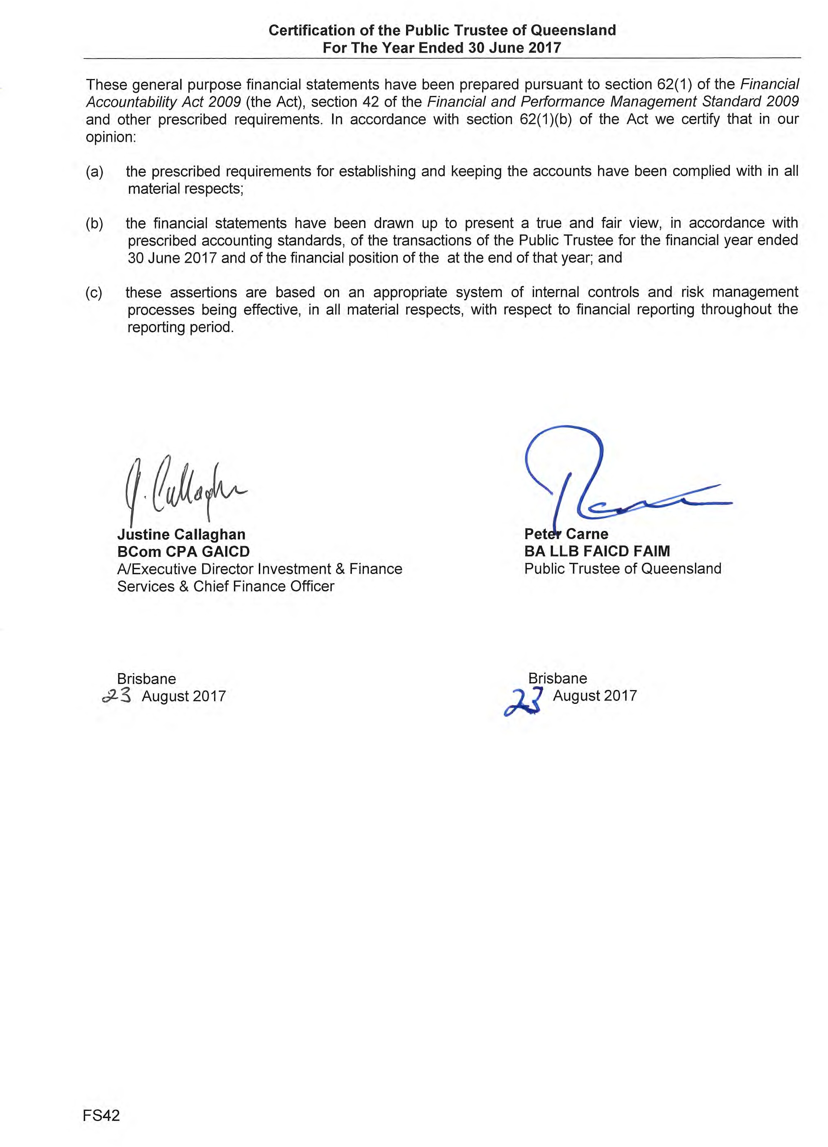

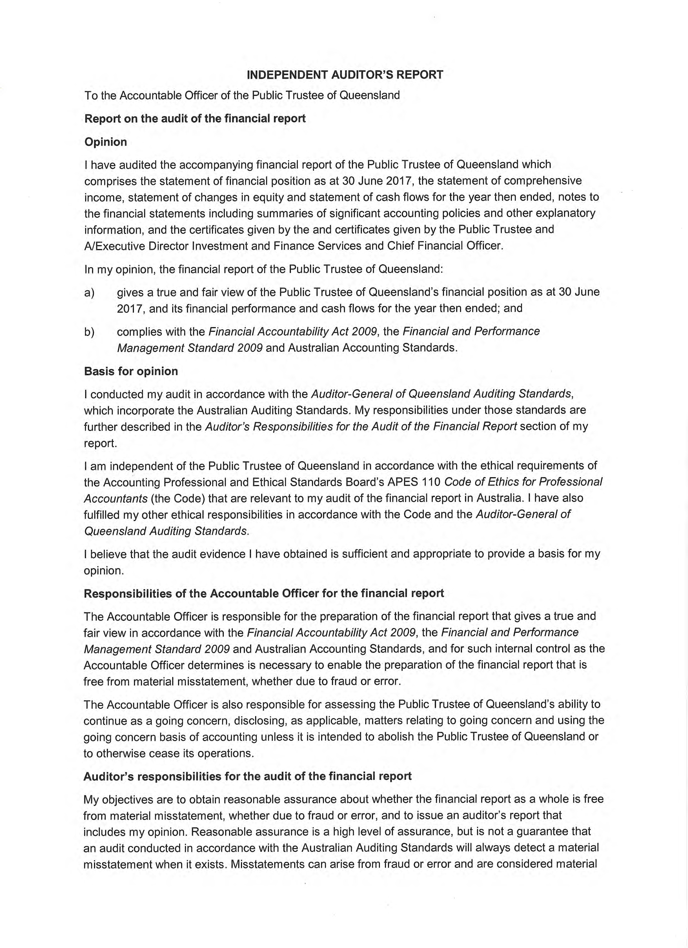

Page 89

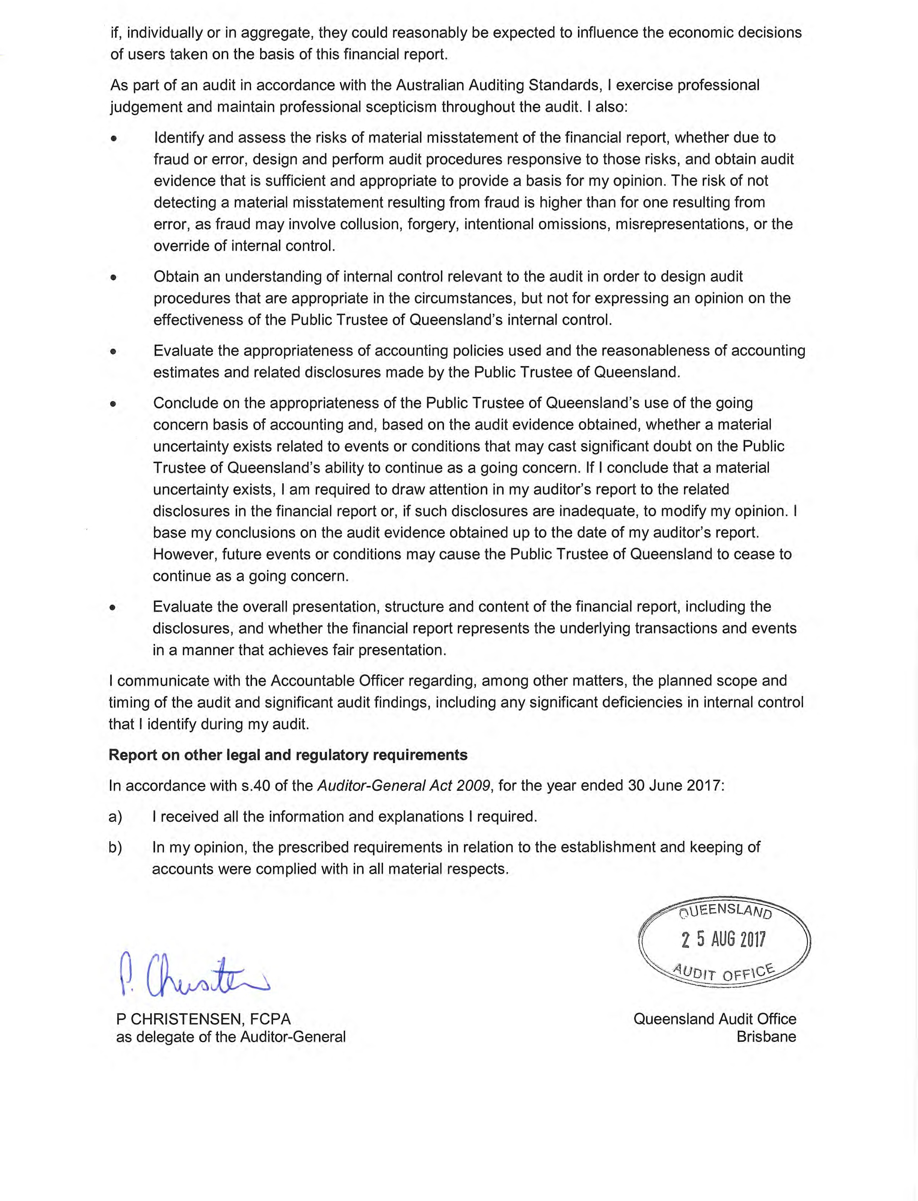

Page 90

The Public Trustee of Queensland Growth Trust

ABN 95 792 610 481

Financial Statements Year Ended 30 June 2017

Contents

Financial Statements
Statement of Comprehensive Income | PTIF 1
Statement of Financial Position | PTIF 2
Statement of Changes In Equity | PTIF 3
Statement of Cash Flows | PTIF 4
Notes to the Financial Statements
Basis of Financial Statements Preparation | PTIF 7
Notes About Our Financial Performance | PTIF 8
Notes About Our Financial Position | PTIF 10
Notes About Risks and Other Accounting Uncertainties | PTIF 13
Other Information | PTIF 17
The Public Trustee of Queensland’s Declaration | PTIF 20
Independent Auditor’s Report | PTIF 21

General Information
The trustee of the Public Trustee of Queensland Growth Trust (the Trust) is the Public Trustee of Queensland (ABN 12 676 939 467).
For the purpose of this report ‘the Public Trustee of Queensland’ refers to the independent statutory individual and ‘the Public Trustee’ comprises all the operating activities under its control.

The head office and principal place of business of the Public Trustee: Trustee House, 444 Queen Street, Brisbane QLD 4000.

For information in relation to the Public Trustee of Queensland Growth Trust’s financial statements, please call (07) 3213 9288, email clientenq@pt.qld.gov.au or visit the Public Trustee’s internet site at www.pt.qld.gov.au.

Statement of Comprehensive Income Year Ended 30 June 2017
 | Notes | 2017 | 2016
 |  | $’000 | $’000
Investment Income
Interest income |  | 14 | 18
Net gains/(losses) on financial instruments held at fair value through profit or loss | 1 | 21,919 | (8,267)
Distributions | 2 | 19,141 | 12,118
Other income |  | 100 | 1
Total Net Investment Income/(Loss) |  | 41,174 | 3,870
Expenses
Trustee fees |  | (4,701) | (4,484)
Total Operating Expenses |  | (4,701) | (4,484)
Profit/(Loss) From Ordinary Activities |  | 36,473 | (614)
Finance Costs Attributable To Unitholders
Distribution to unitholders | 3 | (14,454) | (7,652)
(Increase)/Decrease in net assets attributable to unitholders | 5 | (22,019) | 8,266
Profit/(Loss) For the Period |  | - | -
Other comprehensive income |  | - | -
Total Comprehensive Income |  | - | -

The above statement should be read in conjunction with the accompanying notes.

PTIF 1

Statement of Financial Position As at 30 June 2017
 | Notes | 2017 | 2016
 |  | $'000 | $'000
Assets
Cash and cash equivalents | 6 | 502 | 140
Distribution receivable |  | 5,555 | 5,697
Other receivable |  | 42 | 40
Financial assets held at fair value through profit or loss | 7 | 312,388 | 297,060
Total Assets |  | 318,487 | 302,937
Liabilities
Distributions payable | 3 | 4,383 | 4,656
Redemption payable |  | 436 | -
Trustee fees payable |  | 413 | 396
Total Liabilities (Excluding Net Assets Attributable to  Unitholders) |  | 5,232 | 5,052
Net Assets Attributable to Unitholders - Liability | 5 | 313,255 | 297,885

The above statements should be read in conjunction with the accompanying notes.

PTIF 2

Statement of Changes in Equity Year Ended 30 June 2017

The Trust’s net assets attributable to unitholders are classified as a liability under AASB 132 Financial Instruments Presentation. As such the Trust has no equity and no items of changes in equity have been presented for the current or comparative year.
Changes in net assets attributable to unitholders are disclosed in Note 5.

PTIF 3

Statement of Cash Flows Year Ended 30 June 2017
Notes | 2017 | 2016
 | $'000 | $'000
Cash Flows From Operating Activities
Interest received | 13 | 16
Reduced input tax credit – received | 246 | 233
Distributions received | 19,282 | 10,948
Trustee fees paid | (4,931) | (4,692)
Proceeds from sale of financial instruments held at fair  value through profit or loss | 25,099 | 19,246
Purchase of financial instruments held at fair value through profit or loss | (18,408) | (46,929)
Net Cash Flows Used in Operating Activities | 21,301 | (21,178)
Cash Flows From Financing Activities
Proceeds from applications of units by unitholders | 28,266 | 61,119
Payments for redemptions of units by unitholders | (34,479) | (33,526)
Distributions paid | (14,726) | (6,766)
Net Cash Flows From Financing Activities | (20,939) | 20,827
Net Increase/(Decrease) in Cash and Cash Equivalents | 362 | (351)
Cash and Cash Equivalents at Beginning of the Financial Year | 140 | 491
Cash and Cash Equivalents at End of the Financial Year | 502 | 140

The above statements should be read with the accompanying notes.

PTIF 4

Statement of Cash Flows Year Ended 30 June 2017
 | 2017 | 2016
 | $'000 | $'000
Reconciliation of Cash Flows From Operating Activities
Profit/(loss) for the year | - | -
Increase/(decrease) in net assets attributable to unitholders | 22,019 | (8,266)
Distributions paid to unitholders | 14,454 | 7,652
Net change in financial instruments held at fair value through profit or loss | (15,328) | (19,418)
Net change in receivables and other assets | 139 | (1,174)
Net change in payables | 17 | 28
Net Cash Outflow from Operating Activities | 21,301 | (21,178)

There were no non-cash financing activities during the year or the prior year.

PTIF 5

Contents

Basis of Financial Statements Preparation |  | PTIF 7
Notes About our Financial Performance
1 | Net Gains/(Losses) on Financial Instruments held at Fair Value through Profit or Loss | PTIF 8
2 | Distributions | PTIF 9
3 | Distribution Summary | PTIF 9
4 | Remuneration of Auditors | PTIF 9
Notes About our Financial Position
5 | Net Assets Attributable to Unitholders | PTIF 10
6 | Cash and Cash Equivalents | PTIF 11
7 | Financial Assets held at Fair Value through Profit or Loss | PTIF 12
Notes About Risks and Other Accounting Uncertainties
8 | Fair Value Measurement | PTIF 13
9 | Accounting Estimates and Judgements | PTIF 13
10 | Financial Risk Management | PTIF 13
11 | Events Occurring after the Reporting Period | PTIF 16
Other Information
12 | Key Management Personnel | PTIF 17
13 | Related Party Transactions | PTIF 17
14 | Taxation | PTIF 18
15 | First Year Application of New Accounting Standards or Change in  Accounting Policy | PTIF 19
16 | Future Impact of Accounting Standards Not Yet Effective | PTIF 19

PTIF 6

BASIS OF FINANCIAL STATEMENTS PREPARATION

General Information

The Public Trustee of Queensland Growth Trust (the Trust) is a unit trust structure and was constituted by a Trust Deed Poll on 10 July 1996. The Trust will terminate on 10 July 2076 unless terminated earlier in accordance with the provisions of the Trust Deed.

The Trust Administrator and Registry provider is BDO (Qld) Pty Ltd ACN 134 242 434.The Investment Manager is QIC Limited (‘QIC’) ACN 130 539 123.

The financial statements for the year ended 30 June 2017 were authorised for issue by the Public Trustee of Queensland and the A/Executive Director Investment and Finance Services and Chief Financial Officer at the date of signing the Public Trustee of Queensland’s Declaration.

The Trust was established by the Public Trustee to provide clients of the Public Trustee with a wide range of investment options to meet their lifestyle requirements.

Change in Investment Strategy
Prior to 7 April 2017, the investment strategy of the Trust comprised investments in a number of unlisted unit trusts managed by QIC Limited (QIC). The investments in these unit trusts provided exposure to Australian equities, international equities, fixed interest, global property, cash and absolute return strategies asset classes (refer Note 10(b)(i) for further information on the Trust’s exposure to asset classes).
Following review of the investment strategy with the assistance of external advice, the Public Trustee determined to change the investment strategy so that the Trust invests primarily in the QIC Growth Fund with a small investment (approximately 1% of the Trust) in the QIC Cash Enhanced Fund to manage liquidity. The transition to the revised investment strategy was completed on 7 April 2017.

The investment objective of the Trust is to provide a fully diversified investment strategy for those seeking long-term income and capital growth. As a result of the change in investment strategy outlined above, the investment objective of the Trust changed from generating average returns (net of fees and costs) of CPI + 1.9% over rolling ten year periods to CPI + 2.4% per annum over rolling five year periods.

Compliance with Prescribed Requirements
These general purpose financial statements have been prepared in accordance with Australian Accounting Standards issued by the Australian Accounting Standards Board in Australia.

The Reporting Entity

The Trust is a for-profit entity for the purpose of preparing the financial statements.

Measurement

These financial statements were prepared on the basis of fair value measurement of assets and liabilities except where otherwise stated.

Presentation Matters

All amounts are presented in Australian dollars and have been rounded to the nearest thousand dollars unless otherwise indicated.
The statement of financial position is presented on a liquidity basis. Assets and liabilities are presented in decreasing order of liquidity and do not distinguish between current and non-current. All balances are expected to be recovered or settled within twelve months, except for investments in financial assets and net assets attributable to unitholders. The amount expected to be recovered or settled within twelve months after the end of each reporting period cannot be reliably determined.

PTIF 7

NOTES ABOUT OUR FINANCIAL PERFORMANCE

Net Gains/(Losses) on Financial Instruments held at Fair Value through Profit or Loss

Net gains/(losses) recognised in relation to financial assets held at fair value through profit or loss.

 | 2017  $'000 | 2016  $'000
Financial assets | 21,919 | (8,267)
Net gain/(loss) on financial assets held at fair value through profit or loss | 21,919 | (8,267)

Accounting Policy - Financial Instruments Classification
The Trust’s investments are classified at fair value through profit or loss. They are comprised of financial instruments designated at fair value through profit or loss upon initial recognition.

Financial assets designated at fair value through profit or loss upon initial recognition are those that are managed and their performance evaluated on a fair value basis in accordance with the Trust’s documented investment strategies. The Trust’s policy is for the Public Trustee to evaluate the information about these financial instruments on a fair value basis together with other related financial information.

Recognition / De-recognition

The Trust recognises financial assets and financial liabilities on the date they become party to the contractual agreement (trade date).

Investments are derecognised when the right to receive cash flows from the investments have expired or the Trust has transferred substantially all risks and rewards of ownership.

Measurement

Subsequent to initial recognition, all instruments classified at fair value through profit or loss are measured at fair value with changes in their fair value recognised in profit or loss.

Fair value is the price that would be received to sell an asset or paid to transfer a liability in an orderly transaction between market participants at the measurement date.

The fair value of financial instruments is based on their quoted market prices at the reporting date without any deduction for estimated future selling costs.

Investments in unlisted unit trusts are recorded at the exit price as reported by the managers of the trusts.

Financial liabilities arising from the redeemable units issued by the Trust are carried at the redemption amount representing the unitholders’ right to a residual interest in the Trust’s assets, effectively at fair value at the reporting date.

PTIF 8

Distributions

Distributions from financial assets held at fair value through profit or loss are as follows:

 | 2017  $'000 | 2016  $'000
Distributions | 19,141 | 12,118
Total distributions from financial assets held at fair value through profit or loss | 19,141 | 12,118

Accounting Policy – Distributions
Trust distributions are recognised when the right to receive payment is established.

Distribution Summary

The distributions for the year were as follows:

 | 2017 | 2017 | 2016 | 2016
 | $'000 | CPU* | $'000 | CPU*
Distribution paid - 30 September 2016 | 2,575 | 0.7151 | 127 | 0.0348
Distribution paid - 14 October 2016 | - | - | 332 | 0.0911
Distribution paid - 31 December 2016 | 1,938 | 0.5354 | 1,911 | 0.5234
Distribution paid - 31 March 2017 | 5,558 | 1.5440 | 626 | 0.1726
Distribution payable - 30 June 2017 | 4,383 | 1.2301 | 4,656 | 1.2790
Total distribution | 14,454 | 4.0246 | 7,652 | 2.1009
* CPU is cents per unit

Accounting Policy - Distributions

In accordance with the Trust Deed, the Trust distributes income to unitholders by cash. Where unitholders choose to do so, these distributions may be reinvested into the Trust at the applicable application price. The distributions are recognised in profit or loss as finance costs attributable to unitholders.

The distribution amount payable to unitholders at the end of each reporting period is recognised separately in the statement of financial position when unitholders are presently entitled to the distributable income under the Trust Deed.

Remuneration of Auditors

During the year audit fees of $20,000 (2016: $20,000) were paid or payable by the Public Trustee to Queensland Audit Office for services provided by the auditor of the Trust. Fees for the audit of financial statements are included as part of the Trustee Fees in the statement of comprehensive income.

PTIF 9

NOTES ABOUT OUR FINANCIAL POSITION

Net Assets Attributable to Unitholders

Net assets attributable to unitholders and the movements in the number of units during the year were as follows:

 | 2017 | 2016
Amount | $'000 | $'000
Opening balance | 297,885 | 278,424
Applications | 28,266 | 61,085
Redemptions | (34,915) | (33,392)
Units issued upon reinvestment of distributions | - | 34
Change in net assets attributable to unitholders | 22,019 | (8,266)
Closing balance | 313,255 | 297,885
Units (No’s) | Unit No's '000 | Unit No's '000
Opening balance | 364,029 | 331,240
Application | 32,873 | 73,655
Redemptions | (40,580) | (40,906)
Units issued upon reinvestment of distributions | - | 40
Closing balance | 356,322 | 364,029

Accounting Policy - Net Assets Attributable to Unitholders

Units are redeemable at the unitholders’ option and are classified as financial liabilities as the Trust is required to distribute its taxable income. The units can be put back to the Trust at any time for cash based on the redemption price. The fair value of redeemable units is measured at the redemption amount that is payable (based on the redemption unit price) at the end of the reporting period if unitholders exercised their right to redeem units in the Trust.

Income not distributed is included in net assets attributable to unitholders. Movements in net assets attributable to unitholders are recognised in profit or loss.

Accounting Policy - Applications and Redemptions

The Trust utilises a buy-sell spread methodology to ensure that unitholders joining or leaving the Trust contribute to the transaction costs incurred by the Trust buying or selling assets within the Trust. The buy-sell spread is retained by the Trust (it is not a fee paid to the Public Trustee) to ensure equity among unitholders is maintained.

Application requests are processed utilising the application price to determine the number of units in the Trust to be issued. Redemption requests are processed utilising the redemption price to determine the number of units in the Trust to be cancelled.

PTIF 10

Net Assets Attributable to Unitholders (Continued) Disclosure
Capital Risk Management

The capital structure of the Trust consists of net assets attributable to unitholders as capital, notwithstanding net assets attributable to unitholders are classified as a liability. The amount of net assets attributable to unitholders can change significantly on a daily basis as the Trust is subject to daily applications and redemptions at the discretion of unitholders.

Daily applications and redemptions are reviewed relative to the liquidity of the Trust’s underlying assets on a daily basis by the Public Trustee. Under the terms of the Trust Deed, the Public Trustee has the discretion to reject an application for units and to defer or adjust redemption of units if the exercise of such discretion is in the best interests of unitholders.

The Trust does not have any externally imposed capital requirements.

The Investment Manager manages the capital of the Trust in accordance with the Trust’s investment objectives, policies and restrictions, as outlined in the Trust’s product information statement, while maintaining sufficient liquidity to meet participating unitholders’ redemptions. The investment strategy has changed from 7 April 2017 as per the disclosure in Note (b) on page 7.

The Investment Manager reviews the capital structure on a monthly basis. As part of this review, the Investment Manager considers the risks associated with each asset class.

Cash and Cash Equivalents

For the purpose of presentation in the statement of financial position and the statement of cash flows, cash and cash equivalents includes cash on hand, deposits held at call with financial institutions, other short term, highly liquid investments with original maturities of three months or less from the date of acquisition that are readily convertible to known amounts of cash and which are subject to an insignificant risk of change in value.

Payments and receipts relating to the purchase and sale of investment securities are classified as cash flows from operating activities, as movements in the fair value of these securities represent the Trust’s main income generating activities.

PTIF 11

Financial Assets held at Fair Value through Profit or Loss

 | 2017 | 2016
Designated at fair value through profit or loss | $'000 | $'000
Unlisted unit trusts | 312,388 | 297,060
Total financial assets held at fair value through profit or loss | 312,388 | 297,060
Comprising: Unlisted unit trusts
Units in growth trusts | 309,107 | -
Units in Australian equity trusts | - | 101,321
Units in international equity trusts | - | 104,060
Units in cash trusts | 3,281 | 30,009
Units in global fixed interest trusts | - | 55,874
Units in absolute return strategy trust | - | 5,796
Total | 312,388 | 297,060

An overview of the risk exposures of fair value measurements relating to financial assets at fair value through profit or loss is included in Note 10.

PTIF 12

NOTES ABOUT RISKS AND OTHER ACCOUNTING UNCERTAINTIES

Fair Value Measurement

The Trust measures and recognises financial assets at fair value through profit or loss (FVTPL) (see Note
7) on a recurring basis. The Trust has no assets or liabilities measured at fair value on a non-recurring basis in the current reporting period.

AASB 13 Fair Value Measurement requires disclosure of fair value measurements by level of the following fair value hierarchy:

- Level 1 - Quoted prices (unadjusted) in active markets for identical assets or liabilities
- Level 2 - Input other than quoted prices included within level 1 that are observable for the asset or liability, either directly or indirectly (level 2); and
- Level 3 - Inputs for the asset or liability that are substantially derived from unobservable inputs.

The Trust’s financial assets at FVTPL are all investments in QIC unlisted unit trusts and are classified within level 2 as these markets are not considered to be active but are valued based on alternative pricing sources supported by observable inputs. The Trust does not have any relevant assets classified as level 1 or level 3.

Accounting Estimates and Judgements

The Trust makes estimates and assumptions that affect the reported amounts of assets and liabilities within the next financial year. Estimates are continually evaluated and based on historical experience and other factors, including expectations of future events that are believed to be reasonable under the circumstances.

The majority of the Trust’s financial investments are in QIC unlisted trusts and QIC (the investment manager) may use estimates and assumptions that affect the reported amounts of assets and liabilities within the next financial year.

Financial Risk Management

The Trust’s activities expose it to a variety of financial risks: market risk (including price risk, currency risk, and interest rate risk), credit risk and liquidity risk.

This note presents information about the Trust’s exposure to each of the above risks, as well as the Trust’s objectives, policies and processes for measuring and managing the risk.
The disclosures are prepared on the basis of the Trust’s direct investments and not on a look-through basis to the underlying investments of the unlisted unit trusts that the Trust primarily holds.

(a) Risk Management Framework

The Trust’s overall risk management program focuses on ensuring compliance with the Trust Deed and product information statement and seeks to maximise the returns derived for prudent levels of risk. The primary method of mitigating or controlling risks to the Trust’s investment portfolio is diversification through the QIC Growth Fund.

The Investment Manager of the QIC Growth Fund has been given a discretionary authority to manage the assets in line with the QIC Growth Fund’s investment objectives and employs a disciplined approach to the management of risk. The Trust’s portfolio is constructed utilising investments that provide exposure to different asset classes, the returns from which have low correlation, so as to strengthen diversification and consequently reduce the overall effect on asset specific risk.

PTIF 13

10. Financial Risk Management (Continued)

Risk Management Framework (Continued)

The Investment Manager of the QIC Growth Fund will set asset allocation targets within the approved Dynamic Asset Allocation (DAA) and alter the asset allocation targets to allow the portfolio to move within the DAA ranges, depending on expected future asset class returns.

The Public Trustee uses different methods to measure different types of risk to which the Trust is exposed. These methods include sensitivity analysis in the case of interest rate and other price risks and ratings analysis for credit risk.

Market Risk

(i) Price Risk

The Trust is exposed to securities price risk. This arises from investments held by the Trust for which prices in the future are uncertain, in particular the investments in unlisted unit trusts. Investments are classified in the statement of financial position as at fair value through profit or loss. All investments present a risk of loss of capital. The maximum risk resulting from financial instruments is determined by the fair value of the financial instruments.

As outlined earlier, the Investment Manager of the QIC Growth Fund mitigates price risk through diversification and a careful selection of investments within the DAA ranges.

As referred to earlier, the investment strategy for the Trust was changed effective 7 April 2017. Following transition to the new investment strategy, the Trust invests primarily in the QIC Growth Fund with a small investment (approximately 1% of the Trust) in the QIC Cash Enhanced Fund to manage liquidity.

The following table is a summary of the DAA ranges pertaining to the QIC Growth Fund and the exposure of the Trust to these asset classes as at 30 June 2017.

QIC Growth Trust | Dynamic Asset Allocation |  | Actual
Asset Class | Ranges |  | Exposure
 | Minimum | Maximum | 2017
Global equities | 25% | 75% | 52%
Global fixed interest | -15% | 35% | 8%
Other alternatives | -10% | 40% | 14%
Cash | -14% | 36% | 16%
Global real estate | 0% | 15% | 5%
Fixed infrastructure | 0% | 15% | 3%
Global private equity | 0% | 10% | 2%

PTIF 14

Financial Risk Management (Continued)

Market Risk (Continued)

(i) Price Risk (Continued)
The following table summarises the impact on the Trust’s net assets attributable to unitholders of an increase/decrease in the value of the Trust’s investment in unlisted unit trusts. The analysis is based on the assumptions that the unlisted unit trusts’ net asset values increased by 9.0% (2016: 7.5%) and decreased by 9.0% (2016: 7.5%) with all other variables held constant.

As the Trust’s portfolio is constructed utilising a range of unlisted unit trusts that provide exposure to different assets classes, the price risk represented by the change in the fair value of unlisted unit trusts will also be representative of changes in interest rates and foreign exchange rates that the unlisted unit trusts may also be exposed to.
Impact on Operating Profit/Net Assets Attributable to Unitholders | 2017  $000 | 2016  $000
Fair value of investments in unlisted unit trusts increased by 9.0% (2016:7.5%) | 28,115 | 22,279
Fair value of investments in unlisted unit trusts decreased by 9.0% (2016:7.5%) | (28,115) | (22,279)

The sensitivity analysis presented is based upon the portfolio composition as at 30 June. The composition of the Trust’s investment portfolio is expected to change over time. The sensitivity analysis prepared as at 30 June is not necessarily indicative of the effect on the Trust’s net assets attributable to unitholders of future movements in the value of the investments in unlisted unit trusts.

The 9.0% change in the fair value of investments in unlisted unit trusts has been determined based on management’s best estimate, having regard to a number of factors, including historical levels of changes in the fair value of investments in the unlisted unit trusts.

However, actual movements in the risk variables may be greater or less than anticipated due to a number of factors, including unusually large market shocks resulting from changes in the performance of and/or correlation between the performances of economies, markets and securities in which the Trust has exposure. As a result, historic variations in risk variables should not be used to predict future variations in risk variables.

Credit Risk

The Trust is exposed to credit risk, which is the risk that a counterparty will be unable to pay amounts in full when they fall due.

The main concentration of credit risk, to which the Trust is exposed, arises from the Trust’s investments in unlisted unit trusts. The Trust is also exposed to a counterparty credit risk on cash and cash equivalents and other receivables.

- Unlisted Unit Trusts

The credit risk arising on investments in unlisted unit trusts is mitigated by investing with QIC who is well recognised and has a proven track record of delivering on its stated investment objectives. Continual monitoring of QIC by the Investment Board is also carried out on an ongoing basis.

QIC separately carries out extensive due diligence on any proposed underlying investment managers prior to making an investment allocation to ensure these managers are well recognised and have a proven track record of delivering on their stated investment objectives.

PTIF 15

Credit Risk (Continued)

- Cash and Cash Equivalents

The exposure to credit risk for cash and cash equivalents is low as all counterparties have a rating of AA- (as determined by Standard and Poor’s) or higher.

The investment team of the Public Trustee monitors the Trust’s credit position on a daily basis.

Liquidity Risk

Liquidity risk is the risk that the Trust may not be able to generate sufficient cash resources to settle its obligations in full as they fall due, or can only do so on terms that are materially disadvantageous.
The Trust is exposed to daily cash redemptions of redeemable units. Investments in unlisted unit trusts expose the Trust to the risk that the manager of those unlisted unit trusts may be unwilling or unable to fulfil the redemption requests within the timeframe requested by the Trust.

In order to manage the Trust’s overall liquidity, the Public Trustee has the discretion to defer or adjust redemption of units if the exercise of such discretion is in the best interests of unitholders.
Units are redeemed on demand at the unitholder’s option (except as noted above). Accordingly for both the 2016 and 2017 financial periods, the Trust’s non-derivative financial liabilities contractual maturity is classified within 1 month. However, the Public Trustee does not envisage that the contractual maturity will be representative of the actual cash outflows, as holders of these instruments typically retain them for the medium to long term.

Events Occurring after the Reporting Period

There were no significant events that have occurred since the end of the reporting period which would impact on the financial position of the Trust disclosed in the statement of financial position as at 30 June 2017 or on the results and cash flows of the Trust for the period ended on that date.

PTIF 16

OTHER INFORMATION

Key Management Personnel Disclosures

Trustee

The trustee of the Trust is The Public Trustee of Queensland.

Details of Key Management Personnel

Key management personnel that held positions of authority and responsibility for planning, directing and controlling the activities of the Trust during the financial year (and the previous financial year where relevant), unless otherwise stated, were key management personnel of the Public Trustee comprising:

Position | Responsibilities
The Public Trustee of Queensland | The Public Trustee of Queensland is responsible for administering the fiduciary obligations of the Trust.
Executive Director, Investment and Finance Services and Chief Financial Officer | The Executive Director, Investment and Finance Services and Chief Financial Officer is responsible for the strategic direction of the Trust.
Director, Investment and Taxation Services | The Director, Investment and Taxation Services is responsible for the operational management of the Trust.

Related Party Transactions

Transactions with people/entities related to KMP

No key management personnel had any personal unit holdings or transactions with the Trust. No compensation was directly attributable to key management personnel.

Trustee Fees and Other Transactions

Under the terms of the Trust’s Trust Deed and product information statement, the Public Trustee is entitled to receive Trustee fees, calculated daily on the Trust’s net asset value and paid monthly in arrears.

The fee covers the usual expenses incurred and includes the QIC’s investment management fees charged to the Public Trustee in respect of each of the QIC Trusts and covers other expenses incurred by the Public Trustee such as auditing, accounting expenses and ongoing maintenance of the unit registry.

The annual Trustee fees are grossed up for GST and reduced by the Reduced Input Tax Credits (RITCs) allowed. The annual Trustee fees of the Trust (including GST and reduced by RITCs) are 1.52% (2016: 1.52%).

PTIF 17

Related Party Transactions (Continued)

Trustee Fee Rebate
Trustee fee rebate is available for investors holding more than $100,000. This rebate is a reduction in the Trustee fee and is calculated on the value of each investor’s holding at the close of each month. The tiered Trustee fee rebate structure is as follows:

 | 30 June 2017 | 30 June 2016
Net asset value | Rebate % | Rebate %
First $100,000 | - | -
Next $150,000 | 0.15% | 0.15%
Next $250,000 | 0.40% | 0.40%
Next $500,000 | 0.45% | 0.45%
Next $9M | 0.85% | 0.85%
Next $15M | 1.00% | 1.00%
Over $25M | 1.05% | 1.05%

Taxation

Income Tax

Under current legislation, the Trust is not subject to income tax as unitholders are presently entitled to the income of the Trust. The benefit of imputation credits and foreign tax paid are passed on to unitholders.

Goods and Services Tax (GST)

The GST incurred on the costs of various services provided to the Trust by third parties such as trustee fees have been passed onto the Trust. The Trust qualifies for RITCs at a rate of 55% (2016: 55%); hence expenses have been recognised in profit or loss net of the amount of GST recoverable from the Australian Taxation Office (ATO). Payables are inclusive of GST. The net amount of GST recoverable from the ATO is included in receivables in the statement of financial position. Cash flows relating to GST are included in the statement of cash flows on a gross basis.

PTIF 18

First Year Application of New Accounting Standards or Change in Accounting Policy

Changes in Accounting Policy
The Trust did not voluntarily change any of its accounting policies during 2016-17.

Accounting Standards Early Adopted
No Australian Accounting Standards have been early adopted for 2016-17.

Accounting Standards Applied for the First Time
There are no standards, interpretations or amendments to existing standards that are effective for the first time for the financial year beginning 1 July 2016 that would be expected to have a material impact on the Trust.

Future Impact of Accounting Standards Not Yet Effective

Certain new or amended accounting standards have been published that are not mandatory for the 30 June 2017 reporting period and have not been early adopted by the Trust. The Public Trustee’s assessment of the impact of these new or amended standards (to the extent they are relevant to the Trust) is set out below:
- AASB 9 Financial Instruments and Applicable Amendments (effective from 1 January 2018)
AASB 9 Financial Instruments addresses the classification, measurement and de-recognition of financial assets and financial liabilities. It has now also introduced revised rules around hedge accounting and impairment. The standard is not applicable until 1 January 2018 but is available for early adoption.

The Public Trustee does not expect this to have a significant impact on the recognition and measurement of the Trust’s financial instruments as they are carried at fair value through profit or loss.

The de-recognition rules have not been changed from the previous requirements, and the Trust does not apply hedge accounting. AASB 9 introduces a new impairment model. However, as the Trust’s investments are held at fair value through profit or loss, the change in impairment rules will not impact the Trust. The Trust has not yet decided when to adopt AASB 9.

PTIF 19

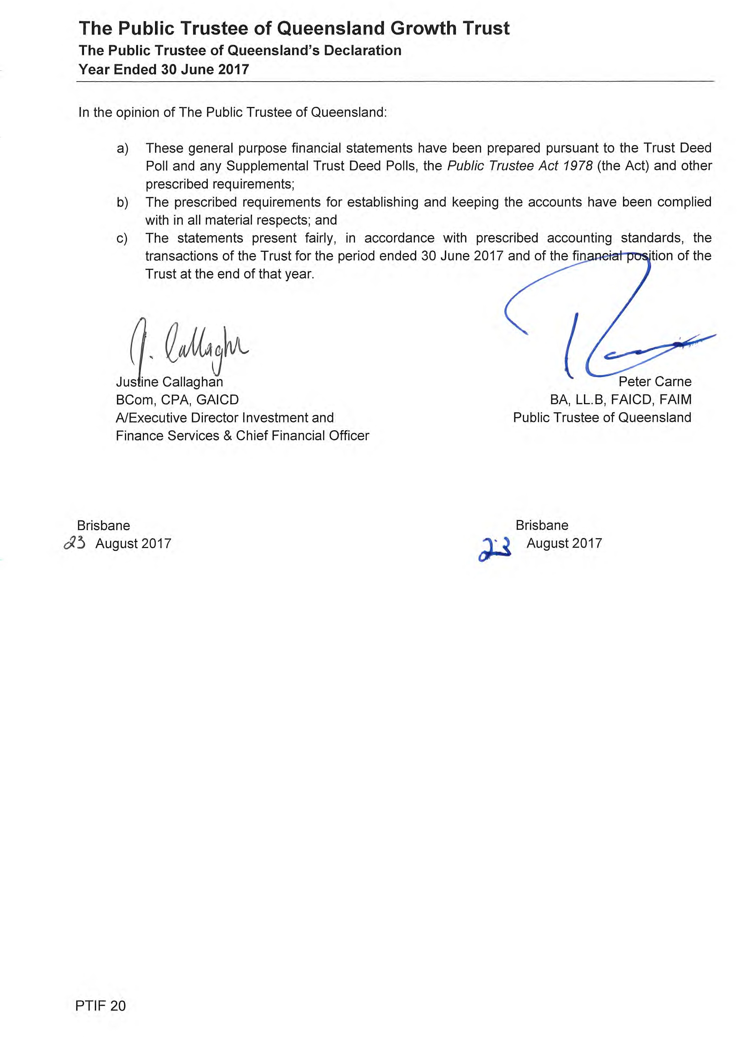

Page 111

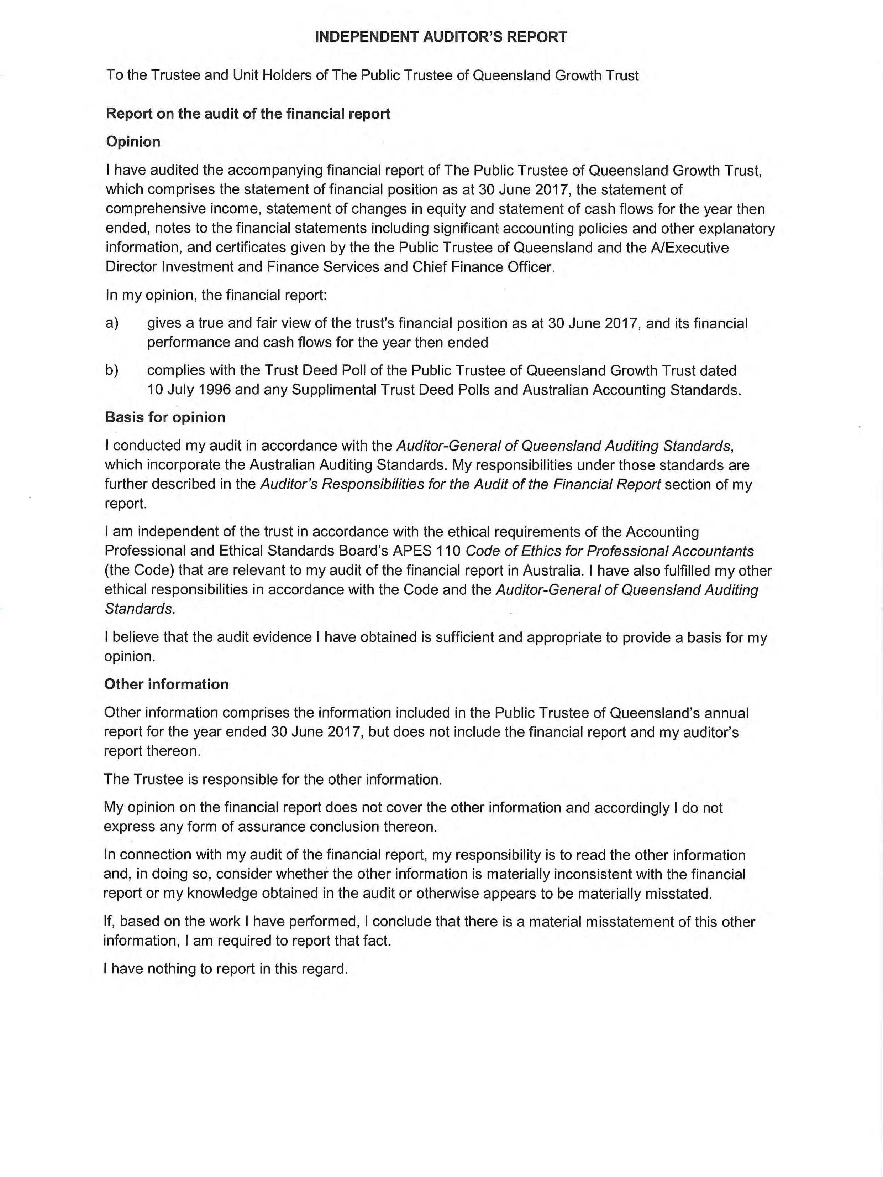

Page 112

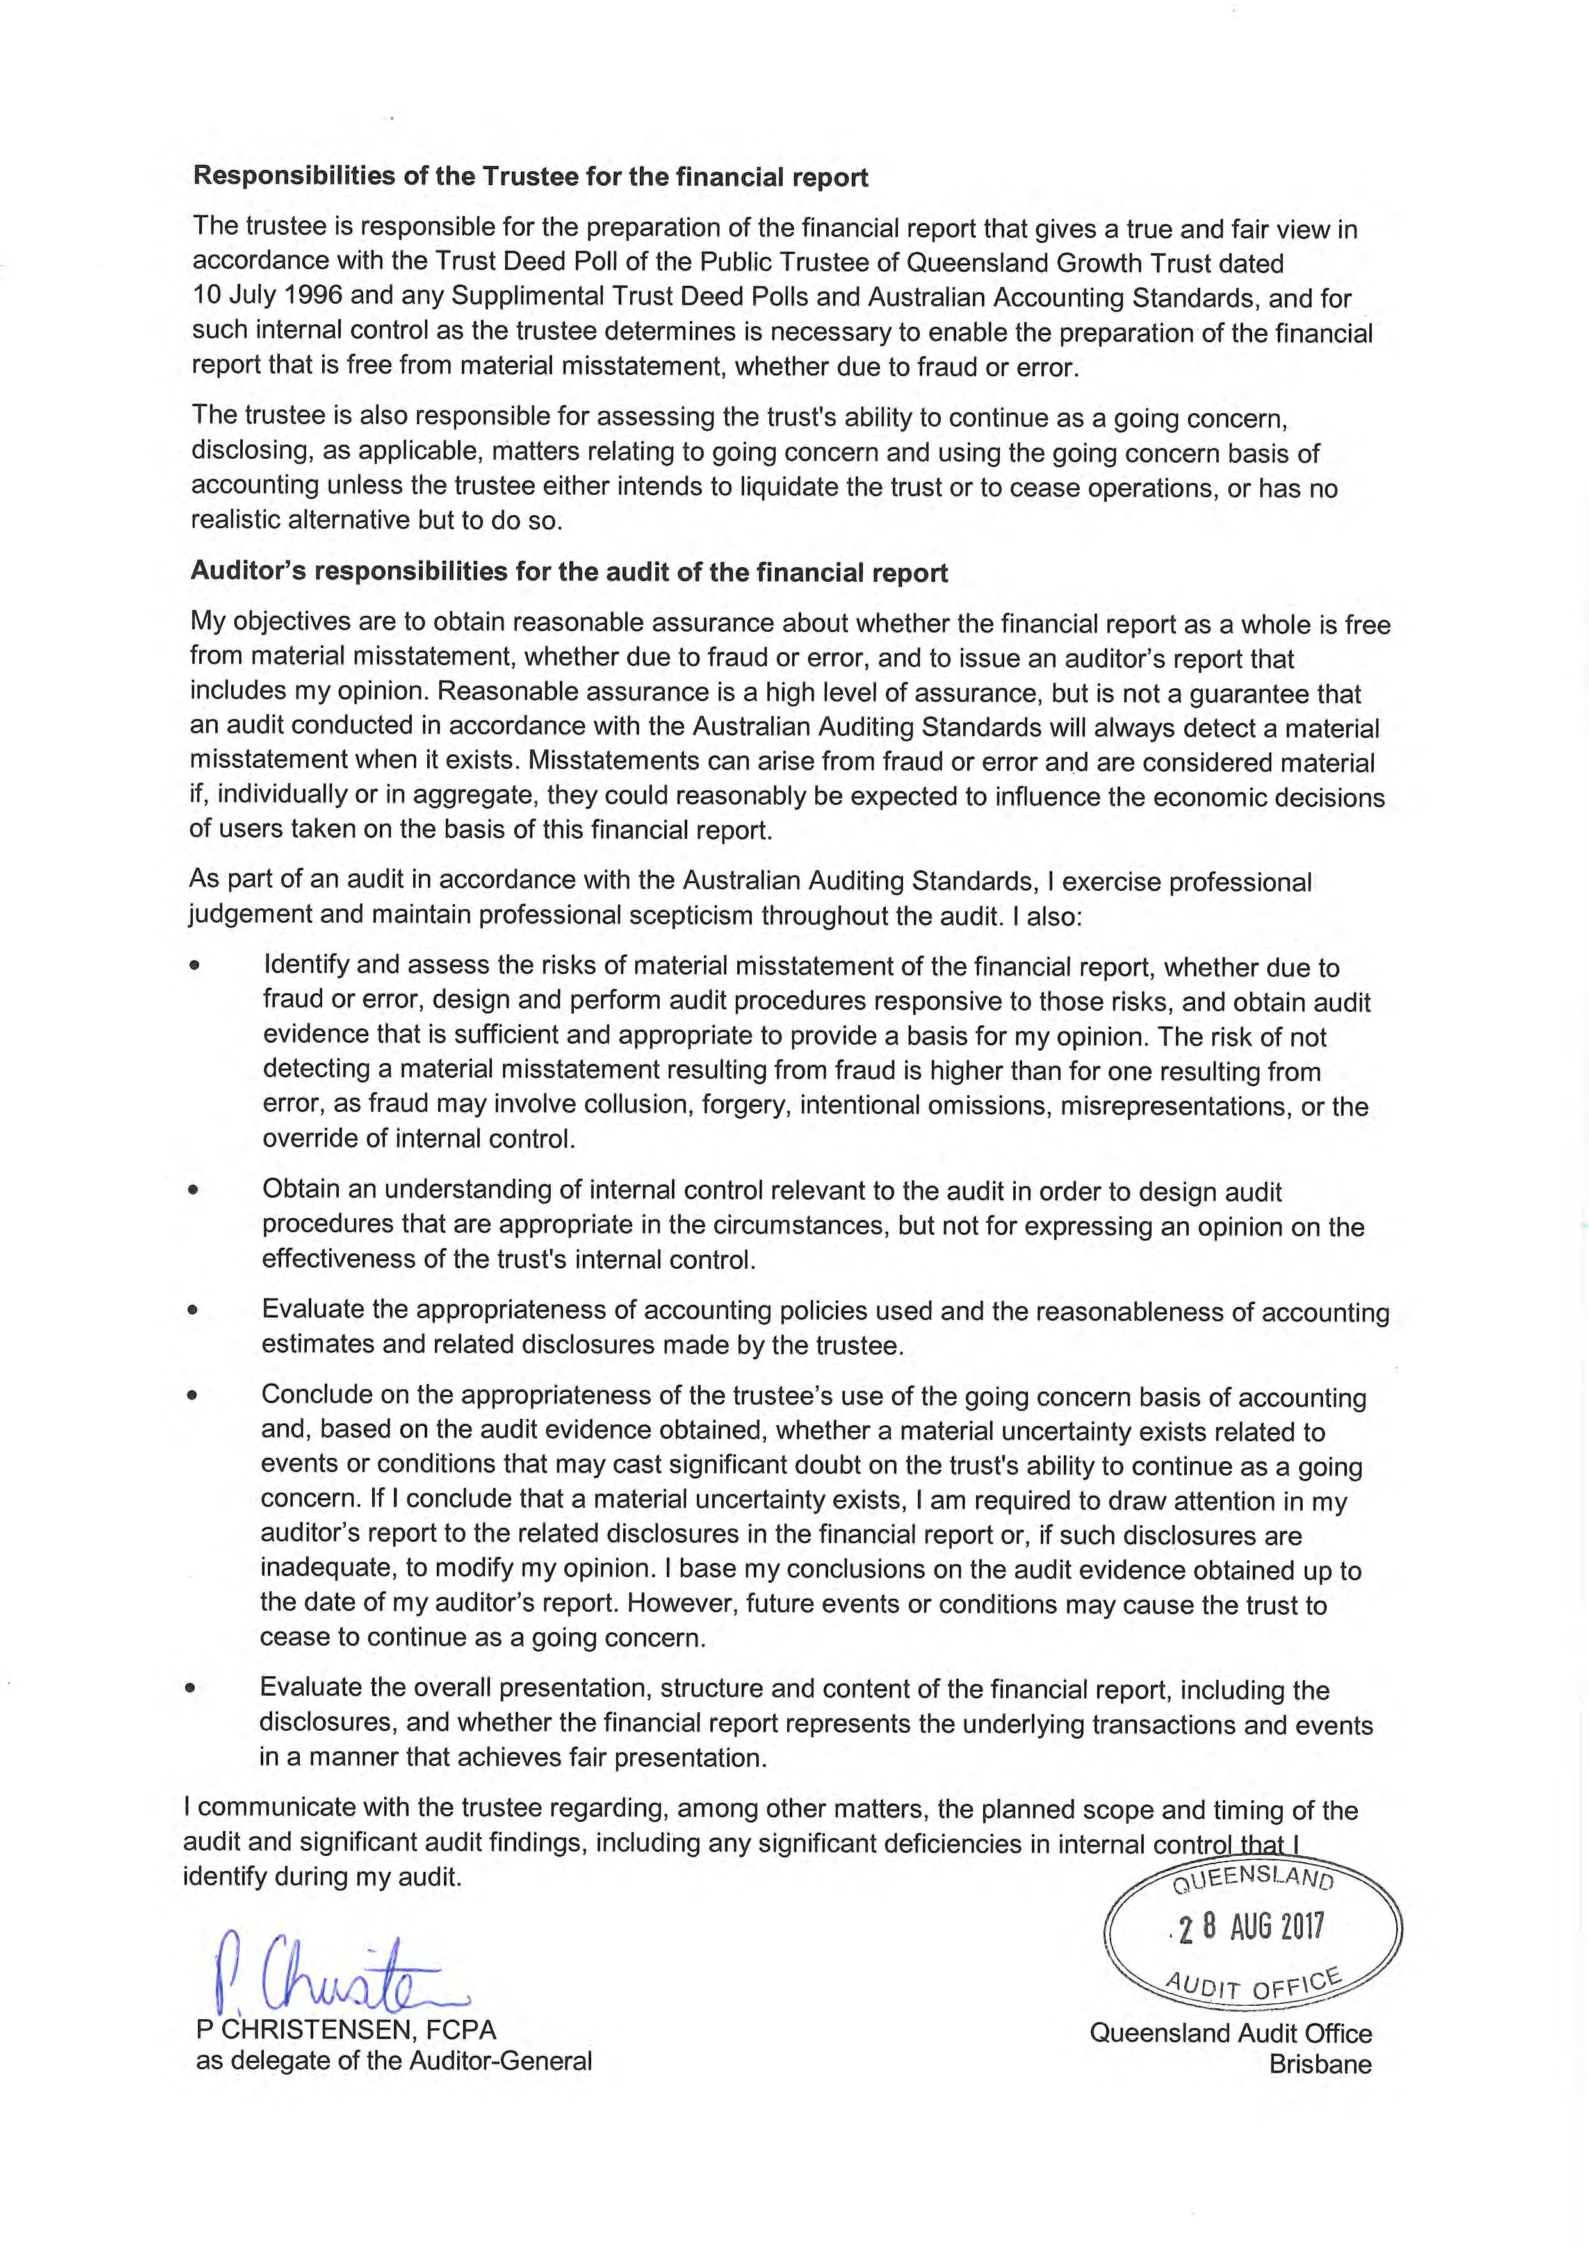

Page 113

Open data

The Open Data initiative is part of the Queensland public sector renewal program.

A number of reporting requirements are to be addressed through publication of information through Queensland Government Open Data website (http://www.data.qld.gov.au) in lieu of inclusion in this annual report.

We must report the following information requirements online:
  - Consultancies
  - Overseas travel
  - Queensland Language Service Policy.

The information is also available on our website, referred to as “Additional Published Information”, at https://www.pt.qld.gov.au/about/publications/annual-reports/

Compliance Checklist

Page 115 The Public Trustee of Queensland Annual Report 2016-17

Summary of requirement |  | Basis for requirement | Annual  report reference
Letter of compliance | - A letter of compliance from the accountable officer or statutory body to the relevant Minister/s | ARRs – section 7 | p. iv
Accessibility | - Table of contents  - Glossary | ARRs – section 9.1 | Contents –  p. iii Glossary –  p. 42
 | - Public availability | ARRs – section 9.2 | p. ii
 | - Interpreter service statement | Queensland Government Language Services Policy  ARRs – section 9.3 | p. ii
 | - Copyright notice | Copyright Act 1968  ARRs – section 9.4 | p. ii
 | - Information Licensing | QGEA – Information Licensing  ARRs – section 9.5 | p. ii
General information | - Introductory Information | ARRs – section 10.1 | p. 1
 | - Agency role and main functions | ARRs – section 10.2 | p. 2-5
 | - Operating environment | ARRs – section 10.3 | p. 6-9
Non-financial performance | - Government’s objectives for the community | ARRs – section 11.1 | pp. 10-11
 | - Other whole-of-government plans / specific initiatives | ARRs – section 11.2 | N/A
 | - Agency objectives and performance indicators | ARRs – section 11.3 | Agency Objectives -  p. 10  Performance Indicators – pp. 7-8
 | - Agency service areas and service standards | ARRs – section 11.4 | pp. 12-13
Financial performance | - Summary of financial performance | ARRs – section 12.1 | pp. 16-19
Governance – management and structure | - Organisational structure | ARRs – section 13.1 | p. 20
 | - Executive management | ARRs – section 13.2 | pp. 20-26
 | - Government bodies (statutory bodies and other entities) | ARRs – section 13.3 | pp. 27-28
 | - Public Sector Ethics Act 1994 | Public Sector Ethics Act 1994  ARRs – section 13.4 | p. 30
 | - Queensland public service values | ARRs – section 13.5 | pp. 31-32

Governance – risk management and accountability | - Risk management | ARRs – section 14.1 | p. 33
 | - Audit committee | ARRs – section 14.2 | pp. 28-29
 | - Internal audit | ARRs – section 14.3 | pp. 34-35
 | - External scrutiny | ARRs – section 14.4 | p. 34
 | - Information systems and recordkeeping | ARRs – section 14.5 | p. 35
Governance – human resources | - Workforce planning and performance | ARRs – section 15.1 | pp. 36-37
 | - Early retirement, redundancy and retrenchment | Directive No.11/12 Early Retirement, Redundancy and Retrenchment  Directive No.16/16 Early Retirement, Redundancy and Retrenchment (from 20 May 2016)  ARRs – section 15.2 | p. 37
Open Data | - Statement advising publication of information | ARRs – section 16 | p. 114
 | - Consultancies | ARRs – section 33.1 | Published to Open Data portal
 | - Overseas travel | ARRs – section 33.2 | Published to Open Data portal
 | - Queensland Language Services Policy | ARRs – section 33.3 | Published to Open Data portal
Financial statements | - Certification of financial statements | FAA – section 62  FPMS – sections 42, 43 and 50 ARRs – section 17.1 | p. 88
 | - Independent Auditors Report | FAA – section 62  FPMS – section 50 ARRs – section 17.2 | pp. 88 and  112-113

FAA Financial Accountability Act 2009
FPMS Financial and Performance Management Standard 2009
ARRs Annual report requirements for Queensland Government agencies

Page 117 The Public Trustee of Queensland Annual Report 2016-17

