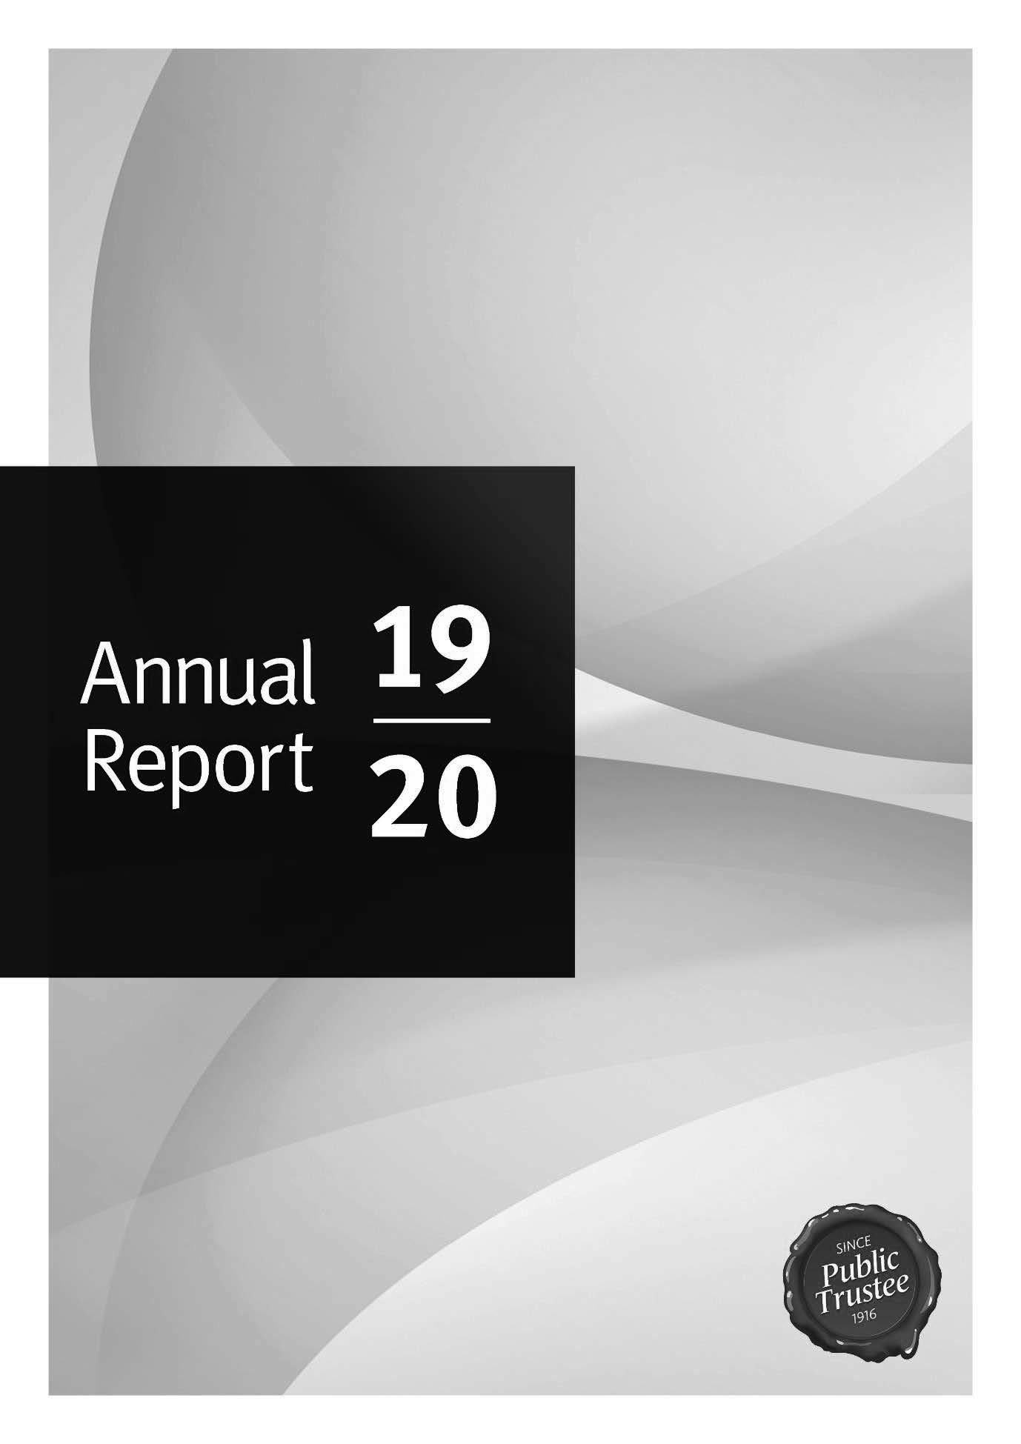

The Public Trustee is committed to providing accessible services to Queenslanders from all culturally and linguistically diverse backgrounds. If you have difficulty in understanding this annual report, you can contact us on 1300 360 044 and we will arrange an interpreter to effectively communicate the report to you.

An electronic copy of The Public Trustee of Queensland Annual Report 2019–20 is available online at www.pt.qld.gov.au. You can also contact us to request a copy by calling 1300 360 044 or emailing governance@pt.qld.gov.au

A number of annual reporting requirements are also addressed through publication of information on the Queensland Open Data website at https://www.data.qld.gov.au/.

ISSN 2205 – 7919

Copyright

© The Public Trustee of Queensland, September 2020. Published by The Public Trustee of Queensland, 444 Queen Street, Brisbane QLD 4000, Australia.

Licence

This work is licensed under the Creative Commons CC BY 4.0 Australia Licence. In essence, you are free to copy, communicate and adapt this annual report, as long as

you attribute the work to The Public Trustee of Queensland.

To view a copy of this licence, visit https://creativecommons.org/licenses/by/4.0/.

Content from this annual report should be attributed as: The Public Trustee of Queensland annual report 2019–20.

Our acknowledgment

We acknowledge the Australian Aboriginal peoples and Torres Strait Islander peoples of this nation, the traditional custodians of these lands. We pay our respects to their ancestors, our First Nations peoples, their spirits and their legacy which give strength, inspiration and courage to current and future generations, both Indigenous and non-Indigenous, towards creating a better Queensland.

Contents
Communication objective ii
Contents iii
Letter of Compliance 1
Message from CEO 2
Who we are and what we do 4
Achievements for 2019-20 5
Customers First 7
COVID-19 Impact 9
Human Rights 11
Non-financial performance 14
Queensland Government objectives for the community 14
Community Service Obligations (CSOs) 14
Summary of our performance 15
Philanthropy 16
Strategic Plan 2020-2024 18
Our priorities 20
Our strategic challenges and opportunities 21
Management and structure 22
Senior internal management committees 22
Public Sector Ethics 26
Public Sector Values 27
Governance – risk management and accountability 29
Risk management 29
Internal audit 30
Audit and Risk Management Committee 30
Information systems and recordkeeping 32
External scrutiny 32
Governance – human resources 33
Workforce planning and performance 33
Early retirement, redundancy and retrenchment 34
Financial performance 35
Public Trustee of Queensland Investment Fund – Growth Trust 38
The Public Trustee of Queensland Financial Statements 39
Public Trustee of Queensland Growth Trust Financial Statements 88
Our offices 110
Outreach locations 111
Our legislation 113
Glossary 114
Acronyms 116
Compliance Checklist 117

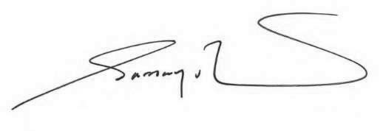

28 August 2020

The Honourable Yvette D’Ath MP Attorney-General and Minister for Justice Leader of the House
GPO Box 149
Brisbane Qld 4000 Dear Attorney-General
I am pleased to submit for presentation to the Parliament the Annual Report 2019-20 and financial statements for the Public Trustee.

I certify that this Annual Report complies with:

- the prescribed requirements of the Financial Accountability Act 2009 and the
Financial and Performance Management Standard 2019, and

- the detailed requirements set out in the Annual report requirements for Queensland Government agencies.

A checklist outlining the annual reporting requirements is provided at page 117 of this annual report.

Yours sincerely

Samay Zhouand

Acting Public Trustee of Queensland and CEO

I am pleased to present the Public Trustee Annual Report 2019-20, which provides information about our financial and corporate performance for 2019-20. The Annual Report has been prepared in accordance with the Financial Accountability Act 2009. This report outlines the significant achievements of the Public Trustee’s dedicated staff over the past twelve months in continuing to enable the delivery of professional, reliable and accessible financial, deceased estate and trust administration services to the people of Queensland.

During the second half of this year, the global impact of the coronavirus pandemic challenged the Public Trustee like many other organisations. Our executive leadership team, supported by staff across the organisation, quickly implemented business continuity arrangements to ensure the ongoing delivery of critical services and support functions. The safety and wellbeing of staff and customers remained our most important priority.

I was impressed with the commitment of all our staff to quickly develop solutions and find new ways of working. Their efforts also provided the driver to accelerate the delivery of a number of planned service and business improvements, including enhanced capability for remote working, new ways for Queenslanders to make a Will by telephone and video- conferencing, and digitisation of records. All regional offices remained open with frontline services transitioning to delivery by email and telephone where possible. We also introduced a toll free telephone number ensuring our customers, including vulnerable Queenslanders, could contact us for essential services.

Despite these challenges, we have continued to provide services that our customers value, achieving positive results in customer satisfaction measures across our primary services - making Wills and Enduring Power of Attorney documents and the delivery of financial, deceased estate and trust administration.

The commencement of the Human Rights Act 2019 (the Act) was a significant milestone this year. This important legislation protects 23 human rights and requires all Queensland public sector entities act in a way that is compatible with, and considers these human rights in all decisions and actions. To prepare for the commencement of the Act, we established a project board and working group to oversee the completion of a number of initiatives to build a culture of valuing human rights as paramount, and placing the human rights of individuals, especially the most vulnerable, at the forefront of service delivery. We continue to focus on embedding human rights into the organisation.

To continue to advance as a modern, learning organisation committed to human rights, we have introduced a Customers First agenda. The Customers First agenda promotes a long- term, strategic focus on meeting our customers’ changing needs. Customers First will continue to underpin our progress towards a future-focused, customer-centric, professional organisation through initiatives that build on community trust, provide greater transparency and ensure the voice of our customers guides our future decision-making.

Our Strategic Plan 2020-2024 cements the Customers First agenda and outlines the strategic objectives to achieve our new purpose: ‘To enhance and protect our customers’

rights, dignity and interests.’ A key strategic objective is to ensure continued financial responsibility and sustainability.

We have already made significant progress in advancing the Customers First agenda including:

- Our Social Responsibility Charter – the Public Trustee has a lead role in representing and assisting the community we serve. Our Social Responsibility Charter includes six guiding principles that outline our responsibilities and defines how we will act and make decisions to achieve our vision to provide security and peace of mind for Queenslanders and be accountable to our customers, our stakeholders and the community

- Reviewing our organisational structure to ensure clarity of roles in customer focused service delivery and corporate support. We have increased support to our regions by appointing dedicated Regional Directors. These roles will ensure our Customers First vision is advanced across all regions for the benefits of our customers, staff and the community
- Establishing reference groups to engage with customer advocacy and government stakeholders – providing a voice for our customers through their support networks and advocacy groups and ensuring we collaborate with other government agencies to implement best practice governance and accountability frameworks.

The past year has been one of significant change at the Public Trustee and I am proud of our achievements. I look forward to the year ahead as we continue to advance as a modern, learning organisation that is committed to human rights and continuous improvement.

Samay Zhouand

Acting Public Trustee of Queensland and Chief Executive Officer (CEO)

Who we are and what we do

The Public Trustee has been serving Queenslanders since 1916 and is governed by the Public Trustee Act 1978.

The Public Trustee is self-funding and operates as a corporation sole, delivering professional and accessible financial, trustee and legal services to the people of Queensland.

Our vision is to provide security and peace of mind for Queenslanders.

Our purpose is to enhance and protect the rights, dignity and interests of Queenslanders – our customers.

We provide professional and accessible:

- estate administration services: we provide executorial services when acting as executor or administrator of a deceased estate
- financial management for those with impaired capacity for decision-making: we assist customers with their financial needs, including budgeting and financial planning
- legal services: the Official Solicitor delivers legal services to the Public Trustee and its customers, and to the Queensland Government
- trusts administration: we provide trustee services for a range of trusts including testamentary trusts and family trusts
- tax and investment services: we provide advice, investment solutions and provision of taxation and trustee services to the Public Trustee and its customers to ensure the prudential management of funds
- life-planning services including making Wills and EPAs
- safe and secure storage of Wills and other life-planning documents
- real estate services: we are a fully licenced real estate agency with licenced professional staff, including auctioneers and an extensive buyer and selling network throughout Queensland. We also facilitate the sale of our customers’ motorised vehicles, goods and chattels
- trusteeship of charitable trusts including the promotion and facilitation of strategic financial welfare to identified and targeted philanthropic beneficiaries.

We also:

- administer unclaimed moneys for the State of Queensland: we hold unclaimed money for Queenslanders who have lost touch with the organisation that owes them the money
- manage the estates of prisoners under Part 7 of the Public Trustee Act 1978
- carry out special functions of a public nature under Part 5 of the Public Trustee Act 1978
- promote and support community education on a range of issues such as elder abuse, the importance of making a Will and appointing an Enduring Power of Attorney.

Our locations

Our services are delivered through a network of regional offices including our head office at 444 Queen Street, Brisbane. We also provide services outside of our offices through the Queensland Government Agent Program and the local court networks. For further information on the location of our offices or outreach locations please refer to pages 110–112 of the report. Alternatively, you may also visit our website at https://www.pt.qld.gov.au/.

Achievements for 2019–20

The Strategic Plan 2016–20 set out the parameters for our strategic direction for our staff, customers and stakeholders. It also outlined how we will contribute to the achievement of the Queensland Government’s objectives for the community, our priorities and our strategies.

2019–20 Service delivery highlights:

- 24,462 Wills made at no cost to Queenslanders
- 10,071 financial management customers1
- 2,551 EPA documents made
- 4,394 trusts administered
- 2,069 new deceased estates accepted for administration
- Over 126,000 calls answered by the Welcome Desk
- 95% overall client satisfaction (Will preparation service)
- $2.75B Total assets under management
- $38.4M in Community Service Obligations, including $29.2M in fees rebated for customers with limited assets
- Over 1.13M Wills stored in our Wills bunker.

The following initiatives demonstrate our achievements against the objectives in the Strategic Plan 2016–20:

Driving value for customers
- delivered greater customer choice on how to make a Will including by telephone, face-to-face and where available, video conferencing
- improved Public Trustee website including accessibility, usability and content
- developed a Customer Experience Strategy 2020–2025 to inform our future state service design and delivery so we can continue to provide a unique customer experience
- updated customer personas and journey maps as part of our ongoing customer co-design research. These will support a customer centric approach for future state service delivery, and a better customer experience
- implemented customer service standards for staff with guidelines on how to interact with our customers at every contact point so we can continue to provide exceptional customer service
- made improvements to our website to make it easier for members of the community to search for, find and claim their unclaimed money
- launched an online fee estimator on the Public Trustee website so customers can easily and quickly obtain an estimate of the Public Trustee’s fees to administer a deceased estate.

Sustainable reinvestment to support business objectives
- rolled out secure file transfer software so we can safely, quickly and easily share information with our customers who prefer paperless correspondence
- upgraded our existing Tax Management System allowing faster tax returns and information provision for our customers
- Primary service improvements – we have a number of continuous improvement initiatives in progress that are designed to reduce staff workload, deliver process efficiencies, and identify better ways to communicate and provide information for customers. These initiatives include

1 Comprised of 9,316 adults with impaired decision-making capacity, acting as financial attorney for 253 customers and managing 502 prisoners’ estates.

streamlining file sharing between regional offices and business units for faster service delivery; enabling more use of email and SMS channels for customer communications; adopting more electronic process management; and using online channels to communicate with service providers
- developed external referral partnerships with the Registry of Births, Deaths and Marriages and Smart Service Queensland to increase community awareness of our free Will-making service. By leveraging additional digital channels, we are able to provide an end-to-end customer experience at no additional cost to the organisation.

Deliver services that are valued
- embedded the Human Rights Act 2019 as part of our day-to-day work and as a consideration in all interactions between our staff and with our customers, other stakeholders and the community
- supported enhanced awareness in the community about the importance of having an up to date and valid Will through speaking at community forums and at Wills Week activities delivered across our regional offices
- developed online training for staff in anticipation of the commencement of the Guardianship and Administration and Other Legislation Amendment Act 2019 including the development of a structured decision-making tool
- established a National Redress Policy Framework to support customers who may have a claim under the National Redress Scheme
- established a Procurement Management Framework enabling standardised procurement procedures, and strengthening our procurement governance and engagement activities.

Embrace business transformation
- improved the transparency of our fees and charges by making available fee calculators and case studies on our website and by providing information that meets accessibility guidelines
- launched ‘Dexter’, the Public Trustee’s first Robotic Process Automation (bot). ‘Dexter’ will assist with the allocation of the more than 60,000 emails received each month in our main client email address from our customers, members of their support networks or organisations that provide services to our customers. This allows us to respond faster to our customers, and streamline the way we work
- commenced benchmarking for a fees and charges review.

Engaged, empowered and agile workforce
- launched the Employee Wellbeing Program to raise awareness and provide a holistic approach to supporting well-being which includes physical, social, emotional and financial well-being
- launched a new Learning Management System to improve the employee experience in accessing online courses, and to store all learning and professional development records
- launched new strategies to communicate important, new and emerging issues to staff
- enhanced flexible working arrangements to further staff engagement
- facilitated engagement events for staff such as World Elder Abuse Awareness Day to raise awareness of issues facing our customers and enhance staff capability to support them.

With the introduction of the Human Rights Act 2019 and the impending legislative amendments arising from the Guardianship and Administration and Other Legislation Amendment Act 2019, the Public Trustee is delivering on its commitment to put people at the centre of all we do through the implementation of the Customers First agenda.

Our mission is to become a more modern, professional and customer focused organisation that provides responsible, ethical and transparent financial, estate and trust administration services for Queenslanders. We will enhance our commitment to provide excellence in customer service by delivering a range of Customers First initiatives which aim to build on community trust, provide greater transparency and ensure the voice of our customers guides future decision-making.

Functional and governance review

The Public Trustee has undertaken a high level functional and governance review to ensure we have the most appropriate organisational structure in place to achieve optimal oversight, leadership and delivery of strategic and operational projects and priorities ensuring we deliver on our social and financial responsibilities to the people of Queensland.

The new structure, implemented in March 2020, will support streamlined customer focused service- delivery with the separation of customer and corporate service delivery functions. Ths includes establishing the Official Solicitor – Corporate Legal Services, and Official Solicitor – Customer Legal Services to minimise the potential for conflicts of interest, while ensuring a focus on the delivery of customer-centric legal services.

The new structure also includes the reorganisation of the regional service delivery network into four regional groups – Northern, Central, South East (South) and South East (East). Each region will be led by the newly established role of Regional Director who will focus on regional-specific needs, support regional managers to deliver enhanced service delivery, identify opportunities for further service improvements and help deliver customer-centric change.

Also as part of the governance and structure transformation, the Public Trustee established an Ethics and Integrity Unit. The purpose of the Unit is to build on the strong moral and ethical principles and values of our organisational culture and promote alignment with public sector ethics standards. The Unit focuses on further integrating these principles and values into our decision-making, leadership, practices and behaviours via new processes, frameworks, training and awareness campaigns.

Customers First initiatives

Another important outcome of the Customers First agenda has been the establishment of four internal working groups, formed with representatives from across relevant business areas, to enhance staff performance, customer and people engagement, enable cross-functional decision-making and accountability and collaborate on the delivery of key initiatives. Each working group will focus on one of the following areas:

  - Trust and Transparency – to increase trust and transparency within the Public Trustee and between the Public Trustee, its customers, stakeholders and the Queensland community
  - Products & Services – to improve customer satisfaction while meeting accessibility and inclusion standards
  - People and Culture – to build an empowered, engaged and capable workforce
  - Financial Services – to ensure a sustainable financial operating model.

There has been a range of initiatives spearheaded by these working groups including:

- Two external advisory groups have been established to ensure an outside in, voice of the customer, and good governance. These will inform the Public Trustee’s decision-making and enable quality policy and service improvements. The Customer Reference Group and the Government Reference Group will work together with the Public Trustee to share industry information, provide guidance, analyse impacts, issues and trends and deliver insights that will influence the delivery of Customers First initiatives and support best practice governance and accountability

- Our Social Responsibility Charter is our guide to supporting our customers and details how we will deliver on this commitment. It includes six guiding principles that outline our responsibilities and defines how we will act and make decisions to achieve our vision and be accountable to our customers, our stakeholders and the community. The Charter was developed in consultation with staff and stakeholders represented on the Government and Customer Reference Groups

- The Financial Independence Program will help identify customers who may be suitable to transition to managing their own finances. The program will help our customers to learn and practice the skills needed to manage their own finances by teaching them how to create and manage their budget as well as pay their bills

- The QCAT Referral Panel (Panel) was launched in May 2020 as a pilot to provide an additional internal decision point for more complex or difficult customer matters. The Panel considers alternative options for each case, with the aim of expediting decisions and therefore saving on potential costs for customers

- To be more open and transparent about our fees and charges we profiled some Financial Management case studies on our website to assist customers to more clearly understand our costs for service

- The Public Trustee strongly believes in the importance of engaging with our stakeholders to gain a better understanding of their perspectives while taking the opportunity to build on relationships with organisations and individuals. One-on-one meetings have been held with a range of stakeholders to discuss some of our Customers First initiatives and business improvements through the COVID-19 period. This included filmed ‘coffee catch-ups’ with representatives from organisations who are members of the Customer Reference Group with videos available to staff. A monthly stakeholder newsletter was also distributed to external stakeholders

- A dedicated senior officer from the Executive Leadership Team (ELT) has been nominated to work with each of our Charitable Trusts to provide advice and support on strategic issues or challenges.

COVID-19 Impact
Like many organisations in Queensland, the Public Trustee has been impacted by the global COVID- 19 pandemic.

Since 31 January 2020, when a Declaration of a Public Health Emergency was made in Queensland, the Public Trustee has prioritised the health, safety and well-being of our staff and customers while continuing to maintain the delivery of services to the Queensland community.

The ELT met regularly to monitor the evolving COVID-19 situation. Members of the ELT have participated in inter-departmental Working Groups to ensure that the Public Trustee received relevant and up-to-date advice and our response was aligned with whole-of-government planning.

The ELT developed a COVID-19 Response Plan as a supplement to the Public Trustee’s existing Business Continuity Plan which required:

- a review of membership of the Business Continuity Team
- identification of critical services and roles, and what resources are required to support them, from the perspective of a global health pandemic
- scenario planning particularly where there is reduced staff availability.

Actions to mitigate potential business continuity risks resulted in programs across the Public Trustee implementing innovative solutions or bringing forward implementation of planned initiatives. These innovations included an increase in working from home capability, the deployment of a softphone application to support flexible working arrangements on an ongoing basis, increased digitisation such as through the transition from paper-based to digital records, and a range of initial transitions from manual, paper-based processes to electronic processes.

The Public Trustee temporarily suspended its Customers First agenda while it conducted its business continuity planning and implemented processes and procedures to maintain service delivery. Once those steps were complete, the Customers First initiatives were re-commenced.

Our Information and Technology team also focused on increased staff awareness of information security including alerting staff to coronavirus themed phishing emails, provided advice on information management and management of physical files, and provided guidance on the acceptable use of video conferencing and collaboration tools.

Details of the financial impact of COVID-19 on the Public Trustee’s financial results can be found in the Financial performance section from page 35.

Customers

All Public Trustee offices remained open, with social distancing measures in place and signage displaying important health information about COVID-19, including reminders about good hygiene. This ensured continued accessibility to services for vulnerable Queenslanders.

From 30 March 2020, the Public Trustee temporarily transitioned in-person Will appointments to telephone and by video-conferencing at the Beaudesert service centre. Will customers have the option of either privately arranging to have their Will executed and witnessed, or attending a Public Trustee office to execute their Will. The Public Trustee received a positive response from the Queensland community to maintaining this important service in uncertain times.

The opening hours for all Public Trustee regional offices were temporarily changed to 9am to 4pm from 14 April 2020. The change in the opening hours provided:

- frontline managers with more time to manage staffing and workload impacts as a result of COVID-19 before daily customer contact began

- an enhanced customer experience by providing staff with time to complete administration, including payments, outside of customer hours, which allows them to focus on customer requests as they are received.

The Public Trustee temporarily ceased all property auctions from 25 March 2020 in line with the directions of the National Cabinet. The Public Trustee re-commenced auctions from 27 July 2020. Open houses are held in accordance with COVID-19 safety requirements including promoting physical distancing, limiting the number of people in enclosed spaces, registering all attendees and providing sanitisation stations.

There have been frequent communications to customers and their support networks and other stakeholders regarding the Public Trustee’s response to COVID-19 through signage at offices, updates on the Public Trustee’s website and stakeholder emails.

Staff

Public Trustee staff and managers have also been regularly updated. A dedicated COVID-19 page was developed for Public Trustee staff to supplement regular email communications and to provide easily accessible COVID-19 related resources.

Managers meetings are being held more frequently to ensure managers have access to the latest COVID-19 information and a forum to discuss any issues arising including the Public Trustee’s business continuity response, changes to procedures and processes across programs, working from home arrangements and how to support their staff.

The Public Trustee has developed and implemented COVID Safe Workplace Plans across the agency. Health and safety processes have also been enhanced in response to a range of possible COVID-19 related scenarios. A range of materials have also been developed to assist managers to better support their staff.

Technology (including infrastructure, application licences and network bandwidth) was acquired and implemented to uplift the capacity for staff to work remotely. Staff and managers continue to be supported to adopt a variety of flexible work practices and flexible work arrangements.

Whole-of-Government response

In line with Government policy, the Public Trustee worked with tenants to provide rent relief for businesses renting our premises with a customised approach for each tenant to assess their individual rent relief requirements.

Following consultation with the Department of the Premier and Cabinet, the decision was made to defer a request to lower interest rates paid to customers from 1 May 2020. The deferral was made in an effort to support vulnerable Queenslanders during this time of unprecedented global uncertainty, while economic activity and employment are under significant pressure from the COVID-19 global pandemic.

Public Trustee staff participated in the Employee Mobilisation Service for up to eight weeks.

From March 2020, the Public Trustee has also been reporting daily on the impact on staff from COVID-19 to the Public Service Commission. These statistics include information on a range of impacts including the number of staff working from home and the number of staff self-isolating on medical advice.

Future outlook

As the COVID-19 pandemic continues to evolve, the Public Trustee remains committed to delivering its essential services in line with the needs of its customers and based on the advice of the Queensland Government while ensuring that the health, well-being and safety of staff and customers remains a priority.

Human Rights

The Public Trustee has been embedding human rights understanding across our organisation before and since the commencement of the Human Rights Act 2019 (Human Rights Act) on 1 January 2020.

We are committed to:

  - building a culture that respects and promotes human rights

  - protecting and promoting human rights

  - promoting a dialogue about the nature, meaning and scope of human rights

  - placing the human rights of individuals, especially the most vulnerable, at the forefront of our service delivery.

Prior to 1 January 2020, we took a number of steps to prepare for the commencement of the Act including:

  - established an organisation-wide working group to develop and progress an implementation plan to ensure that we are best placed to meet our legislative obligations arising from the Human Rights Act from 1 January 2020

  - all programs reviewed policies, procedures, manuals and related documents to ensure that they were compatible with human rights and promoted actions and decision-making in line with the Human Rights Act

  - we reviewed how we deliver our services to our customers to ensure that we are acting compatibly with their human rights

  - our Complaints team reviewed the Complaints Management Framework to ensure that our process is in line with the new complaints processes and reporting requirements under the Human Rights Act

  - our Human Resources Services team reviewed their policies and procedures to ensure alignment with the Human Rights Act and consulted important stakeholders such as the Agency Consultative Committee and ELT

  - commenced development of our Social Responsibility Charter

  - created a project page so staff could follow the progress of the Working Group and access further information about human rights

  - provided regular communication to staff about the Human Rights Act and encouraged staff to familiarise themselves with the legislative changes and access a range of resources developed within the Public Trustee and from external sources such as the Queensland Human Rights Commission

  - produced a Human Rights Act Introductory Awareness Video for our staff

  - all staff completed a mandatory self-paced online course, delivered in conjunction with the Queensland Human Rights Commission, in December 2019

  - 64 senior and executive staff attended training on the Human Rights Act delivered by Crown Law

- celebrated Human Rights Month by holding a PT-wide morning tea on Human Rights Day, 10 December 2019, which provided an opportunity for staff to learn more about human rights and what it means to them, our customers and the broader Queensland community.

Since the Human Rights Act came into force:

- we have finalised our Social Responsibility Charter

- we have embedded human rights into our Strategic Plan 2020–2024

- all new staff are enrolled in the mandatory self-paced online course on the Human Rights Act

- incorporated awareness of the Human Rights Act and its application into our corporate orientation day which is attended by all new employees

- new and existing staff can access a range of resources and guides on acting and making decisions that are compatible with human rights. This includes case studies illustrating actions and decision-making that are compatible with human rights and which put the customer at the forefront of our service delivery

- the consideration of human rights in all decision-making for frontline employees is being measured as part of the quarterly quality assurance program, which examines the quality of evidencing of decisions, and provides for systems review, training opportunities and trend analysis

- all programs are required to consider human rights and the Human Rights Act when developing, implementing and reviewing their policy documents to ensure that the Public Trustee acts compatibly with human rights when acting or decision-making.

Human rights complaints

The Public Trustee has reviewed its Complaints Management Framework to ensure that:

- human rights complaints are identified at the point of receipt

- the complaints process is compatible with human rights, the principles of natural justice and incorporates the complaints resolution process available under the Human Rights Act.

The Public Trustee has advised its customers of the availability of making a human rights complaint and the complaints process through:

- our website - https://www.pt.qld.gov.au/contact/contact-us/compliments-and-complaints/

- our Complaints Management Policy and leaflet called ‘Your Complaints Journey’ which are also available on the Public Trustee’s website.

During 2019-20, the Public Trustee received five complaints that were assessed as human rights complaints:

- three complaints were identified by the complainant as human rights related

- two complaints were assessed by the Public Trustee as being human rights related.

The complaints were resolved by the Public Trustee providing an explanation to the customers or the customers’ support network about the decision that was made or the action that was taken. In each case, the Public Trustee was of the view that it had acted compatibly with human rights and in line with its obligations under the Human Rights Act.

The Queensland Human Rights Commission has not notified the Public Trustee of any unresolved complaints that it has accepted for review.

COVID-19

As outlined in this report, the global COVID-19 pandemic has impacted the Public Trustee in a number of ways. Throughout this period, the Public Trustee has endeavoured to balance continued service delivery with:

- the health, well-being and safety of our staff and customers

- the different needs of our customers

- ensuring that there are multiple avenues for our customers to contact the Public Trustee including in person, by telephone and by email.

Throughout the COVID-19 period, the Public Trustee’s Complaints Unit has remained available during its standard operating hours to ensure that the Public Trustee can receive and respond to any concerns that our customers and stakeholders may have to any changes in service delivery.

Non–financial performance

Queensland Government objectives for the community

The Public Trustee’s strategic objectives are aligned with the Queensland Government’s objectives for the community.

We contribute to Our Future State: Advancing Queensland’s Priorities to Be a responsive government
by:
  - undertaking a key role in Queensland’s guardianship system
  - advocating for the rights and financial interests of people with impaired decision-making capacity and protecting them from neglect, exploitation and abuse
  - supporting Queenslanders to protect and manage their financial well-being at all stages of life
  - delivering a customer experience that is tailored, relevant and accessible to Queenslanders
  - enhancing customer and community understanding of the Public Trustee.

Community Service Obligations

The total cost of Community Service Obligations delivered for the 2019–20 financial year was $38.4M representing an increase of 3.5 per cent from the previous financial year (which was $37.1M). An amount of $40.3M is budgeted for 2020–21.

Category of Community Service Obligations | 2019–20  Actual  $M | 2020–21  Budget  $M
Fees rebated for clients with limited assets | $29.2 | $30.8
Fees rebated for principal residence and other | $0.8 | $0.8
Management of estates of prisoners | $0.6 | $0.6
Public community education and advice to the courts and tribunals in the areas in which the Public Trustee has expertise | $1.5 | $1.5
Providing a free Will-making service to Queenslanders | $4.8 | $5.1
Cash contribution to the Office of the Public Guardian | $1.2 | $1.2
Civil Law Legal Aid - outlays written-off and administrative support | $0.3 | $0.3
Total | $38.4 | $40.3

Community Service Obligations are reported in our Financial Statements in two areas:
  - deduction from fee revenue ($32.4M 2019–20) where there is rebate of all or part of a fee to customers (Note 1 of the Public Trustee Financial Statements)
  - expenditure ($1.3M 2019–20) as grants and contributions towards other sector operations. (Note 6 of the Public Trustee Financial Statements).

Note that the provision of free-Will making services is not included in revenue in the Financial Statements.

Summary of our performance

Client Experience and Delivery is the frontline interface with our clients and the community, providing:
  - deceased estate administration - the Public Trustee administers deceased estates pursuant to Wills or on intestacy, delivering quality service to beneficiaries

  - financial management - the Public Trustee acts as administrator for financial matters for clients with impaired capacity for decision-making pursuant to the Guardianship and Administration Act 2000 or as a financial attorney pursuant to the Powers of Attorney Act 1998

  - a Will making service - the Public Trustee prepares Wills free of charge for all Queenslanders.

We measure our performance across the Client Experience and Delivery service area using three effectiveness measures and one efficiency measure.

The table below summarises our performance (quantifiable measures and qualitative achievements) against performance indicators in the Public Trustee’s Service Delivery Statement 2019–20 and those in our Strategic Plan 2016–2020. Our objective is to deliver a full range of accessible, responsive and person-centric services that recognise our customers’ human rights.

Client Experience and Delivery | 2019–20  Target/Est | 2019–20  Actual | 2020–21  Target/Est
Service standards  Effectiveness measures  Overall client satisfaction with the deceased estate administration service as measured by client satisfaction index1 | 70% | 72% | 70%
Overall client satisfaction with the financial management service as measured by client satisfaction index1 | 70% | 76% | 70%
Overall client satisfaction with Will preparation services2 | 90% | 95% | 90%
Efficiency measure  Cost per Will3 | $175 | $1954 | $180

Notes:

- The satisfaction index is calculated by an independent market research provider on an annual basis. The index is calculated by summing 50% of the overall satisfaction score and 50% of a score derived from service and process factors, which have been weighted according to importance and combined to provide a single score.
- All clients preparing a Will with the Public Trustee receive a Wills Questionnaire. The Wills Questionnaire contains eight questions relating to the quality and delivery of the Will-making service provided. The overall satisfaction level is calculated as a percentage of positive responses to total number of responses received.
- This service standard is calculated using the total estimated cost of making free Wills divided by the number of Wills drafted and completed in the financial year. The total cost is comprised of direct and indirect costs specifically attributable to the Will-making service including employee expenses, supplies and services, and apportioned overheads.
- The 2019-20 actual cost is higher than target as a result of fewer Wills being completed during the 2019-20 financial year. In response to COVID-19, in-person Will appointments were temporarily suspended however Will customers were still able to have Wills drafted via telephone or video appointments and could choose to make private arrangements or attend a Public Trustee office to have them executed.

The Public Trustee conducts a customer satisfaction survey with beneficiaries of deceased estates at completion of administration, with customers (and their support network) for whom the Public Trustee acts as financial manager and trust administration customers. The overall objective of the research is to gain understanding and insights into our customers’ satisfaction with our services and processes and their overall experience.

The results of this research are highly valued and are used to develop and implement a range of operational improvements including communication and supervision strategies, and enhanced financial management, deceased estate and trust administration processes.

We use the insights and information obtained through this research to inform continuous improvement initiatives that focus on improving the customer and employee experience.

Philanthropy

The Public Trustee is trustee for the following leading philanthropic charitable trusts in Queensland.

Queensland Community Foundation
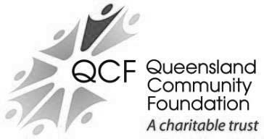

The Queensland Community Foundation (QCF) was established in 1997 to provide a permanent source of philanthropic funding for charitable organisations to enable them to respond to the needs of the Queensland community.

The QCF has net assets of $94M under management. During the year, QCF paid $3.0M in distributions to a broad range of charities.

For further information, visit www.qcf.org.au.

QCF Sub Fund: Gulf Area Community Social Development Established under the umbrella of the QCF in 2000, this sub fund has net assets close to $6.3M.

The sub fund supports the Gulf Area Community by providing grants to projects and initiatives that encourage cultural, educational, health and social development.

Queensland Aboriginal and Torres Strait Islander Foundation
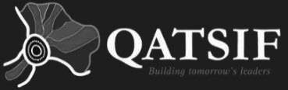

The Queensland Aboriginal and Torres Strait Islander Foundation was established in 2008 and provides a secure, independent and perpetual funding source to advance the education of Aboriginal and Torres Strait Islander children and young people in Queensland through provision and promotion of scholarships.

The trust has net assets of $41.6M.

Senior education scholarships of more than $1.9M for young Queensland Aboriginal and Torres Strait Islander students were approved in 2019–20. In total, 10,424 students have been approved for scholarships since the foundation was established in 2008.

For further information, visit www.qatsif.org.au.

Lady Bowen Trust

Established in 2006, the Lady Bowen Trust aims to re-engage people experiencing chronic homelessness so they achieve genuine, positive and lasting outcomes. The trust supports Mission Australia which maintains Roma House, a facility to enhance clients’ life skills, confidence and resilience while assisting them to find secure accommodation.

The trust has net assets of $5.1M with distributions paid totalling $0.2M in 2019–20.

For further information, visit www.ladybowentrust.org.au.

The Forde Foundation
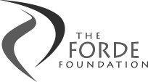

The Forde Foundation was established in August 2000 in response to the findings of the Commission of Inquiry into Abuse of Children in Queensland Institutions, better known as the Forde Inquiry. The foundation is designed to support former residents of Queensland institutions. Financial support is provided to individuals for specific purposes such as dental care, education, training and personal development opportunities.

The foundation has net assets of approximately $3.9M with distributions paid totalling to $0.1M in 2019–20.

For further information, visit www.fordefoundation.org.au.

Gladstone Foundation

Established in early 2011, the Gladstone Foundation allows for industry funds to be channelled into this perpetual trust to provide social infrastructure and service needs in the Gladstone Region.

Specific purposes of the trust are relieving poverty, assisting the aged, relieving sickness or distress, advancing religion and education, providing child care services on a non-profit basis and other purposes which benefit the Gladstone Region.

Initial capital received by the trust was $13.5M. The foundation has net assets close to $6.1M as at 30 June 2020, with distributions paid totalling $0.7M in 2019–20.

For further information, visit www.gladstonefoundation.org.au.

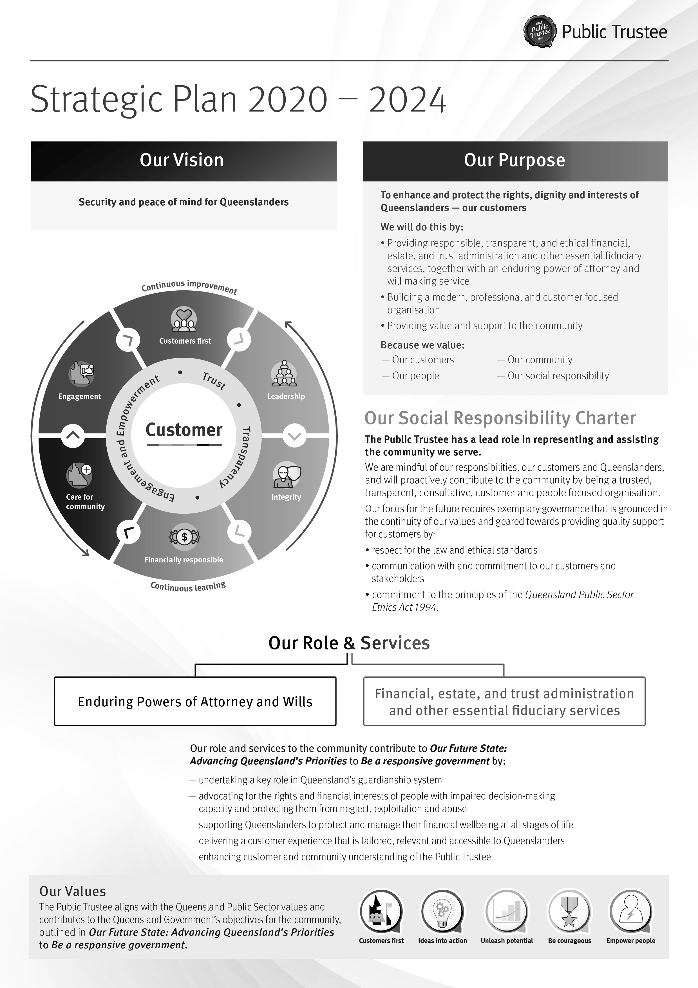
Strategic Plan 2020–2024

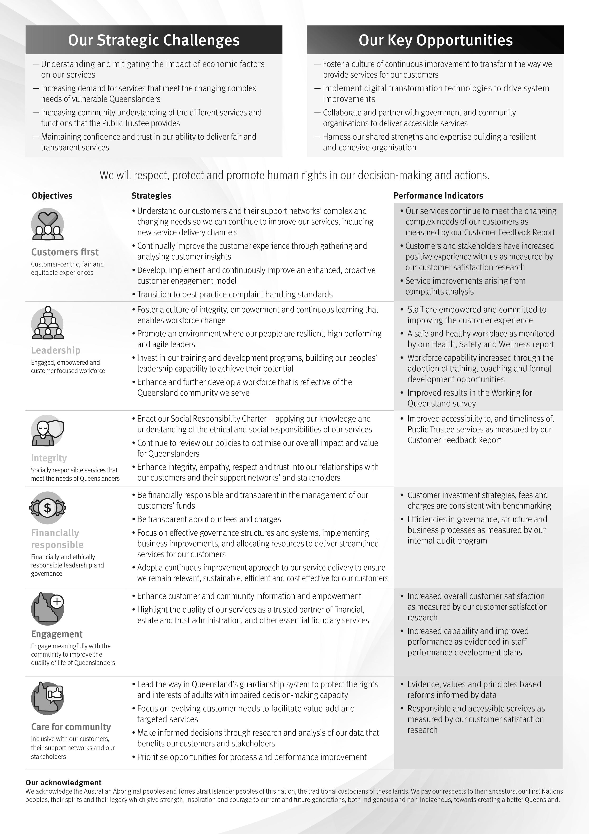

We have developed and released our new Strategic Plan 2020–2024 which will help drive the Public Trustee towards a more modern, professional and customer focused organisation. It will serve as our blueprint to help us achieve our revised vision to 'provide security and peace of mind for

Queenslanders'; and clearly articulates our purpose to 'enhance and protect the rights, dignity and interests of Queenslanders – our customers'.

Importantly, the 2020–2024 Plan is built around the principles within our Social Responsibility Charter. This has been a deliberate approach, as the Charter represents our core promise to our customers, staff and the community.

Our priorities

Our key priority for 2020–21 will be to continue our Customers First initiatives to deliver organisational capability, process and technology changes aligned with our strategic objectives, including ensuring continued financial responsibility and sustainability, and to support future business needs. These initiatives build on community trust, provide greater transparency and ensure the voice of our customers is heard to guide our future decision-making. We will engage collaboratively with our stakeholders by building goodwill, sharing knowledge and expertise, and fostering partnerships for the benefit of our customers and the community.

Other priorities for 2020–21 include:

  - Establish a Customer Advocate Office: this initiative is a national first for the Australian Public Trustee sector and an important step to build on our commitment to continuously improve our services and enhance customer and community trust. The Customer Advocate will assist the Public Trustee in developing customer focused policies and procedures and ensure that customers’ views are heard and drive future improvements. This is a unique and important initiative to support customers and their networks, making it easier to discuss issues and facilitate complaints

  - National Redress Scheme Unit: building upon the National Redress Scheme Framework, this specialist Unit will establish key networks with stakeholders, agencies and other statutory authorities to best provide trauma informed support to our customers who may be survivors of institutional child sexual abuse and who may have a claim under the Scheme

  - Implement the Structured Decision-Making Framework: the framework, supported by the delivery of the Structured Decision-Making training program, will assist frontline staff in making better decisions through better engagement with customers and their support network throughout the decision-making process

  - Legal Expert Transformational Panel: the Panel brings respected members of the legal community together with the Public Trustee to share information, provide advice, analyse issues and discuss opportunities to enhance Customer Legal Services to provide improved outcomes for customers. The guiding principle is to improve issues affecting customer satisfaction for services provided, including around costs, timeliness and quality assurance

  - Delivery of learning programs to further build technical and leadership capabilities across the Public Trustee to support an enhanced customer experience such as specialised technical training to trust officers at all levels and the Lead4Queensland strategy

  - A culture of integrity will be enhanced with a comprehensive approach to education and awareness raising on Ethics and Integrity. Ethics and Integrity matters will be further explained using a series of topics presented through information sessions, elearning, workplace discussions, written communications, policy updates and formal learning sessions

  - Undertake a range of employee lifecycle business improvement activities including recruitment processes and policy modernisation to better meet business and internal

customer needs. For example, a review of recruitment processes is underway with the intent to better support internal customers and reduce complexity.

Our strategic challenges and opportunities

In developing our Strategic Plan 2020-2024, we considered the major challenges facing Queensland now and into the future, and how they will impact the Public Trustee. We have identified a number of key risks and opportunities in achieving our vision and purpose, as outlined below.

Our strategic challenges include:
  - understanding and mitigating the impact of economic factors on our services
  - increasing demand for services that meet the changing complex needs of vulnerable Queenslanders
  - increasing community understanding of the different services and functions that the Public Trustee provides
  - maintaining confidence and trust in our ability to deliver fair and transparent services.

Our strategic opportunities include:
  - fostering a culture of continuous improvement to transform the way we provide services for our customers
  - adopting modern information and communication technology and digital practices, systems and technologies to drive system improvements
  - collaborating and partnering with government and community organisations to deliver accessible services
  - harnessing our shared strengths and expertise building a resilient and cohesive organisation.

Management and structure

As part of the functional and governance review, the Public Trustee established a new organisational structure to ensure we have in place appropriate leadership and oversight to ensure progress on strategic and operational priorities. The new structure was developed in consultation with key stakeholders, including staff.

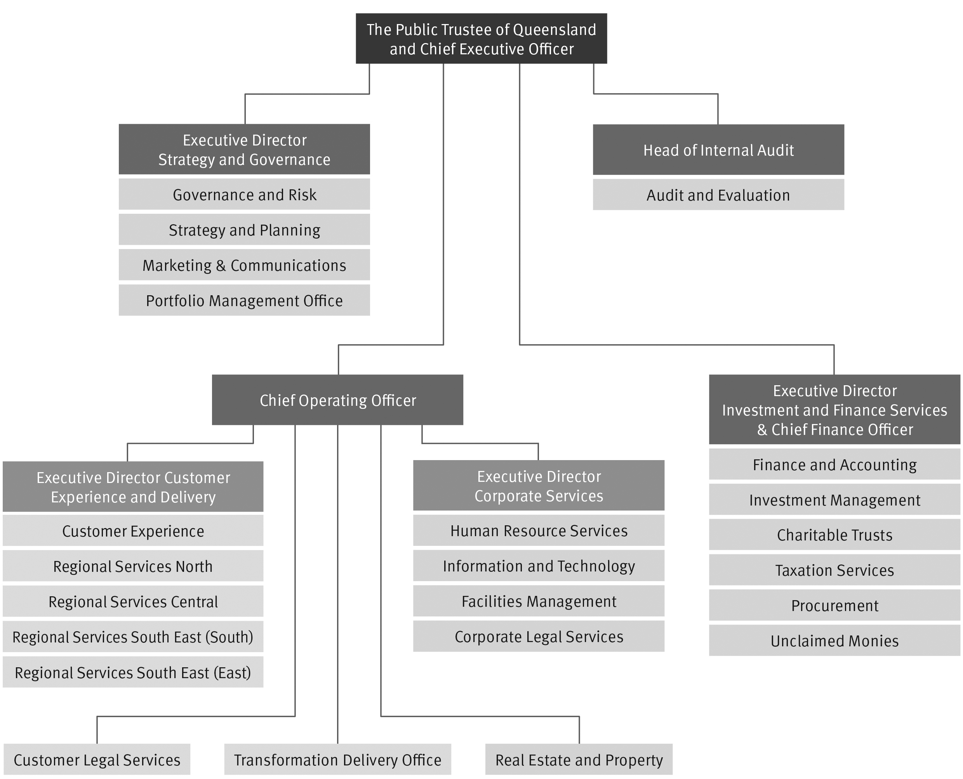

Senior internal management committees

The Public Trustee has established a range of internal management committees to support all areas of operation. The committees have varying roles and functions and are established for specific purposes either because of a legislative imperative or in response to the needs of the organisation.

Our leaders’ membership across these governance committees demonstrates our commitment to delivering services for Queenslanders in a transparent and accountable way. Our committees are integral components of the Public Trustee’s governance arrangements and ensure appropriate decision-making and accountability.

Board of Management

Following the implementation of the new functional structure, a Board of Management (BoM) was established.

The BoM is the senior leadership, planning and governance group of the agency. It was put in place to ensure there is clear accountability and streamlined decision-making across the organisation.

The BoM comprises:

  - The Public Trustee of Queensland (Chair)
  - Chief Operating Officer (COO) (Deputy Chair)
  - Executive Director, Investment and Finance Services and Chief Finance Officer (CFO)
  - Executive Director, Strategy and Governance.

The BoM is supported by the Executive Leadership Team (ELT), which will continue to provide strategic insights and advice to support the organisation.

Samay Zhouand

Acting Public Trustee of Queensland and CEO

Samay Zhouand has more than 17 years’ experience in legal, accountability, governance and risk management advice and decision-making across government. Samay started his career as a lawyer with the former Department of Employment, Training and Industrial Relations. In his substantive role, Samay is the Chief Inspector of Queensland Corrective Services where he leads the objective and evidence informed scrutiny of the correctional system in Queensland.

Samay has a background in accountability, which is grounded in good administrative decision-making practices, integrity, objectivity and risk management. He has led multiple key functions ranging from legal services, information rights and ethical standards to internal audit and inspectorate functions, as well as acting in other key senior executive roles.

Samay has introduced key innovative governance, performance management, and operational effectiveness initiatives that advanced administrative outcomes. These include the establishment of an independent Probation and Parole inspection framework and key research insights and projects such as resilience programs, behavioural economics experiments and Australia’s first full MQPL+ Survey (measuring the quality of prison life) in collaboration with Cambridge University.

A barrister, Samay holds a Bachelor of Laws with Honours and a Bachelor of Arts, as well as qualifications in business and government.

Samay is committed to ensuring that the Public Trustee continues to provide trusted, sustainable and customer focused services for Queenslanders.

Jeanette Miller

A/Chief Operating Officer (COO)

Jeanette is a public policy analyst with over 25 years’ experience in the Queensland Public Service, including 15 years in central agencies.

Jeanette has extensive experience in managing the development and evaluation of government policies and programs, as well as leading and managing teams within dynamic and vibrant environments.

During her time in the public sector, Jeanette has lead multidisciplinary teams responsible for major policy initiatives relating to the State’s budget, fiscal and economic position; trade, energy (including renewable energy); state development; industry attraction; tourism (including Global Tourism Hubs,

such as Queens Wharf); and developing industry roadmaps for Biofutures, Hydrogen, and Resource Recovery.

Jeanette has extensive experience in working across whole-of-Government major reforms, such as the Crime and Misconduct Commission Inquiry into Abuse of Children in Foster Care; National Health Reforms; and Queensland Skills and Training Reforms.

Jeanette’s focus is on delivering the Customers First Agenda.

Shane Sullivan

A/Executive Director, Investment & Finance Services & Chief Finance Officer (CFO)

Shane Sullivan commenced in May 2020 as the Acting Executive Director Investment and Finance Services and CFO. Shane is responsible for the management of financial reporting, payroll, procurement, charitable trusts, unclaimed money, customer taxation, as well as the investment framework for the Public Trustee. Prior to this appointment, Shane was the Acting CFO, Rio Tinto Growth & Innovation. Shane has extensive experience in senior finance leadership roles predominantly in the mining industry, in particular with Rio Tinto Growth & innovation, Rio Tinto Exploration and Argyle Diamonds.

Shane has a Master of Commerce (majoring in Management Accounting) from the University of New South Wales and is a Fellow of CPA Australia, a Fellow of the Governance Institute of Australia and a member of the Australian Institute of Company Directors.

Jacob Fredericks

A/Executive Director, Strategy and Governance

Jacob commenced as acting Executive Director, Strategy and Governance in March 2020 and is accountable for Strategy, Planning, Governance, Risk, Marketing and Communications, Portfolio Management Office and the office of the CEO. He is an experienced public servant with over 10 years’ experience across the Queensland Government including in the Department of the Premier and Cabinet, Department of Science, Information Technology and Innovation, and the Department of Transport and Main Roads. Jacob’s focus is on leading the Public Trustee’s strategy, governance and planning processes to achieve its Customers First agenda.

Jacob has a Bachelor of Laws (Hons), a Bachelor of Psychological Sciences, a Graduate Diploma in Legal Practice, Skills and Ethics, and a Graduate Certificate in Policy Analysis.

Information and Communication Technology (ICT) and Digital Steering Committee

In 2019-20, a new committee was established following recommendations by the Queensland Audit Office. The role of the committee is to provide strategic leadership for ICT, Information Security and Digital aligned with enterprise strategic objectives and processes.

The core functions of the committee are to:
  - review and approve ICT and digital strategies, plans and policies
  - ensure effective and equitable use of current and future ICT and digital resources
  - appropriately manage ICT and digital risk.

Membership of the committee is determined by the Public Trustee of Queensland. The members as at 30 June 2020 were:
  - COO (Chair)
  - CFO (Deputy Chair)
  - Executive Director, Strategy & Governance
  - Executive Director, Corporate Services

  - Representative from Human Resource Services
  - Representative from Customer Services
  - Chief Information Officer (CIO), Department of Justice and Attorney-General (non- remunerated).

Public Trust Office Investment Board

The Public Trust Office Investment Board (the Board) is established under section 21(1) of the Public Trustee Act 1978. The functions of the Board are to control and manage the investments of the Common Fund, and to provide advice to the Public Trustee on the investment management of the Public Trustee of Queensland Growth Trust.

Significant achievements of the Board in 2019–20 were:
  - endorsed the interim investment objectives for the Public Trustee Common Fund
  - reviewed the credit policy, taking into consideration the risk appetite of the organisation and the counterparty risks that prevail in the global financial environment
  - reviewed the operating limits for interest rate and credit risks
  - monitored the investment strategy of the Common Fund taking into consideration the continued historically low yield environment
  - endorsed revised benchmarks for interest rates payable to customers
  - noted the interest rate structure for interest rates payable to customers
  - reviewed the strategic asset management plan for buildings of the office. The Public Trustee of Queensland Growth Trust is audited by the Auditor-General.

Remuneration

Meetings/ Approved  Position Name sessions annual, attendance sessional or  daily fee |  |  |  | Approved  sub-committee fees if applicable | Actual fees received (GST  exclusive)
The Public Trustee of Queensland | Samay Zhouand | 5 | N/A | N/A | N/A
External Member | Henry Smerdon | 5 | Meeting fee - 4 hours or | N/A | $2000
 |  |  | less $400
External Member | Sandra Birkensleigh | 5 | Meeting fee - 4 hours or less $400 | N/A | $2000
Officer of the Department administered by the  Treasurer | Geoffrey Waite | 5 | N/A | N/A | N/A
No. scheduled meetings | 5

Total out of pocket expenses N/A

Under the Public Trustee Act 1978, the Public Trust Office Investment Board must consist of at least three members, one of whom shall be The Public Trustee of Queensland and one of whom shall be an officer of the Department administered by the Treasurer.

The Public Trust Office Investment Board has adopted the Code of Conduct for the Queensland Public Service.

Public Sector Ethics

Our employees are bound by the Code of Conduct for the Queensland Public Service. The Public Trustee maintains high ethical standards that support and underpin our fiduciary responsibilities.
Our new Strategic Plan 2020-2024 has an emphasis on the delivery of quality frontline services by providing our customers with professional and effective services in a responsive manner. To deliver quality frontline services, we must empower employees to act in an ethical manner.

In particular and following a high-level governance and structure review, we established an Ethics and Integrity Unit as part of our Human Resource Services area. The aim of this Unit is to develop, implement and promote a range of strategies which raise awareness of ethical standards and support ethical decision-making and behaviour. In 2019-20, those strategies included:
  - educating employees about ethical standards required in the workplace through our orientation program and mandatory online compliance training including:
    - Code of Conduct for the Queensland Public Service
    - fraud and corruption control
    - information privacy
    - right to information
    - complaints management
    - recordkeeping and file management
    - cybersecurity awareness

  - providing employees, managers and the ELT with regular communication and updates on ethics and integrity topics including:
    - regular updates on integrity initiatives
    - making resources available on the Ethics and Integrity Intranet page
    - topics and information from the Crime and Corruption Commission, Queensland Ombudsman and relevant bodies in other jurisdictions

  - incorporated integrity as a key aspect of the Social Responsibility Charter and Strategic Plan 2020-2024

  - established an independent email enquiries line for employees to seek confidential advice on ethics and integrity matters

  - updated key policies and procedures to support our compliance with the Public Service Act 2008 and the Public Sector Ethics Act 1994

  - promoted the importance to all employees on declaring secondary employment and managing actual, perceived or potential conflict of interests

  - ongoing liaison with key integrity agencies to enhance processes and practice at the Public Trustee

  - revised our Public Interest Disclosure Management Strategy

  - reviewed human resource policies and procedures to align with the Queensland Public Service values and Code of Conduct for the Queensland Public Service

  - The Queensland Ombudsman delivered training on Public Interest Disclosures to all managers in October 2019. The training covered a range of issues including an overview of the Public Interest Disclosure Act 2010, the impact of wrongdoing in the public sector and encouraging a pro-disclosure culture.

Public Sector Values

Work was undertaken to assess the culture at the Public Trustee and to identify key cultural attributes to shape future culture. During 2019–20, the Public Trustee began focusing on promoting and reinforcing behaviours to enhance a culture of ‘customer focused professionals’ and ‘learner improvers’.

The Queensland Public Service values underpin our workplace culture and are based on the Public Sector Ethics Act 1994 and the Code of Conduct for the Queensland Public Service.

We continued to embed and implement the Public Service values into our organisation as demonstrated below.

Customers first

- we introduced a new Customers First agenda supported by a Social Responsibility Charter and new organisational structure to enhance the way services are delivered to customers
- we provided training, new processes and procedures to better support the human rights of our staff, customers and their stakeholders
- we continued to provide specialised technical training to trust officers at all levels in order to provide excellent service to customers and to minimise risk.

Ideas into action

- we streamlined internal human resource procedures to reduce time and complexity for staff
- we delivered the ‘Engaging, Empowering and Enhancing 2019’ conference to approximately 78 middle and senior managers from across the organisation. The Conference focused on trust through people, customers, growth and governance and included information about the Human Rights Act 2019 and the pending legislative amendments from the Guardianship and Administration and Other Legislation Amendment Act 2019
- we created a People and Culture working group, as part of our Customers First agenda, to generate ideas and solve key challenges which resulted in updated and more accessible financial and human resources delegations.

Unleash potential

- we continued to enhance and deliver our specialised, organisation-specific, mandatory online compliance training for all employees to equip our workforce with the knowledge and skills to meet customer and stakeholder expectations
- we delivered the Corporate Orientation program for new employees throughout the year
- we delivered, in partnership with the Australian Institute of Management, Supervisor

Development workshops for employees at Administrative Officer Level 4 and 5 classifications. These workshops were focused on self-awareness and management, the skills to supervise and lead small teams, as well as how their work impacts on organisational outcomes
- we provided assistance to individual employees to build their professional capabilities through the support and management of our Study and Research Assistance Scheme.

Be courageous

  - we realigned how we deliver human resource services by reallocating business partners and introducing a dedicated recruitment team to better support staff
  - we established an Ethics and Integrity Unit to build knowledge and capability of our responsibilities as public servants.

Empower people

  - the Public Trustee held a Privacy Awareness Week Shopfront during Privacy Awareness Week in May 2020 so staff could learn how to best protect personal information – both their own and our customers
  - the third and final cohort of 25 managers graduated from the Leadership and Management Development Program delivered in partnership with the Queensland University of Technology. This program aimed to provide our middle management employees an opportunity to develop strategic leadership skills and behaviours
  - employees were actively engaged in the implementation of the new customer focused organisational structure through opportunities to provide feedback on the implementation and input on the more detailed alignment of new work units. Over 150 items of feedback were received, considered and responded to. Several ideas were incorporated into the final structure
  - the introduction of regular information sharing meetings for managers during the fast evolving COVID-19 pandemic highlighted the value of providing up to date information and learning materials to this important group. These forums have continued and provide managers with the opportunity to learn and ask questions about new initiatives and to cascade meaningful information to all staff
  - regular updates from the Human Resource Services team provided a further mechanism to keep all staff informed about health, safety and well-being, new and updated policies and procedures, learning opportunities, and ethics and integrity matters.

Governance – risk management and accountability

Risk management

Risk management at the Public Trustee is governed by our Risk Management Framework, a core component of our overall corporate governance and accountability framework. Aligned to the AS/NZS ISO 31000:2018 Risk Management Standard and designed for our specific business and organisational environment, the framework encompasses policies, procedures, systems and strategies that effectively manage our risks through regular engagement and consultation.

The BoM is responsible for risk management across the Public Trustee and is supported by the ELT, Governance & Risk Directorate, Internal Audit and the Audit and Risk Management Committee.

The Public Trustee is committed to promoting a risk management culture and to organisational risk management principles. Risks are identified and monitored on an ongoing basis to ensure they adequately reflect the current operating environment and are brought to the attention of BoM where required. Significant risks at organisation and program area levels are regularly reviewed and reported to the BoM and the Audit and Risk Management Committee.

In 2019–20, the Governance and Risk team continued to embed a culture of risk management at the Public Trustee, in accordance with the Risk Management Framework:

  - continually enhancing the Risk Management Framework for consistency of risk assessment, monitoring and reporting in line with the ISO 31000:2018-2 Risk Management – Guidelines and other applicable standards

  - conducting risk workshops with leadership teams to identify and assess significant risks across the Public Trustee. Individual program registers, and the Material Business and Strategic Risk Register, are reviewed by risk owners as part of regular management meetings to enable informed decision-making

  - providing advice and guidance on risk ownership, escalation, treatment, review and reporting to program areas across the Public Trustee

  - providing advice, guidance and co-ordination of business continuity planning and response including reviewing the Business Continuity Plan, development of a COVID-19 Response Plan, identifying critical functions, identifying and implementing risk management strategies in response to the COVID-19 global pandemic and COVID-19 scenario testing.

The Public Trustee is committed to complying with the Queensland Government’s Information Security Policy (IS18:2018). The policy seeks to ensure all departments apply a consistent, risk-based approach to the implementation of information security to maintain confidentiality, integrity and availability. In addition to other requirements, IS18 requires the Public Trustee to develop an information security management system (ISMS) which supports people in the organisation to ensure information security is front of mind when making decisions. Ongoing implementation and compliance with the policy is overseen by the ICT and Digital Steering Committee.

Internal audit

Internal Audit provides independent, objective assurance and consulting to improve the operational performance of the Public Trustee.

The unit’s role is defined in its Charter, approved by The Public Trustee of Queensland and endorsed by the Audit and Risk Management Committee.

The charter has regard to the Financial and Performance Management Standard 2019 and the Institute of Internal Auditors’ International Standards for the Professional Practice of Internal Auditing.

Internal Audit is independent and reports directly to the Acting Public Trustee of Queensland, with oversight by the Audit and Risk Management Committee. The current Head of Internal Audit holds a Bachelor of Commerce (Hons). He is a Certified Internal Auditor, Financial Services Auditor, and Information Systems Auditor and is also certified in Control Self-Assessment.

The Strategic and Annual Internal Audit Plan is developed in consultation with key stakeholders and takes into account the significant risks identified by management through the Public Trustee’s Risk Management Framework. Strong links with the Queensland Audit Office provide the foundation for a collaborative audit approach to ensure optimal audit coverage across all areas of the organisation, including financial and compliance audits, operational and efficiency audits, information system audits, and investigations.

In 2019–20, Internal Audit conducted independent reviews and audits of our internal controls, business processes and management practices. Key achievements included:
  - developed an internal audit plan based on strategic risks and operational risk registers
  - successfully executed the internal audit plan, providing reports to the Audit and Risk Management Committee and the Acting Public Trustee of Queensland
  - monitored and reported on the status of implementation of internal audit recommendations to the Audit and Risk Management Committee
  - supported management by providing advice on corporate governance and related issues including fraud and corruption prevention programs and risk management.

Audit and Risk Management Committee

The Audit and Risk Management Committee is an independent advisory body established to assist The Public Trustee of Queensland in fulfilling the Accountable Officer’s responsibilities under the Financial Accountability Act 2009, Financial and Performance Management Standard 2019 and other relevant legislation.

The committee operates under terms of reference established in accordance with the Audit Committee Guidelines – Improving Accountability and Performance published by Queensland Treasury.

The committee assists with reviewing:
  - financial statement preparation processes and oversight
  - the risk management framework
  - the fraud and corruption control framework
  - performance management, compliance and reporting
  - internal audit plans for endorsement
  - actions from internal and external audit reviews.

The Audit and Risk Management Committee met four times during 2019–20. Voting members of the Audit and Risk Management Committee for 2019–20 were:
Name | Details
Sandra Birkensleigh | External Chair
Felicity Cooper | External Member
Janine Walker AM | External Member
Kathryn Williams | Nominee of the Acting Public Trustee of Queensland2
Jeanette Miller | Nominee of the Acting Public Trustee of Queensland3

Standing invitees of the Audit and Risk Management Committee are:

- The Public Trustee of Queensland
- Members of the Board of Management
- Head of Internal Audit
- Senior Director, Governance and Risk
- Queensland Audit Office

Remuneration payments

Remuneration to external members during the 2019–20 financial year is detailed below.

Remunerated committee members | Amount (GST exclusive)4
Sandra Birkensleigh | $18,700
Felicity Cooper | $12,500
Janine Walker AM | $12,500
Total | $43,700

External members are required to comply with the Code of Conduct for the Queensland Public Service during their term.

2 Voting member for meetings held in August and December 2019.
3 Voting member for meetings held in March and June 2020.
4 Including any outstanding fees for services provided during 2019-20.

Information systems and recordkeeping

The Public Trustee is committed to meeting its responsibilities under the Public Records Act 2002 and other relevant legislation, Queensland State Archives policies and best practice methods. We continue to explore and implement ways of enhancing our efficiency and agility in providing services to Queenslanders, and demonstrate our commitment to quality information and records management that reduces the reliance on paper records through automation and digitisation.

In 2019-20, we demonstrated our commitment to compliant recordkeeping practices by:

  - upgrading our electronic Document and Records Management System (eDRMS) to ensure reliability, performance and security of electronic records
  - developing and introducing electronic tracking of internal documents through our eDRMS
  - reviewing and updating the Business Classification Scheme within our eDRMS including attaching Retention and Disposal references
  - updating our Information Security Classification in our eDRMS to be in line with the Queensland Government Information Security Classification Framework
  - continuing to deliver mandatory online recordkeeping training for all employees and contractors
  - disposing of public records in accordance with the Public Trust Office Retention and Disposal Schedule (QDAN 651 v.1) and the Queensland Government General Retention and Disposal Schedule.

External scrutiny

The Public Trustee is subject to external scrutiny by entities including the:

  - Crime and Corruption Commission
  - Queensland Audit Office
  - Queensland Ombudsman
  - Office of the Public Advocate
  - Office of the Information Commissioner
  - Queensland Parliament’s Legal Affairs and Community Safety Committee.

Governance – human resources

Workforce planning and performance

Our employees are employed under the Public Service Act 2008 and related industrial instruments aligning with Queensland Public Service Commission and Office of Industrial Relations’ policies and directives.

The workforce profile full-time equivalent establishment is 599.77 (as per the Minimum Obligatory Human Resources Information report for the quarter ending 30 June 2020). The Public Trustee employed 638 employees as headcount.

In 2019–20, the permanent separation rate was 8.88 per cent.

During 2019-20 there was a focus on workforce planning and resourcing for regional offices and the development of short term talent pools. A strategy was implemented to attract suitable entry level candidates with life experience and an affinity towards supporting service delivery in regional offices. Short term talent arrangements are in place for regions outside of south east Queensland. Further work is planned to address requirements within south east Queensland.

Some of the strategies we have in place to proactively retain employees include a structured on- boarding program to maximise integration of new employees into the Public Trustee, structured training programs for customer facing employees, access to flexible work arrangements (such as part time return to work programs following parental leave), and supervisor and leadership development options to support career development.

The Public Trustee has a strong history of promoting gender diversity with the overall gender profile comprising 75 per cent female and 25 per cent male employees. This gender profile exists across all levels of the Public Trustee with the ELT consisting of 70 per cent female and 30 per cent male members.

On 6 March 2020, International Women’s Day, the Public Trustee held a diverse workforce panel to discuss the theme #EachforEqual supporting a gender equal world. Our celebration offered staff an opportunity to hear from our panel members about their professional and personal experiences of equality and what it means for them, how they work to raise awareness and take action, as well as celebrate the amazing achievements of the women we work with. The Public Trustee is proud of its workforce diversity.

A key strategy in positioning the Public Trustee for the future of work involved development of the first stage of the learning journey and career map for customer facing employees. This work was undertaken to provide insights to future learning requirements and further support the Customers First initiatives.

The learning map encompasses eight weeks of structured orientation, online and face to face learning for new frontline employees. Online learning materials are progressively being updated to align with changes in legislation and contemporary business requirements including the addition of online Human Rights Act training being added to the suite of new starter learning materials.

Technical training, supervisor and leadership development is also incorporated into the learning journey and career map.

Supervisor development programs continued in 2019-20. These courses are designed for supervisors in the levels of AO4-AO6 and target capability development for new and existing supervisors.

Preliminary work on a new strategy to implement the Lead4Queensland assessment, based on Queensland Public Sector Leadership Competencies, was also progressed.

Development of employees is linked to the Performance Planning and Development framework which provides a mechanism for employees and their manager to set priorities, outline required behaviours and discuss development and career interests. Employees may access a range of opportunities to progress development including mobility through secondments within the Public Trustee or the broader Public Service, undertaking tertiary study, on the job learning and participation in projects.

Further flexibility and support for work life balance is demonstrated in the Public Trustee’s significant part time workforce. A total of 74 employees work part time which equates to 11.76 per cent of the workforce.

Apart from access to flexible work arrangements, employee well-being has been promoted through the Employee Wellbeing Program which is built around six key areas of social, physical, financial and emotional well-being, healthy eating, cancer screening and a number of supporting campaigns.

The industrial and employee relations framework incorporates an active approach to consultation with employees and unions. Seven regular Agency Consultative Committee meetings were conducted throughout the year in addition to two extraordinary meetings.

Early retirement, redundancy and retrenchment

No redundancy, early retirement or retrenchment packages were paid during the 2019–20 financial year.

Financial performance

The Public Trustee’s Financial Statements are included from page 39.

The Public Trustee recorded an operating loss of $12M against a budgeted loss of $5.4M. The operating loss recorded is predominantly due to lower fees and interest revenue as well as higher than anticipated employee and other expenses. These were partially offset by savings in supplies and services and lower interest expense.

The prioritisation of the safety and well-being of our customers and staff in response to COVID-19 impacted the financial performance for the year. The curtailment of some of our services as a result of the Government’s COVID-19 restrictions and rent relief provided to tenants reduced our revenue during the period. Additional technology costs were incurred to facilitate staff working remotely and supplementary cleaning services and supplies were procured for our facilities throughout the state.

The Public Trustee deferred the implementation of changes to the Public Trustee Regulation 2012 with effect from May 2020 in order to assist vulnerable Queenslanders by not reducing the interest rate payable to customers, resulting in a higher interest expense for the Public Trustee.

Our revenue sources in the last two financial years comprise the following:

Revenue sources | 2019-20 | 2018–19
Fees | 71% | 66%
Interest Revenue | 25% | 30%
Other Revenue | 4% | 4%
Total Revenue | 100% | 100%

Gross revenue from fees decreased by 2 per cent from the previous year. The low interest environment, the curtailment of some of our services, predominantly property auctions, and higher Community Service Obligations have resulted in a decrease in revenue compared to the prior year.

The majority of Community Service Obligations (excluding the provision of free Will-making services) are deducted from gross fees to arrive at net fees reported in the financial statements, with the remaining amount recorded in contributions expense. This year, we provided a total of $38.4M in Community Service Obligations at no cost to the Queensland Government, which was a 3.5 per cent increase from the previous year. As the Public Trustee is self-funded, these obligations were met from our own sourced revenue.

Our expenditure in the last two financial years comprises the following:

Expenditure | 2019-20 | 2018–19
Employee Expenses | 64% | 59%
Supplies and Services | 18% | 22%
Interest Expense | 8% | 13%
Depreciation and Amortisation | 3% | 3%
Contributions | 1% | 1%
Other Expenses | 6% | 2%
Total Expenditure | 100% | 100%

Total expenses increased 1.2 per cent from the previous year. Employee expenses increased by 8.1 per cent from prior year as a result of wage increases and the $1,250 one-off payment to employees which the Public Trustee has funded following the certification of the enterprise bargaining agreement. Non-employee expenses decreased by 8.8 per cent mainly due to lower interest expense and supplies and services, partially offset by higher other expenses.

Other Comprehensive Income

The Public Trustee holds interests in financial assets and various land and buildings located throughout the state from which our offices operate. These assets are recorded at fair value and are revalued periodically in accordance with Australian Accounting Standards. The gains and losses that result from these revaluations are recorded as other comprehensive income in the statement of comprehensive income.

All land and buildings were revalued during the 2018-19 financial year by independent valuers. The land and building values were not adjusted during the 2019-20 financial year as there was no significant change in the fair value of the Public Trustee’s land and buildings based on the movement in the relevant indices year-on-year.

The market value of the Public Trustee’s financial assets recorded unrealised gains of $5.2M due to the improved market value of the existing bond portfolio as interest rates further declined. This increase in other comprehensive income, combined with the operating loss, resulted in total comprehensive loss of $6.8M for 2019-20.

Statement of Financial Position

Total Assets
Total assets include cash, financial instruments (mainly short to medium term investments) and property, plant and equipment.

As at 30 June 2020, the Public Trustee held $977.2M in assets, a decrease of $5.2M from 30 June 2019, mainly due to a smaller investment portfolio compared to the prior year. Total assets include right-of-use assets as a result of the implementation of AASB 16 Leases in the 2019-20 financial year.

Total Liabilities
The Public Trustee’s liabilities include amounts held on behalf of customers, amounts owing to staff for leave entitlements and amounts owed to suppliers. Total liabilities were $760.4M as at 30 June 2020, an increase of $2.6M from the previous year. The increase in liabilities is primarily due to the recognition of a lease liability following the implementation of AASB 16.

Statement of Changes in Common Fund Reserves
Total Common Fund reserves were $216.8M as at 30 June 2020, decreasing from $224.6M in the prior year due to the operating deficit for the year, opening accumulated surplus adjustments relating to the implementation of AASB Leases and AASB 15 Revenue from Contracts with Customers, offset by the gains on financial assets referred to above.

Prospective Outlook

A budgetary deficit is forecast for the 2020–21 financial year which includes investment in continuous improvement initiatives which will ensure that the Public Trustee continues to be a sustainable self- funding organisation into the future, with a move towards a more modern, customers first service organisation. It is expected that the low interest rate environment, COVID-19 and an increasing number of customers eligible for rebates under the Public Trustee’s Community Service Obligations policy will continue to impact the financial results in the coming year. However, a number of strategies are being developed to minimise the impact of the current environment on the Public Trustee’s financial position.

Chief Finance Officer Statement

Our Chief Finance Officer (CFO) has fulfilled the responsibility as required by the Financial Administration Act 2009. The CFO has provided the Acting Public Trustee of Queensland with a statement about financial controls, in accordance with section 54 of the Financial and Performance Management Standard 2019. This statement was noted by the Audit and Risk Management Committee.

Public Trustee of Queensland Investment Fund – Growth Trust

The Public Trustee of Queensland Growth Trust (Growth Trust) was established to provide our customers with the opportunity to have their funds managed by the Public Trustee with the expert assistance of a professional investment manager.

The Public Trustee is the manager and trustee of the Growth Trust and is responsible for determining the investment objectives and strategy, arranging for the proper investment of all monies and ensuring the appointed investment manager achieves acceptable rates of return. The Public Trustee has appointed QIC Limited ACN 130 539 123 (QIC) as the investment manager of the Growth Trust.

The investment aim and objective of the Growth Trust is to provide a fully diversified investment strategy for those seeking long-term income and capital growth. The investment objective of the Growth Trust is to generate average returns (net of fees and costs) of CPI + 2.4 per cent per annum over rolling five year periods.

The Growth Trust currently gains exposure to various assets classes and investment sectors by investing in the QIC Long Term Diversified Fund (formerly known as the QIC Growth Fund), while liquidity for the Growth Trust is managed by an investment of approximately one per cent in the QIC Cash Enhanced Fund or holding funds in cash at bank.

The asset allocation strategy of the Growth Trust is managed within the QIC Long Term Diversified Fund, a diversified portfolio of assets including Australian and international shares, fixed interest, property, infrastructure, private equity, alternative assets and cash.

The investment objective of the Growth Trust and performance for the five year period ending 30 June 2020 is as follows:

Fund | CPI Objective (after fees) | Objective Target Return (%) | Annualised Return (%)
Growth Trust | CPI + 2.4% over rolling 5 years | 3.70% | 3.85%

Further information on the Growth Trust is available in its Product Information Statement and additional information is available on our website at http://www.pt.qld.gov.au/about/publications/investments/.

Our offices

To contact us, phone 1300 360 044 or email clientenq@pt.qld.gov.au.

Brisbane
Trustee House
444 Queen Street, Brisbane QLD 4000
GPO Box 1449, Brisbane QLD 4001

Sunshine Coast
Suite 1-3, 20 Innovation Parkway,
Birtinya QLD 4575
PO Box 49, Buddina QLD 4575

Brendale
170 South Pine Road, Brendale QLD 4500 PO Box 5204, Brendale DC QLD 4500

Bundaberg
Trustee House
189 Bourbong Street, Bundaberg QLD 4670
PO Box 860, Bundaberg QLD 4670

Cairns
Trustee House
27 Sheridan Street, Cairns QLD 4870
PO Box 656, Cairns QLD 4870

Gladstone
Trustee House
66 Goondoon Street, Gladstone QLD 4680
PO Box 5021, Gladstone QLD 4680

Ipswich
Trustee House
99 Brisbane Street, Ipswich QLD 4305
PO Box 140, Ipswich QLD 4305

Mackay
Trustee House
18 Brisbane Street, Mackay QLD 4740
PO Box 401, Mackay QLD 4740

Maryborough
277 Alice Street, Maryborough QLD 4650
PO Box 280, Maryborough QLD 4650

Mount Isa
30-32 West Street Mount Isa QLD 4825
PO Box 960, Townsville QLD 4810

Redcliffe
Trustee House
165 Sutton Street, Redcliffe QLD 4020
PO Box 131, Redcliffe QLD 4020

Rockhampton
Trustee House
67 East Street, Rockhampton QLD 4700
PO Box 273, Rockhampton QLD 4700

Southport
Trustee House
66 Nerang Street, Southport QLD 4215
PO Box 876, Southport QLD 4215

Toowoomba
Trustee House
447 Ruthven Street, Toowoomba QLD 4350
PO Box 139, Toowoomba QLD 4350

Townsville
370 Flinders Street, Townsville QLD 4810
PO Box 960, Townsville QLD 4810

Outreach locations

Outreach for our Will and EPA making services are usually conducted on a regular basis at the below locations. Some of these locations may be unavailable due to COVID-19 restrictions. Please phone 1300 360 044 or email clientenq@pt.qld.gov.au for more information on an outreach location near you.

Brisbane
- Chermside Centrelink
- Cleveland Courthouse
- Holland Park Courthouse
- Mitchelton Centrelink
- Nundah Centrelink
- Toowong Centrelink
- Wynnum Courthouse
- Woodridge Centrelink

Bundaberg
- Childers Courthouse

Cairns
- Mareeba Courthouse
- Atherton Courthouse
- Innisfail Courthouse
- Mossman Courthouse

Ipswich
- Beaudesert Queensland Government Customer Centre – in person and video conferencing
- Richlands Courthouse

Maryborough
- Gympie Courthouse
- Hervey Bay Courthouse
- Tin Can Bay RSL Sub Branch Inc.

Mount Isa
- Cloncurry Courthouse

Rockhampton
- Yeppoon Courthouse
- Woorabinda
- Dululu / Wowan
- Central Queensland University

Southport
- Beenleigh Neighbourhood Centre
- Palm Beach Centrelink

Sunshine Coast
- Nambour Courthouse
- Caloundra Courthouse

- Noosa Courthouse

Townsville
- Ayr Courthouse
- Charters Towers Courthouse
- Ingham Courthouse
- Townsville Dispute Resolution Centre

Across all our locations we also provide a visitation service for people who have difficulty in attending a Public Trustee office or outreach location for exceptional circumstances generally relating to medical and health reasons.

Our legislation

The Public Trustee administers the Public Trustee Act 1978. We have a wide range of powers and functions, and operate in accordance with many other Acts including:

Acquisition of Land Act 1967 Adoption Act 2009
Agents Financial Administration Act 2014
Airports Assets (Restructuring and Disposal) Act 2008
Associations Incorporation Act 1981
Body Corporate and Community Management Act 1997
Building Units and Group Titles Act 1980 Charitable Funds Act 1958
Child Protection Act 1999
Child Protection (International Measures) Act 2003 Civil Partnerships Act 2011
Collections Act 1966 Corrective Services Act 2006
Criminal Proceeds Confiscation Act 2002
Debt Collectors (Field Agents and Collection Agents) Act 2014
Disposal of Uncollected Goods Act 1967 Drugs Misuse Act 1986
Financial Accountability Act 2009 Gaming Machine Act 1991
Guardianship and Administration Act 2000 Human Rights Act 2019
Industrial Relations Act 2016 Information Privacy Act 2009 Integrity Act 2009
Integrated Resort Development Act 1987 Justice Legislation (COVID-19 Emergency
Response-Documents and Oaths) Regulation 2020
Land Act 1994
Land Sales Act 1984 Legal Profession Act 2007 Liquor Act 1992
Local Government Act 2009
Manufactured Homes (Residential Parks) Act 2003

Mineral Resources Act 1989 Mixed Use Development Act 1993
Motor Dealers and Chattel Auctioneers Act 2014
National Injury Insurance Scheme (Queensland) Act 2016
Personal Injuries Proceedings Act 2002 Police Powers and Responsibilities Act 2000 Powers of Attorney Act 1998
Property Law Act 1974 Property Occupations Act 2014 Public Guardian Act 2014
Public Interest Disclosure Act 2010
Public Officers Superannuation Benefits Recovery Act 1988
Public Records Act 2002 Public Sector Ethics Act 1994 Public Service Act 2008
Residential Services (Accreditation) Act 2002
Residential Tenancies and Rooming Accommodation Act 2008
Retirement Villages Act 1999 Right to Information Act 2009 Sanctuary Cove Resort Act 1985
Second-hand Dealers and Pawnbrokers Act 2003 South Bank Corporation Act 1989
Storage Liens Act 1973 Succession Act 1981
Surrogacy Act 2010 Trust Accounts Act 1973
Trustee Companies Act 1968 Trusts Act 1973
Victims of Crime Assistance Act 2009
Workers’ Compensation and Rehabilitation Act 2003
Work Health and Safety Act 2011 Youth Justice Act 1992

Glossary

This glossary provides a simple description of some terms used in or relevant to this report to generally assist the reader.

Administrator
An administrator is a substitute decision-maker and makes decisions on behalf of an adult with impaired decision-making capacity in respect to financial matters. An administrator is appointed by the Queensland Civil and Administrative Tribunal or a Court under the Guardianship and Administration Act 2000.

Attorney
An attorney is the person nominated by an individual under a power of attorney or an EPA to manage their affairs.

Beneficiary
A beneficiary is a person or organisation who receives a benefit under a Will or trust which may include personal effects, property or money.

Charitable and Philanthropic Trusts
The Public Trustee acts as trustee for various significant charitable and philanthropic trusts. These trusts are established for charitable purposes and usually will have a deductible gift recipient status, which means that people who make donations to the trustee for the use of the charitable trust can receive a tax deduction for the donation.

Common Fund
Under section 19 of the Public Trustee Act 1978, all moneys vested in or coming into the hands of the Public Trustee on behalf of clients, shall be held in one or more common funds and shall be invested by the Public Trustee.

Enduring Power of Attorney (EPA)
An EPA is an important legal document that gives someone else the power to make personal or financial decisions on behalf of the donor (the maker of the EPA) under the Powers of Attorney Act 1998. The Public Trustee accepts appointment as a financial attorney under EPAs.

Further information regarding EPAs can be found in the publication ‘Let’s talk about Enduring Powers of Attorney’ available online at https://www.pt.qld.gov.au/media/1812/lets-talk-about-enduring-powers- of-attorney_brochure_dl_2020.pdf.

Executor
The role of an Executor of a Will is to administer the estate of a deceased person and distribute the assets in accordance with the deceased’s Will.

Further information regarding executorship can be found in the publication ‘Let’s talk about Executor Services’ available online at https://www.pt.qld.gov.au/media/1815/lets-talk-about- executors_brochure_dl_2020.pdf.

General Retention and Disposal Schedule
The General Retention and Disposal Schedule covers records of common activities and functions, and transitory and short term records created as part of routine transactional business practices.

Growth Trust (Public Trustee of Queensland Investment Fund Growth Trust)
A unit trust is an investment vehicle that enables a number of investors to pool their money to make investments in a variety of assets such as property and shares. The Growth Trust is a unit trust. The Public Trustee is the Trustee and manager of the Growth Trust. Queensland Investment Corporation (QIC) is the investment manager.

Intestacy
Where a person dies without a valid Will the person is said to have died intestate. The person who administers the estate and distributes it in these circumstances is normally referred to as an Administrator. The Public Trustee is often asked to act as administrator in intestate estates.

Majority
Majority is the age at which a minor (child) is said to have reached full legal age and is competent to manage his/her own affairs. The age of majority in Queensland is prescribed by the Law Reform Act 1995. Section 17 of the Act provides that “the age of majority is 18 years”.

Minor’s Trust
Often there is a need for a Trustee to hold property on behalf of a minor. The Public Trustee often becomes involved in a minor’s trust where the child has received assets from a deceased estate or personal injury claim etc. In these circumstances the Public Trustee holds the assets in trust for the benefit of the minor.

The Public Trustee
The Public Trustee is legislated by the Public Trustee Act 1978 and is a corporation sole constituted by the Act.

The Public Trustee of Queensland
The appointment to the position of the Public Trustee of Queensland is made by the Governor in Council and the position holder is subject to the Minister for Justice.

Queensland Civil and Administrative Tribunal
The Queensland Civil and Administrative Tribunal has the legislative power to appoint guardians and administrators for an adult with impaired decision-making capacity. This makes sure that the adult’s needs are met and their interests protected.

Queensland Government Agent Program
In rural and smaller regional areas, local and Queensland Government offices have been nominated as part of the Queensland Government Agent Program as agents for public sector agencies including the Public Trustee. A broad range of government services can be accessed at these offices which provide information, help and advice on all Queensland Government services. Information on participating offices can be found at: www.qld.gov.au/about/contact- government/contacts/government-service-offices/.

Trust
A trust exists where the owner of property is obliged to deal with that property for the benefit of some other person or people or for some particular purpose recognised by law, for example for a charitable purpose. There are three key elements of a trust: a trustee, beneficiary/beneficiaries (or, in the case of a charitable trust, a charitable purpose) and trust property.

Trustee
A trustee is the person (including the Public Trustee of Queensland) who holds the trust property and administers the trust in accordance with the terms of the trust for the benefit of the beneficiary/beneficiaries or the purpose of the trust. The trustee is under an obligation to deal with those assets not for his or her own benefit but for the benefit of the beneficiaries or the purpose of the trust (for example, a charitable purpose).

Will
A Will is a document stating how a testator (the maker of the Will) would like their estate (assets) to be distributed after they die. The Succession Act 1981 defines how a Will should be prepared for it to be valid.

Further information regarding the Public Trustee’s will-making service can be found in the publication ‘Let’s talk about Wills’ available online at https://www.pt.qld.gov.au/media/1813/lets_talk_about_wills_brochure_dl_2020.pdf.

ACN | Australian Company Number
AASB B | Australian Accounting Standards Board Billion
BoM CEO | Board of Management Chief Executive Officer
CFO | Chief Finance Officer
CPI | Consumer Price Index
eDRMS | electronic Document and Records Management System
ELT | Executive Leadership Team
EPA | Enduring Power of Attorney
FTE | Full-time equivalent
GST | Goods and Services Tax
ICT IS ISMS ISO M | Information and Communication Technology Information Security Policy  Information Security Management System International Organization for Standardization Million
N/A | Not applicable
QCF | Queensland Community Fund
QDAN | Queensland Disposal Authority Number
QIC | Queensland Investment Corporation
QUT SMS WH&S | Queensland University of Technology Short Message Service  Workplace Health and Safety

Summary of requirement |  | Basis for requirement | Annual report reference
Letter of compliance | - A letter of compliance from the accountable officer or statutory body to the relevant Minister/s | ARRs – section 7 | 1
Accessibility | - Table of contents  - Glossary | ARRs – section 9.1 | iii 114
 | - Public availability | ARRs – section 9.2 | ii
 | - Interpreter service statement | Queensland Government Language Services Policy  ARRs – section 9.3 | ii
 | - Copyright notice | Copyright Act 1968  ARRs – section 9.4 | ii
 | - Information Licensing | QGEA – Information Licensing  ARRs – section 9.5 | ii
General information | - Introductory Information | ARRs – section 10.1 | 4
 | - Machinery of Government changes | ARRs – sections 10.2, 31  and 32 | N/A
 | - Agency role and main functions | ARRs – section 10.2 | 4
 | - Operating environment | ARRs – section 10.3 | 4-10, 18-21
Non-financial performance | - Government’s objectives for the community | ARRs – section 11.1 | 5-6, 14
 | - Other whole-of-government plans / specific initiatives | ARRs – section 11.2 | N/A
 | - Agency objectives and performance indicators | ARRs – section 11.3 | 14-16, 18-21
 | - Agency service areas and service standards | ARRs – section 11.4 | 15
Financial performance | - Summary of financial performance | ARRs – section 12.1 | 35-38
Governance – management and structure | - Organisational structure | ARRs – section 13.1 | 22
 | - Executive management | ARRs – section 13.2 | 22-24
 | - Government bodies (statutory bodies and other entities) | ARRs – section 13.3 | 25-26

 | - Public Sector Ethics | Public Sector Ethics Act 1994  ARRs – section 13.4 | 26-27
 | - Human Rights | Human Rights Act 2019  ARRs – section 13.5 | 11-13
 | - Queensland public service values | ARRs – section 13.6 | 27-28
Governance – risk management and accountability | - Risk management | ARRs – section 14.1 | 29
 | - Audit committee | ARRs – section 14.2 | 30-31
 | - Internal audit | ARRs – section 14.3 | 30
 | - External scrutiny | ARRs – section 14.4 | 32
 | - Information systems and recordkeeping | ARRs – section 14.5 | 32
Governance – human resources | - Strategic workforce planning and performance | ARRs – section 15.1 | 33-34
 | - Early retirement, redundancy and retrenchment | Directive No.04/18 Early Retirement, Redundancy and Retrenchment  ARRs – section 15.2 | 34
Open Data | - Statement advising publication of information | ARRs – section 16 | ii
 | - Consultancies | ARRs – section 33.1 | https://data.qld.gov.au/
 | - Overseas travel | ARRs – section 33.2 | https://data.qld.gov.au/
 | - Queensland Language Services Policy | ARRs – section 33.3 | https://data.qld.gov.au/
Financial statements | - Certification of financial statements | FAA – section 62  FPMS – sections 38, 39 and  46  ARRs – section 17.1 | 84,106
 | - Independent Auditor’s Report | FAA – section 62 FPMS – section 46  ARRs – section 17.2 | 85-87, 107-109

FAA Financial Accountability Act 2009

FPMS Financial and Performance Management Standard 2019

ARRs Annual report requirements for Queensland Government agencies QGEA Queensland Government Enterprise Architecture

